Media Security Policy
Animal Care Department
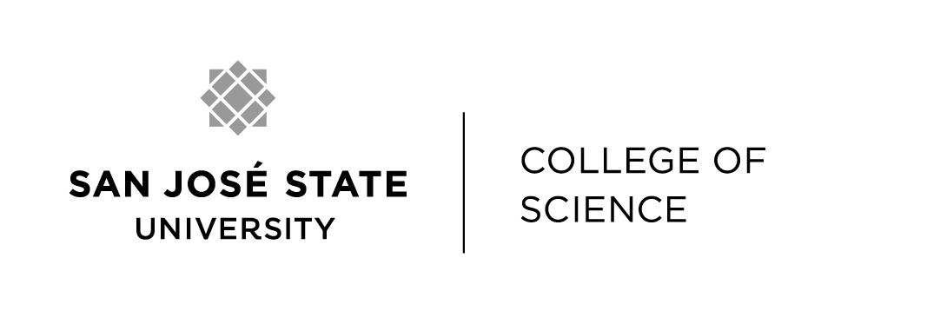

OCTOBER 2022

Purpose and Scope

The University Animal Care department has established a Media Security Policy (MSP) that is intended to protect the confidentiality and integrity of SJSU research, to assure respect for the privacy and safety interests of faculty, staff and students, and to prevent misleading representation of animal care and use at SJSU and its affiliates. This policy describes the allowable use of visual recording in any area where animals are housed, tested or used at San Jose State University and Moss Landing Marine Laboratories (including laboratories, vehicles/conveyances, and field study locations), and provides investigators guidance on presenting, sharing and protecting or reporting of images involving live or dead animals, or their parts, in efforts to share or promote scientific interests and SJSU-supported programs.
Media Security Policy

The use of any recording device (e.g., film camera, digital camera, camera phones, digital recorder, sound recorder, live streaming equipment, etc.) is prohibited in animal use areas with the following exceptions:
- When performed by government inspectors (e.g. USDA Veterinary Medical Officer);
- When performed by an authorized PI or designee when required for scientific reasons (e.g., publications, laboratory documentation) as described in the respective IACUC-approved protocol;
- When performed by an authorized PI or designee for the purpose of recording instructional activities as described in the respective IACUC-approved protocol;
- When performed by or at the direction of authorized University Animal Care veterinary staff for the purpose of diagnosing or documenting clinical disease, veterinary care or treatment;
- When performed by personnel authorized by the University Animal Care department when required to document condition of facilities, or compliance, or animal handling issues; and
- When performed to report or convey concerns related to animal welfare, care, or treatment.
Principal Investigators or faculty who wish to allow filming in animal use areas for reasons not described above must involve the Animal Care Program Manager or Campus Veterinarian in planning these activities prior to filming or recording. This includes photography or filming by journalists or other outside interests. Investigators and faculty are strongly encouraged to collaborate with designated press officers on recording an approved media session or the information dissemination process. Contact the Office of Strategic Communications and Marketing at 408-924-1166 or by visiting http://www.sjsu.edu/communications for more information.
Individual or group noncompliance with the Media Security Policy shall be considered a violation of SJSU’s Policy on Animal Care and Use S14-6 (and subsequent revisions thereof), and could result in suspension of an approved animal use protocol by the IACUC.

Guidance for Implementing this Policy

Rights of Individuals

Faculty, staff and students who may be photographed or recorded in the course of their work should be informed when such activity is imminent. Any individual may decline being photographed, filmed, or recorded and is not required to be subject to recording.
Avoiding Unintended Distribution of Images

Although recording of animals or animal activities may be justified or necessary for instructional or scientific presentations or publications, investigators should recognize that animal use that is perceived as appropriate by the IACUC might not be seen that way by members of the public who lack important context. Special attention should be given to the secure processing, transport and storage of negatives, disks, tapes, media cards, etc. and dissemination of images or recordings taken by investigators or authorized personnel in the course of their work.
Principal Investigators shall protect all IACUC-approved media involving animal care and use generated at or produced by SJSU or its affiliates from unintended copying or distribution by the intended viewer or the public-at-large. In such instances, investigators must utilize appropriate digital security to maintain full control of virtual postings or online sharing of such images or recordings at all times.
Every effort should be made to show appropriate and accurate context when audio or visual recordings are made (e.g., if an animal is anesthetized or sedated, include the anesthetic vaporizer or tray holding the bottle of the tranquilizing agent; have personnel wearing required personal protective equipment appropriate for the work appear in the image).
Every effort should be made to avoid showing identifying landmarks for security purposes (e.g., building and room numbers, worker’s name badges, etc.).
Faculty, staff and students should be mindful of the potential for photographs and video images of animals used in teaching and research to be the target of public records requests. In some circumstances, such photographs or video images may be accessible to members of the public under California’s Public Records Law. Faculty and staff are encouraged to consult with campus Legal Services prior to creating such photographs or video images.
Careless or casual use of recorded images or recordings from animal use areas or in the field (e.g. posting on social media platforms) could unintentionally expose students, staff and faculty to unwanted attention and harassment or misrepresent the nature of such activities occurring at or by San Jose State University and its affiliates. Investigators and faculty should consider asking students and visitors to read this policy prior to entering animal use areas, engaging in animal-related activities, taking photographs or other recordings, or adding this policy to departmental or course-specific policies or agreements.
Individuals are encouraged to report any posting, sharing or distribution of prohibited or casual images involving the care and use of animals at SJSU, MLML, or in the field by contacting the SJSU Animal Care Program Manager at (408-924-4929 or Lawrence.young@sjsu.edu).

