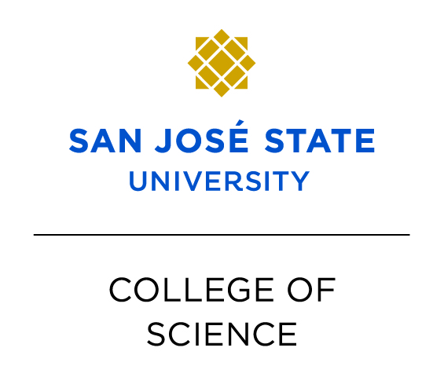

San Jose State University
College of Science Advising Center
Academic Advising Internship
The academic counseling intern will serve as a member of the professional counseling team in providing academic education to students and help new students transition to the College of Science at San Jose State University. This internship is designed as a hands-on application of academic counseling activities. Under the supervision of a student services professional the intern will assume counseling responsibilities which include career and major advising, workshop delivery, and resource development.
QUALIFICATIONS:
• Second year masters-level students preferred. First year students with proven related experience may be considered.
• Candidates must currently be working toward a graduate degree in career counseling, college counseling, psychology, or a related field.
• Background in Science, Math, or Engineering is highly desired. Must have an interest in working with students in these academic areas.
• Ability to work on an inter-departmental team which includes counselors, faculty, staff, prospective students and their families, and campus administrators.
• Must have strong research skills and interest in developing exploration tools targeted to Math and Science.
• Strong verbal and written communication and presentation skills.
RESPONSIBILITIES:
Responsibilities include, but are not limited to:
Advise on general University policies and procedures.
Answer inquiries concerning College of Science programs, courses, and policies.
Advise students on curriculum and degree requirements and course articulations.
Assist students in resolving academic difficulties.
Provide general support for student related activities.

Assist with drop-in office hours and advising appointments sessions related to academic counseling.
Co-facilitate special population (e.g.; frosh, transfer, students on academic jeopardy) workshops and individual sessions.

Support advising sessions for College of Science during summer orientation.
The intern will check-in with student regarding issues such as:
selecting courses for next semester,
time management,
placement in to learning communities
determine resources needed by the student like tutoring, counseling…
stress management
to “check in” on student’s progress.

The incumbent will have the opportunity to provide academic advising for entering freshmen, undergraduates, transfer, and second baccalaureate students entering a major within the College of Science.
COMMITMENT:
This internship is a one academic year commitment, starting Fall semester 2010. Interns must be available to work spring, summer, and fall for up to 20hrs per week, which includes supporting new student orientation programs and outreach events. The intern will receive at least one hour of individual supervision with a student services professional weekly. Interns must receive academic credit for their internship hours.
COMPENSATION:
Competitive hourly salary
Access to professional development opportunities
May be used for supervised experience hours, pending approval
APPLICATION PROCESS:
Application deadline: September 8, 2010; by 4:00 p.m.
Please submit cover letter and resume to:
Ann Baldwin, Office Manager
Ann.Baldwin@SJSU.edu ◙ 408-924-5184 ◙ DH 213

