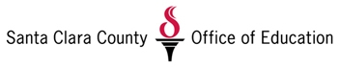
School Counselor Internship
Santa Clara County Office of Education
Alternative Education Department
Application Process

Applicants for internships as a school counselor for the Santa Clara County Office of Education, Alternative Education Department must meet the following requirements:

- Completed Application
- One Letter of Recommendation
- Resume
- Enrollment in EDCO 292
- Intern a minimum of 16 hours per week for the duration of one semester

Once the above is completed, please contact Michelle DeCaro at (408) 573 – 3207 or michelle_decaro@sccoe.org.

