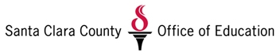
School Counselor Internship Application
Santa Clara County Office of Education
Alternative Education Department

1. What has prepared you for an internship with the Alternative Education Department and our underserved students?
______________________________________________________________________________________________________________________
___________________________________________________________
___________________________________________________________

2. How do you bring “hope” to a person who feels they have run out of options and chances?
______________________________________________________________________________________________________________________
______________________________________________________________________________________________________________________

3. What attribute, trait, or skill would you bring to the school site?
______________________________________________________________________________________________________________________
___________________________________________________________

4. What grade level of students would you prefer to work with?
Middle school ______ High School ______
Community School ______ Court School _____

5. Any additional information you would like to add?
__________________________________________________________
__________________________________________________________
__________________________________________________________

