*This is Why They Hate Us* by Aaron Aceves 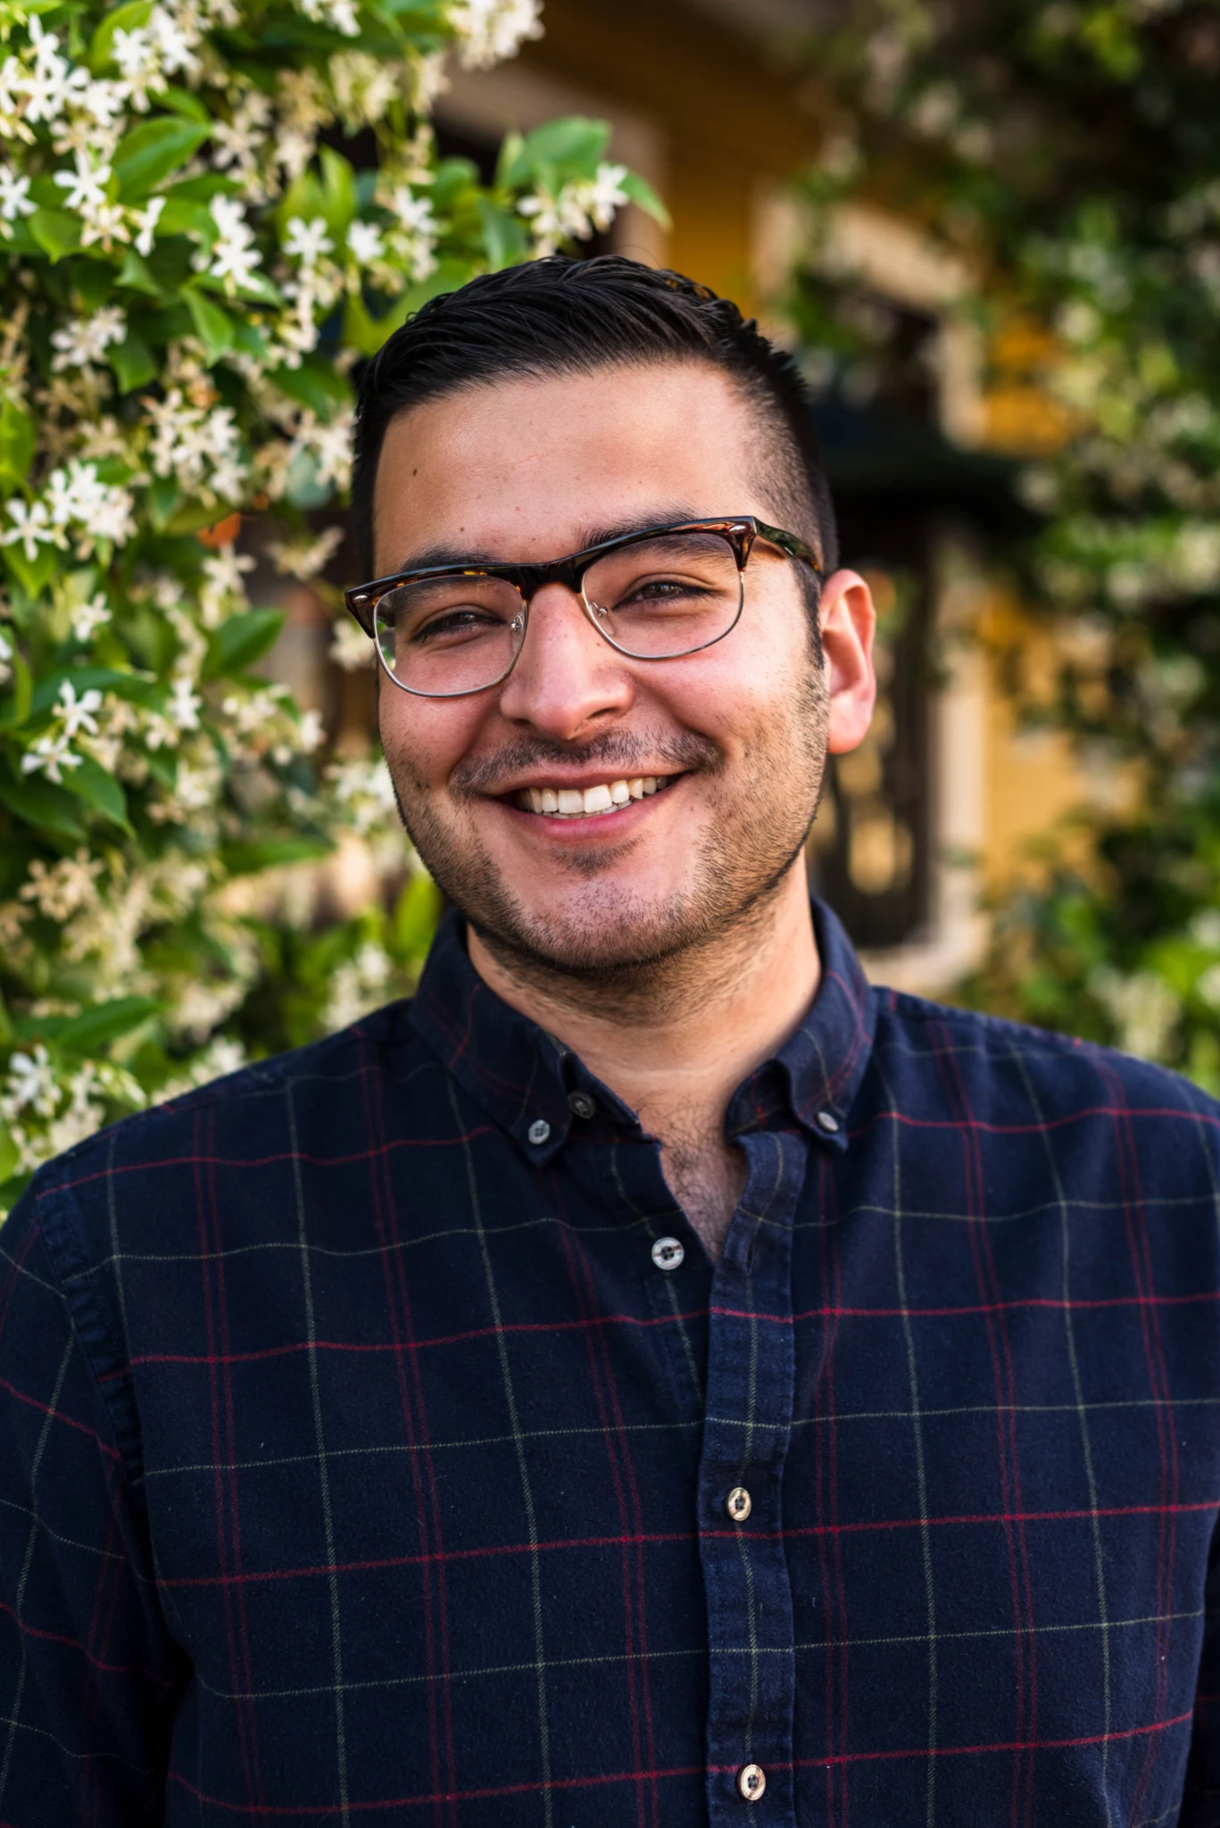

The author is Aaron Aceves. He is Mexican-American, born and raised in East-L.A. Like the main character of his debut novel, *This is Why They Hate Us* Aceves is bisexual.

The novel is the only book Aceves has out currently; however, he has several short stories, articles, and other published writings. He is a Harvard graduate and has an MFA from Columbia University. He is currently a professor at The University of Texas, where he works as an Early Career Provost Fellow.

Complimentary to the novel is an [Annotated playlist](https://diversebooks.org/cover-and-playlist-reveal-for-this-is-why-they-hate-us-by-aaron-h-aceves/)  which can be found on the blog diversebooks.org

[Aaron Aceves Website](https://aaronhaceves.wordpress.com/)

**Summary**

The novel follows Enrique, nicknamed Quique, over his summer vacation and attempts to get over his crush on his friend Saleem. Quique is a closeted bisexual. In the beginning only his best friend, Fabiola, knew his secret. As the story unfolds and Quique explores his sexuality, he reveals himself to more and more people. Quique also has difficulties revealing parts of himself that do not have to do with his sexuality with others. Saleem and his parents know about his struggles with mental health, which he keeps hidden from Fabiola.

Quique desperately craves love, but struggles to figure out how to get it. He describes the different potential relationships as “prospects” and is very naive about what he is actually engaging in. Many of these encounters leave him more confused and dissatisfied than before he experienced them. Later on Saleem returns and Quique struggles even more to determine what their interactions mean. In the end Quique comes out and reveals who he is to his family and friends. He comes clean about his mental health issues and despite some initial difficulties, starts a relationship with Saleem.

**Three Significant quotes**

“ I consider the possibility of having such intense chemistry with someone that is expressed physically and mutually, and I feel this literal ache in my chest that I get every time I’m talking to a guy who’s nice and confident and athletic and everything else I’m not” (20)

This quote comes from when Fabiola and Enrique are talking about relationships and their personal experiences. This quote sets up the tone of the book. Quique sees himself as unworthy. He constantly has this yearning for love, but is afraid to try. He was also very focused on the physical aspects of love. As the book goes on he understands that love is not just physical, but this a hard learned lesson for him.

“If I could make one wish, I know exactly what it would be. I would ask the genie/fairy/leprechaun/unicorn/phoenix/whatever for a talent or skill that I could use to make enough money to be able to tell my parents to quit their jobs. I constantly imagine what their faces would look like, how fucking happy they’d be. But then I crash back down to reality, and I realize I can’t save them” (68)

This quote shows how thoughtful and concerned Quique is. He constantly worries about his loved ones. In particular he worries about his parents. He has a deep love and admiration for them, but is also terribly afraid that they will reject him if he comes out to them. More than anything he wants to protect his parents.

“I feel like a zoo animal sometimes. You know how they talk about a tiger that’s born in captivity but still yearns for the wild? It feels like I’m that tiger, as if I were born in a cage, but I still feel the jungle beneath my feet, as if it’s ingrained in my DNA” (156)

This quote is from Saleem. This comes after Saleem and Quique have a heated discussion with their history teacher about Palestine. Saleem brings up the metaphor of the tiger, but it has multiple meanings. Saleem wants community; he wants to feel connected to his heritage, but he is trapped into a world that denies it. Quique too is trapped. He is trapped by himself and by the dangers of coming out. He is worried his loved ones will reject him, but in school in particular he could be assaulted just like a fellow classmate was, when he came out. In the end when we find out Saleem is attracted to Quique the metaphor grows. These boys are unable to be who they truly are, so they are tigers in a cage.

**Using this book in a classroom**

This book would fit best into the category outlined in chapter 6 of *Adolescents in the Search For Meaning: Tapping the Powerful Resource of Story*, wish is “Books about identity, discrimination, and struggles with decisions”.

In a classroom setting I would choose excerpts from the text, not the full text. I believe this text may be difficult to teach in its entirety because of the explicit depictions of sexual behaviors and the lack of textual complexity.

Despite these difficulties, I do believe the content is extremely relevant to teens as Quique is someone who is struggling to come to terms with his identity, as many teenagers are. The most crucial part of this book is the journey of self acceptance and the search for identity. Quique wants to hide who he is from fear of rejection. He also wants to explore who he is, but he cannot do that without accepting himself first. He does not deny that he is bisexual, but he does not accept love for himself.

I would focus on the excerpts that show Quique’s inner thoughts. These parts are the most malleable for students to analyze, they are also what I would consider the most relatable. A Yearning for acceptance and love is universal.

A motif in the novel is the letters Quique receives in the year book. An activity I might use is having the students write their own yearbook letters to Quique either as themselves or as characters in the book.

**Text Complexity**

The Quantitative Tools I am using are the Lexile & Quantile tools and The Dale-Chall Readability calculator. The results are as follows.

Lexile & Quantile Tools:

* Age range 14-99
* Score 660L

Dale-Chall:

* Age range:12-13
* Difficulty: average
* Grades: 7-8

Structure:

The book is written entirely through the view of Quique. It follows his summer and all unfolds in chronological order. Aceves uses a mix of Quique personal thoughts and dialogue between the characters, but it is always through Quique’s perspective

Language Conventions and Clarity:

As seen in the Lexile & Quantile tools and the Dale-Chall analysis, the novel is not very complex in its language or sentence structures. It uses many colloquialisms and references potentially niche topics that although do not detract from the reading if it is unknown, would add to the reading as Quique identifies with characters from the novels he reads.

Knowledge Demands:

references many novels, such as, *Call Me By Your Name* and *The Picture of Dorian Grey*. There Are also many references to Palestine and Saleem is Palestinian. As mentioned in the language section there are also book characters that Quique identifies with. I do not believe any of this background knowledge is required to understand the themes nor the story, but could add to the understanding of Quique’s character and other characters.

Levels of Meaning:

This text is easily understood, but emotionally it may be difficult for some readers to digest. The metaphors used are not too complex and can be flipped to apply to multiple situations. There are also not very many overarching metaphors or too many themes. The book is centered on Identity, acceptance, and love. These themes go hand in hand. The complexity is not in the words or the structure, but in the emotions and experiences Quique has. None of them are truly horrifying events. He is never assaulted or beaten, but he is still hurt deeply.

**Key Passage**

From page 258-259

“The main character of the book is a bi seventeen year old like me … Will anyone ever tell me I’m the one?”