Kevin Nguyen

Professor Warner

Literature for Young Adults

7 October 2024

*A Land of Permanent Goodbyes* Book Talk

**Atia Abawi**

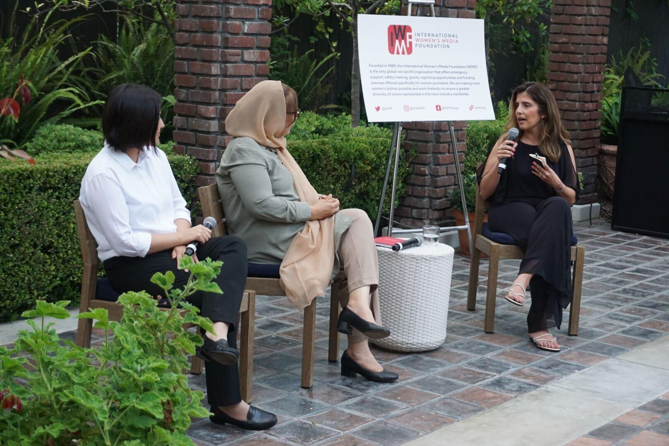

Abawi depicted on the right, hosting a talk with Afghan women for the International Women’s media Foundation.

<https://www.atiaabawi.com/>

* Born as a refugee in West Germany after her parents fled Afghanistan in 1981 due to the Soviet invasion
* Was responsible for the creation and management of CNN’s Kabul bureau after being hired as the organization’s Afghanistan correspondent

**Summary**

Tareq is a teenage boy living with his grandmother, parents, and five siblings in Syria as it is undergoing a civil war. The bombing of their home forces the surviving family members to decide to leave Syria as nowhere within the country’s borders is safe. What’s left of his family must go to Tareq’s uncle who can give them enough money to leave. They are scrutinized by both pro-government forces and rebels as they travel across territories occupied by the different factions. Their status as refugees makes them reliant on whoever is willing to deal with them, regardless of their motives. Alexia is a volunteer helping with

**Three Representative Quotes**

**Quote 1**

Tareq’s father Fayed drives his family out of their home city while Tareq tries to think of who was responsible for his family’s deaths.

“ The article that Tareq thought of was one shared primarily by friends and family who supported the government. It claimed that the loss of fertile land sparked the anti-government revolt in 2011, beginning in an area where farmers were feeling more than a pinch in their wallets because of the decade-long dry-up[...]

That article, and many articles for that matter, made a lot of claims about what may have ignited the war. In reality, there were many sparks that started the inferno that burned a great civilization into the ashes - there always are[...]

After the strike that killed his family, Fayed decided that he needed to get his two surviving children out of his homeland, a decision he would regret putting off for the rest of his life, as ghosts of his other children and wife constrict his every breath.” (30)

I think the quote is useful because it realistically shows how people respond to tragedy in their lives. Tareq remembering the article alleging the cause of the civil war depicts a young adult’s desire for an explanation to the violence inflicted on his family. Many times people want a simple cause for their suffering that they can direct the blame onto but the quote presents no such answer. Fayed’s decision to leave Syria shows the difference in thinking between a teenager and an adult. Tareq’s father spends no time wondering who was responsible for the bombing, he is only concerned with the wellbeing of his surviving family. There is no time for machismo and seeking revenge when you have people who depend on you, you just have to move on.

**Quote 2**

Tareq and his younger sister Susan wait on the Turkish coastline for the smugglers to bring the inflatable boats that will take them to Greece. They are separated from Fayed by the smugglers, who want to load as many people onto the boats without sinking. He helps Susan put on the vest given to her.

“Tareq hastily blew up Susan’s vest. It was a yellow inflatable meant only for swimming pools. The warning label stated “THIS IS NOT A LIFESAVING DEVICE - WILL NOT PREVENT DROWNING”. But the store clerk had promised Tareq that it was better than most of the life jackets being sold, including the ones he would offer him. The Turkish clerk had pulled out an orange vest and said Tareq could purchase an authentic Yamaha vest for $150 or the black-and-red fake one for $20. The clerk told him it was the best of the fakes on the market as he squeezed the vest. “Not stuffed with paper, see? It has foam inside.” He guaranteed the vest wouldn’t let Tareq drown, a hollow warranty. *If I drown, how do I get my money back?* Tareq wanted to ask the pushy salesman just to hear his response. But he held his tongue in front of his father, who was already tense and afraid.” (158)

The quote gives perspective into the desperation of the refugees and the industry built around taking advantage of them. Because of them having no governmental body advocating for their rights, there is no legal recourse for Tareq’s family. But refugees would be willing to pay whatever they had in order to leave their situation. The result is a race to the bottom in the smuggling industry to provide the lowest quality goods for the most amount of profit.

**Quote 3**

Tareq and Susan are at the Macedonian border encampment in winter. They meet with Dr. Kassem and his wife, who were on the boat with them. They choose to adopt a baby named Heba whose parents died during the trip crossing from Turkey into Greece. The Macedonians keep the border closed, claiming for the sake of security, while the temperature drops to lethal levels at night.

“After several more hours, the border finally reopened. Not out of mercy and kindness, but out of fear of bad press attention in Western Europe.

Two children and one adult died that night. Including baby Heba and Dr. Kassem’s wife. The infant froze, her lungs burned by the icy air she had inhaled. The woman’s heart gave out soon after witnessing the baby’s pale lips and cold gaze. The doctors said it, too, was because of the weather, but her husband knew better.” (261)

The quote highlights how even after leaving their country, refugees are still not safe, but instead of being faced overt violence, they are subject to the whims of the countries they are trying to enter which treat them as dangerous by default. The closing of the border highlights how few practical protections refugees have. While the United Nations might declare that refugees have certain rights, there is no way for them to actually enforce the law for every refugee at every border. It is only when they are put under scrutiny that they follow international law. The quote reveals how without the threat of negative press, many countries would simply leave their borders closed, with fatal results.

**Application In Classroom**

*A Land of Permanent Goodbyes* would be a useful resource in World Literature. Many young adults have parents with immigrant backgrounds or are immigrants themselves, and I would present this book as providing some insight to the struggles that they had to go through.I would be confident in having students read the book in sophomore year, as while it does contain some graphic depictions of violence, it is no more violent than *The Kite Runner*, which is already used as part of the sophomore year literature class curriculum in some schools. I feel as though the book most belongs in Chapter 7 of *Adolescents in the Search for Meaning: Tapping the Powerful Resource of a Story*, because while it had elements of both Chapter 5 and 6, the internal conflicts of dealing with death and identity are secondary to Tareq’s goal of surviving the various barriers impeding him from seeking asylum.

**Text Complexity**

**Quantitative**

Lexile Rating: 760L

ATOS Level: 9.00

**Qualitative**

The book’s language is not complex and the omniscient narrator often tells rather than have the reader infer meaning through description of body language or use of tone. The Exeter quality of including different perspectives is partly there, as while the volunteer Alexia is a second protagonist, there is no conflict between her goals and Tareq’s. There is little use of symbolism and subtext. But complexity was likely not Abawi’s goal with the novel, as the more accessible language also makes it available to readers who may not know English as their first language. The story being of refugees seeking asylum would likely motivate students of a contemporary classroom, who often have immigrant backgrounds. The desire to keep the family intact during the journey and the indifference of host countries can correlate with the students’ own life experiences. Even if the book does not, it is still useful in portraying the humanity of refugees and the difficulties that they face as the debate about immigration policy in the United States continues.