
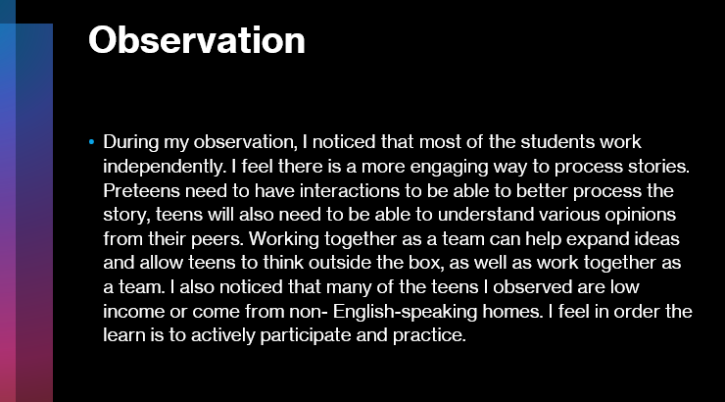


I chose The Giver because it is a one-of-a-kind book about a dystopian world, where feelings and emotions are stripped away to ensure a flawless, and orderly existence. In this world everything is in perfect order, babies are applied and given away based on availability; The babies are then perfectly numbered until they are of the age to be named and passed over to suspecting parents. Spouses are selected by whom are most compatible, and careers are chosen for you as part of “The ceremony of the Twelves.” The main character Jonas is selected for one of the most necessary jobs within the community. Jonas was selected to be the “Receiver,” considered the most prestigious job within the district. Jonas’ role was to experience and accept all the memories from the previous unsuccessful world. All the pain, emotions and love that was previously banned from the city, are to be transferred to Jonas; He is to keep these emotions so no one else can experience such tragic and lovely things. As Jonas begins his studying with the wiser and older Giver, Jonas discovers there is much more to this ordain existence he currently knows. Jonas is determined to restore forgotten memories, he begins to question authority and overcome obstacles, revealing a life far richer than the one he’s been trained to accept.

Harry Potter and the Prisoner of Azkaban- The third book in the bestselling Harry Potter series, now illustrated in glorious full color by award-winning artist Jim Kay! For twelve long years, the dread fortress of Azkaban held an infamous prisoner named Sirius Black. Convicted of killing thirteen people with a single curse, he was said to be the heir apparent to the Dark Lord, Voldemort. Now he has escaped, leaving only two clues as to where he might be headed: Harry Potter's defeat of You-Know-Who was Black's downfall as well. And the Azkaban guards heard Black muttering in his sleep, "He's at Hogwarts . . . he's at Hogwarts."Harry Potter isn't safe, not even within the walls of his magical school, surrounded by his friends. Because on top of it all, there may well be a traitor in their midst.
We Were Here- When it happened, Miguel was sent to Juvi. The judge gave him a year in a group home--said he had to write in a journal so some counselor could try to figure out how he thinks. The judge had no idea that he actually did Miguel a favor. Ever since it happened, his mom can't even look at him in the face. Any home besides his would be a better place to live. But Miguel didn't bet on meeting Rondell or Mong or on any of what happened after they broke out. He only thought about Mexico and getting to the border to where he could start over. Forget his mom. Forget his brother. Forget himself.
Life usually doesn' t work out how you think it will, though. And most of the time, running away is the quickest path right back to what you're running from. From the streets of Stockton to the beaches of Venice, all the way to the Mexican border, We Were Here follows a journey of self-discovery by a boy who is trying to forgive himself in an unforgiving world.
Whale Talk- There's bad news and good news about the Cutter High School swim team. The bad news is that they don't have a pool. The good news is that only one of them can swim anyway. Bestselling author Chris Crutcher's controversial and acclaimed novel follows a group of outcasts as they take on inequality and injustice in their high school. T.J. Jones hates the blatant preferential treatment jocks receive at his high school, and the reverence paid to the varsity lettermen. When he sees a member of the wrestling team threatening an underclassman, T.J. decides he's had enough. He recruits some of the biggest misfits at Cutter High to form a swim team. They may not have very much talent, but the All-Night Mermen prove to be way more than T.J. anticipated. As the unlikely athletes move closer to their goal, these new friends might learn that the journey is worth more than the reward.
Tweak- Nic Sheff was drunk for the first time at age eleven. In the years that followed, he would regularly smoke pot, do cocaine and Ecstasy, and develop addictions to crystal meth and heroin. Even so, he felt like he would always be able to quit and put his life together whenever he needed to. It took a violent relapse one summer in California to convince him otherwise. In a voice that is raw and honest, Nic spares no detail in telling us the compelling, heartbreaking, and true story of his relapse and the road to recovery. As we watch Nic plunge into the mental and physical depths of drug addiction, he paints a picture for us of a person at odds with his past, with his family, with his substances, and with himself. It's a harrowing portrait--but not one without hope.
Beautiful Boy- What had happened to my beautiful boy? To our family? What did I do wrong? Those are the wrenching questions that haunted David Sheff's journey through his son Nic's addiction to drugs and tentative steps toward recovery. Before Nic became addicted to crystal meth, he was a charming boy, joyous and funny, a varsity athlete and honor student adored by his two younger siblings. After meth, he was a trembling wraith who lied, stole, and lived on the streets. David Sheff traces the first warning signs: the denial, the three a.m. phone calls-is it Nic? the police? the hospital? His preoccupation with Nic became an addiction in itself. But as a journalist, he instinctively researched every treatment that might save his son. And he refused to give up on Nic.

Beautiful Boy
The Giver
Speak
Harry Potter

I chose The Giver because it is a one-of-a-kind book about a dystopian world, where feelings and emotions are stripped away to ensure a flawless, and orderly existence. Jonas is determined to restore forgotten memories, he begins to question authority and overcome obstacles, revealing a life far richer than the one he’s been trained to accept. I believe this book is helpful to teens because it helps them make wise choices and determine what is best for themselves. The book is also a great reminder about friendships and first loves, something that can be tricky for teens to navigate. This book can be helpful for teens to acknowledge they don’t necessarily have to reject their parents demands but make wiser choices that help benefit them in the future. A teen that learns to choose wisely can have a valuable future if they choose the best path. Because The Giver is such a well-read book, there are several Exeter Qualities the book includes. The first and main Exeter Quality is “Imaginative and well- structured plots going beyond simple chronologies to include time shifts and differing perspectives.” The Giver follows an imaginative world that demonstrates different plots and perspectives from various characters. Based off the Exeter Qualities the type of genre is very easily displayed, fantasy. However, it does follow the path of three teens adjusting to a new daily routine and learning who they are as individuals. Jonas questions what is beyond and determines that he needs to explore more to understand reality.

Sustained silent reading time.
Poem review. Have students’ study and break down the poem, meter, rhyme for the poem and short story provided. Have them compare their observations among the table. This will allow students to comprehend and break down the text being studied and to share thoughts and details about the reading out loud. Be able to determine central or main ideas, as well as supporting sentences.

The Road Not Taken
By Robert Frost
Two roads diverged in a yellow wood,
And sorry I could not travel both
And be one traveler, long I stood
And looked down one as far as I could
To where it bent in the undergrowth;
Then took the other, as just as fair,
And having perhaps the better claim,
Because it was grassy and wanted wear;
Though as for that the passing there
Had worn them really about the same,
And both that morning equally lay
In leaves no step had trodden black.
Oh, I kept the first for another day!
Yet knowing how way leads on to way,
I doubted if I should ever come back.
I shall be telling this with a sigh
Somewhere ages and ages hence:
Two roads diverged in a wood, and I—
I took the one less traveled by,
And that has made all the difference.

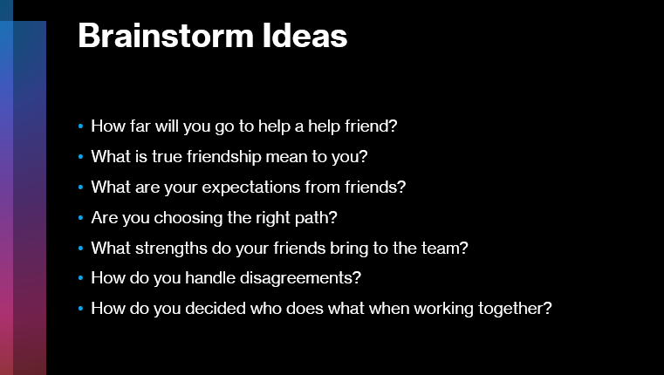
Allow the students to read a few chapters every night. Recap each class for a few minutes and have the students participate and provide key details and main points from the previous night’s reading. Keep journals while they are reading and note all the sections of the story that contain friend elements, or paths of self-discovery. Also have students keep track of important facts about the story. Allow students some time to compare journal entries among their tables.

Have students work together as a table and create their own dystopian worlds as they read through the novel. Add details and rules, laws, and create a type of hierarchy etc..

Write 1-2 pages on your contribution to the team project and how your contribution adds value to the Dystopian world.

Works Cited
Cutcher, Chris. Whale Talk. Greenwillow Books, 2001.
De la Pena, Matt. We Were Here. Delacorte Press, 2009.
Frost, Robert. “The Road Not Taken.” Poetry Foundation, Poetry Foundation,
https://www.poetryfoundation.org/poems/44272/the-road-not-taken. Accessed 12/1/2024.
Lowry, Lois. The Giver. Houghton Mifflin Harcourt, 1993.
Rowling, J.K. Harry Potter and the Prisoner of Azkaban. Scholastic, 1999.
Sheff, David. Beautiful Boy: A Father’s Journey Through His Son’s Addiction. Houghton Mifflin, 2008.
Sheff, Nik. Tweak: Growing Up on Methamphetamines. Atheneum Books for Young Readers, 2007.

