Chapter 8. Manipulator-Mechanism Design
12-1-14

Note: The photo images are downloaded from the internet as non-copywrited materials.

Robot types and work envelopes

Articulating – 6 axis
SCARA
Cartesian –Gantry robot
Cylindrical
Polar (Spherical)
Parallel - Stewart mechanism (“Spider Man”), double SCARA-Parallel hybrid
Others – Mobile, wafer handling, dual arm (“Lost Head”)

Youtube vedeo on robot work envelopes

https://www.youtube.com/watch?v=YbQ4O0BYlcc

OSHA safety requirements

https://www.osha.gov/dts/osta/otm/otm_iv/otm_iv_4.html#1

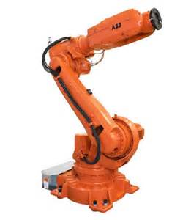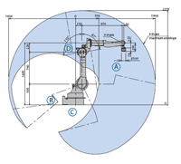

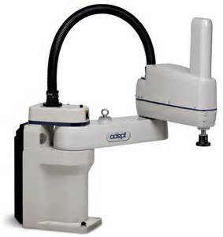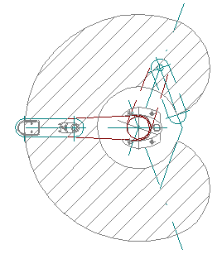

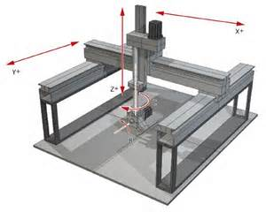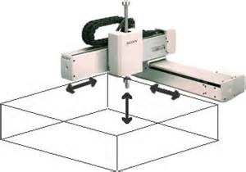

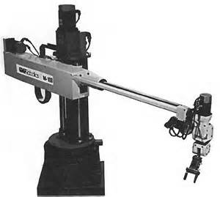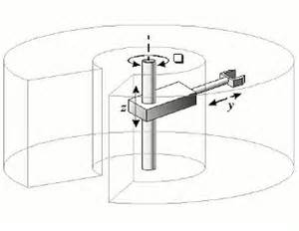

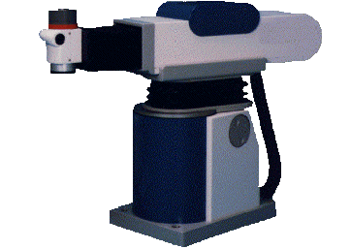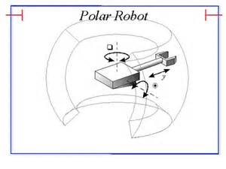

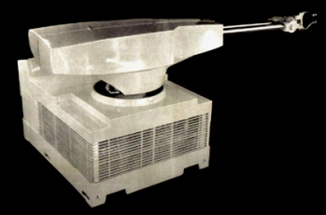 GM Unimate robot, the first industrial robot

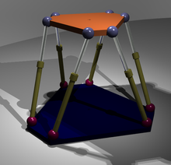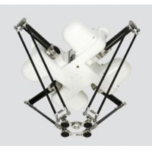

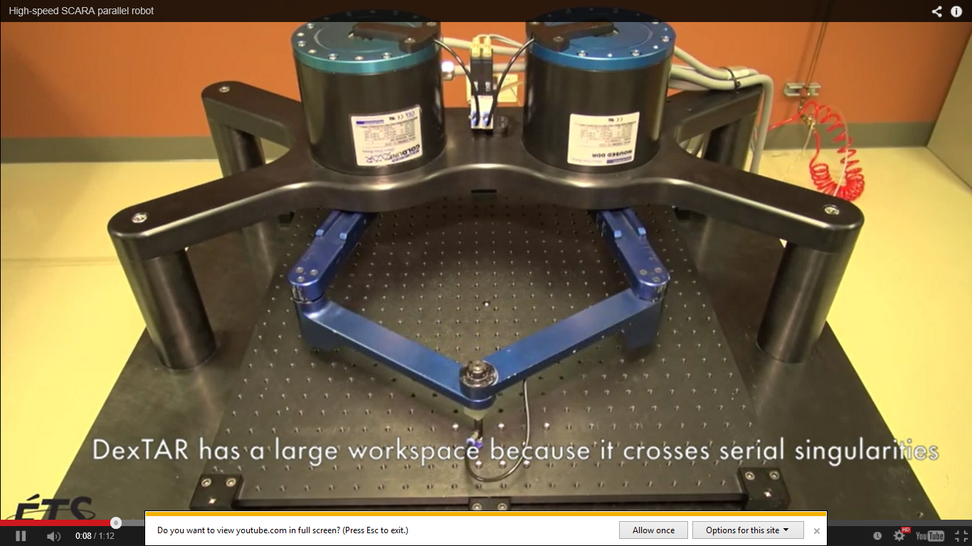

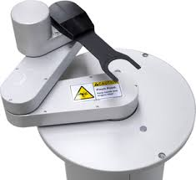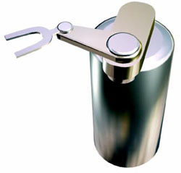

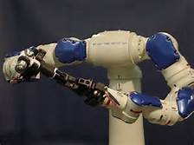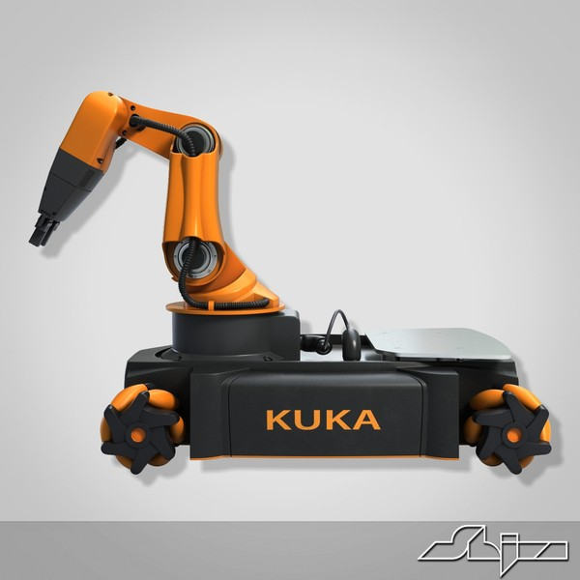

End Effectors and Force-Torque Sensors

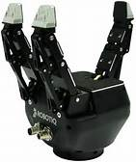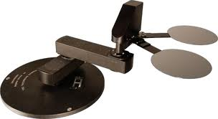

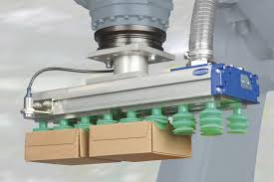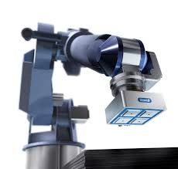

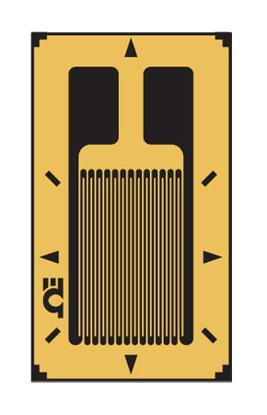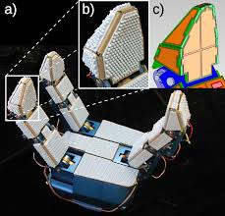

Adaptive gripper with sensor suite installed
(a). Closeups show (b) texture and (c) taxels.

Degrees of Freedom

Normally equal to the number of joints. Some joints are linked together by a belt or gear assembly. In such instance, the degrees of freedom will be one less. Example: 2nd and 3rd joints of a wafer handling robot.

Closed Loop Robot Structures

When end effector motion is constrained by two or more links as in a Stewart mechanism and two arm robots.

Grubler’s formula for the DOF of closed loop robots

$F=6(l-n-1)+ \sum_{i=1}^{n}{fi}$ (8.9)

where F = the total DOF, l = the number of links, n = the number of joints, f_{i} = the number of DOF for joint i.

Solve 8.8 (uncollected Homework)

For the Stewart mechanism l = 14 (top & bottom, 2 parts to each of 6 linear actuators) , n = 18 (6 universal, 6 ball & socket, 6 linear), sum of f_{i} = 36 (2 DOF per universal, 3 DOF per ball & socket, 1 per actuator)

Motors

Robots motors are generally servo motors which are equipped with encoders for closed loop control.

Speed, Accuracy and Repeatability

Speed = SCARA robots are fast. Parallel robots are even faster.

Accuracy = ½ of Control Resolution determined by the encoder step angle of the joint motors

Repeatability (Precision) = ±3σ, always less than Accuracy, due to link frame deflection and joint motor backlash.

Robot accuracy – ½ of control resolution – CR determined by encoder spacing

Repeatability – Mechanical limits – Inherently less precise than stepper motor with gear assembly given the same stepping angle.

Position Sensing:

The force or torque command to an actuator at each joint is based on error between the sensed position of the joint and the desired position – each joint have some sort of position-sensing device.

For revolute joints – rotary optical encoder, potentiometer, tachometer.
For prismatic joints – Potentiometer, linear optical encoder if linear actuator is used.
Rotary encoder if lead screw mechanism is used.

Properties

Redundancy of joints – Having extra joints or degrees of freedom to avoid singularities or manipulate the robot arm around obstructs.

Compliancy of arms – SCARA robot is vertically non-compliant, i.e., no force or torque is needed to sustain load on the end effector.

Stiffness of links – For positional accuracy in the presence of links sagging due to their weight and the load.

Flexible members

in parallel k_{p} = k₁ + k₂
in series 1/k_{s} = 1/k₁ + 1/k₂

Shafts, Gears, Belts, and Links – Equations given in pp. 248, 249

Repeatability – Determined experimentally through sampling in Cartesian space.

σ²${=σ}_{x}^{2}{+σ}_{y}^{2}{+σ}_{z}^{2 }$

Actuators

Mostly DC motors, some AC and Stepper motors.

Pneumatic for linear actuators – relatively low accuracy.

Hydraulic – For large industrial robots.

Position Sensing

- Optical encoders – For both motor feedback control and distance travelled.
Incremental (pulse train). Absolute (binary position code).
- Resolvers – For conversion of shaft polar angle to rectangular (XY) coordinates
– Represented by sine and cosine angles (90° phase shift winding output)
- Provide velocity and position data and DC motor commutation.

- Tachometers – For velocity checking.

- Potentiometers – Linear position sensing. Thick film voltage dividers.

- LVDT (Linear Variable Differential Transformer) – High cost, high accuracy

Force and Torque Sensing – Joint, wrist, and tip

Measures the reaction forces developed at the interface between mechanical assemblies.

- Joint sensors measure the Cartesian components of force and torque acting on a robot joint. For a joint driven by a DC motor, sensing is done simply by measuring the armature current.

- Wrist sensors are mounted between the tip of a robot arm and the end-effector. They consist of strain gauges that measure the deflection of the mechanical structure due to external forces.

- Tip sensors are the load cells or an array of strain gages mounted on the tip.

