George Bernard Shaw

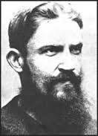
(GBS) 1856-1950
Here is his dashing young intellectual phase, though he is usually seen as a white-bearded sage.
Best known as an Irish wit and a playwright, but he was also a pamphleteer and public speaker on topics related to economics and social justice, a Fabian and co-founder of the London School of Economics. A famous critic of music, art, and theater.
Won the Nobel Prize for Literature & the Academy Award for Pygmalion (screenplay).
Greatest hits: Arms & the Man, Saint Joan, Man & Superman, Heartbreak House, Major Barbara, Caesar & Cleopatra, John Bull’s Other Island, Mrs. Warren’s Profession.
Born in Dublin but lived his adult life in England. One of the most famous men ever.

