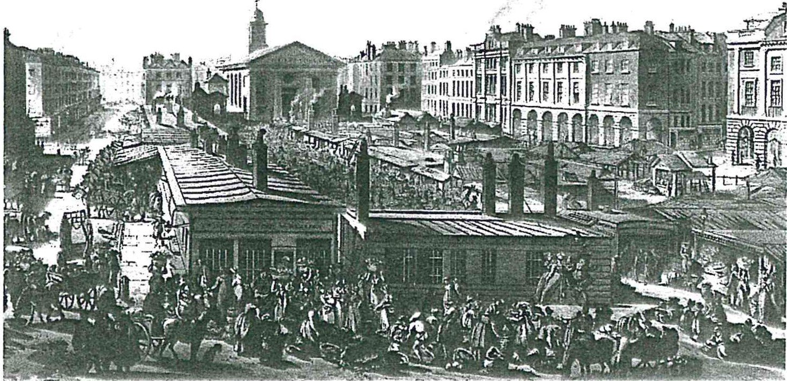

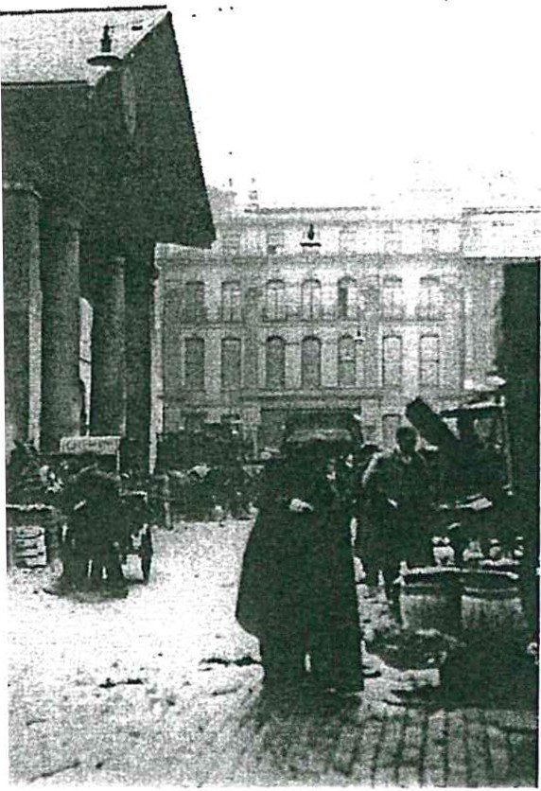
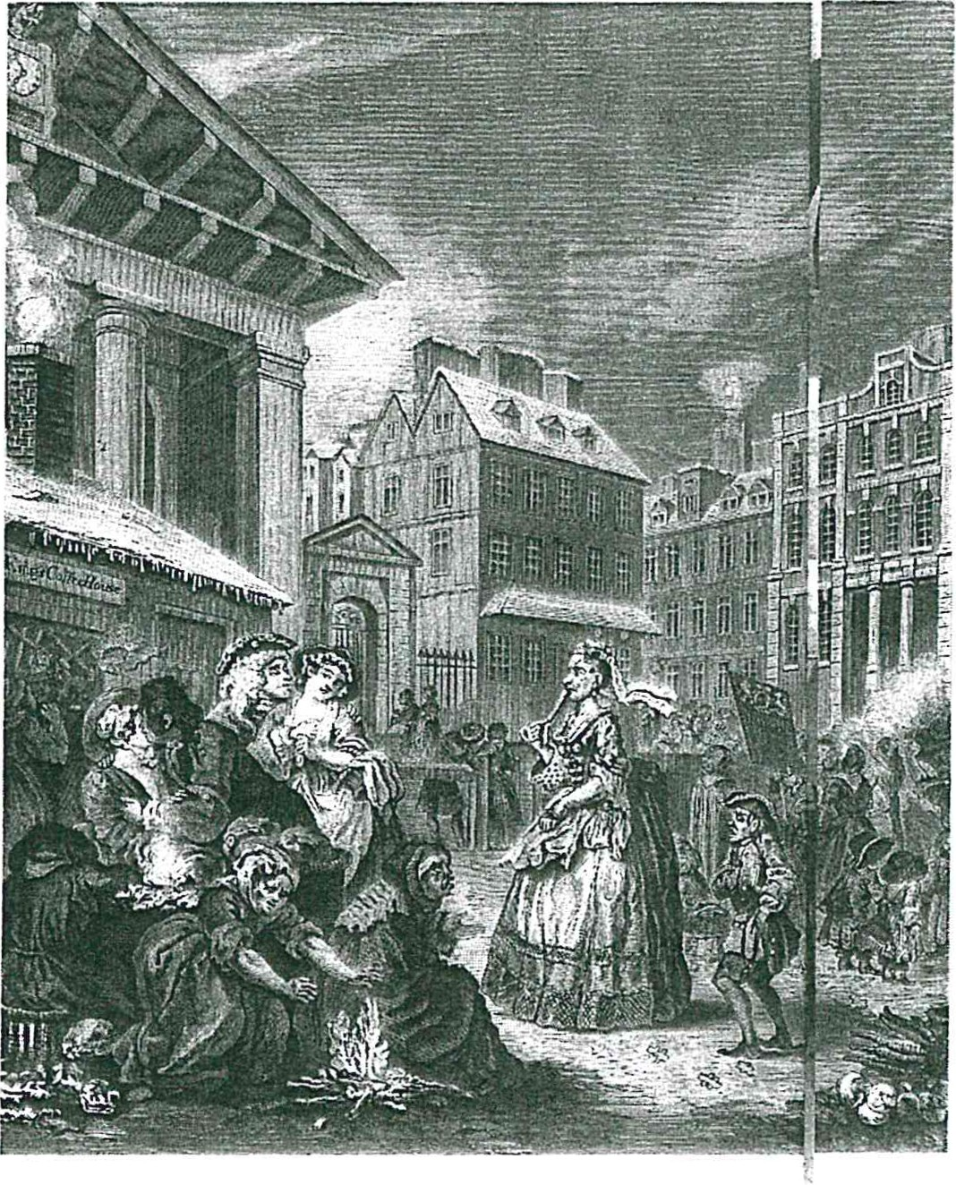T GARDEN OVER THE CENTURIES, M TOP: ETCHING BY THOMAS ROW-
/ING THE' MARKETS IN 1811; ENGRAVING OGARTH, 1720; PHOTOGRAPH c.1905 TTY).

'OR FLOWER GIRL" FROM AN ALPHABET
JOLSON. 1898 (PUNCH & JUDY INC).
Liza's· London
BY D ENiS J OHNSTON

The city of London is really a group of cities that have grown together like an organism, through the energy of unfettered capitalism. In the first century BC, Julius Caesar described an affiu­ ent and well-organized tribal society that he found there on the marshy banks of the lower Thames. A century later the Romans founded Londinium on the same site, and it quickly became a thriv­ ing centre of trade. The city did not wither after the Romans left, but remained a vibrant commercial centre, miraculously surviving several sporadic cycles of plague and fire. In his landmark "biography" of London published in 2000, Peter Ackroyd notes that London "is per­ petually rising from flame and ruin. Indeed it has been defined throughout its history by such resurrections ." The most famous of these, of course, came after the Great Fire of 1666, on the ashes of which the present city arose. The Great Fire ironically
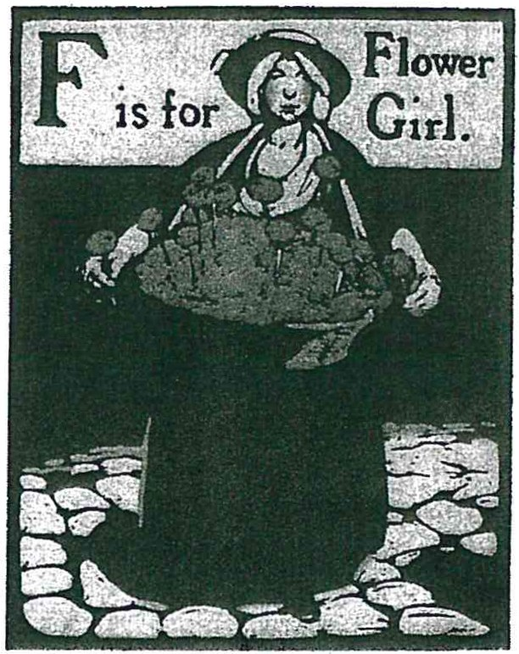brought great benefits : it ,put a stop to a devastating plague, made way for much-needed urban renewal, and gave birth to one of London's most famous landmarks, St Paul's Cathe­ dral. Pygmalion begins in the portico of another St Paul's, however: a small but picturesque church in Covent Garden. Originally a convent garden of the Benedictines of Westminster Abbey, Covent Garden began its rise to fame as part of an early experiment in suburban development. In 1630, a time when the cities of London and Westminster were beginning to grow together, the property's
·post-Reformation owner, the Earl of Bedford, commissioned the Royal Surveyor to design what was to be the first of London's many residential squares. It was bounded on the east by Bedford's own garden wall and on the west by a modest church, designed with a distinctive portico of Tus­ can columns that ' was unique in Europe at the
time. In 1670 the estate obtained a charter to establish a fruit, vegetable and flower market in the square, and Covent Garden quickly °became the most famous market in Britain, perhaps in the world. Soon it was also the site of one of London's most celebrat­
-ed theatres, which from the mid-nineteenth century became the English home of Italian opera. Covent Garden's church had a theatrical flavour too: its designer Inigo Jones was n English pioneer in scne design as well as architecture, and his St Paul's holds the earthly remains of such stage luminaries as playwright William Wycherley and actress Ellen Terry. Perhaps Shaw chose to begin his Pygmalion here as a sly allusion to Covent
,,.._ Garden's eminence in theatre as well as commerce; more likely, however, he just wanted a place where a couple of English toffs might be forced to talk to a Cockney flower-girl long enough to get his story underway.
Between 1800 and 1900, the population of London grew from 1 million to 6.5 million, leading to an incredible disparity between the city's rich and its poor. Living con­ ditions were often appalling, a theme which G8S explored in his first play Widowers' Houses. It is no.wonder that many Londoners preferred to be out amid the exhilarating activity of the city's streetscape than home in the gloom of their tiny lodgings. The streets and markets outside were alive with bustling humanity: an 1870 report places the num­ ber of London street-vendors at 40,000 - including dustmen and flower girls - selling an incredible array of merchandise and services. The noise in the main streets must have been overwhelming , as the hawkers' cries mingled with the sound of horses' hooves

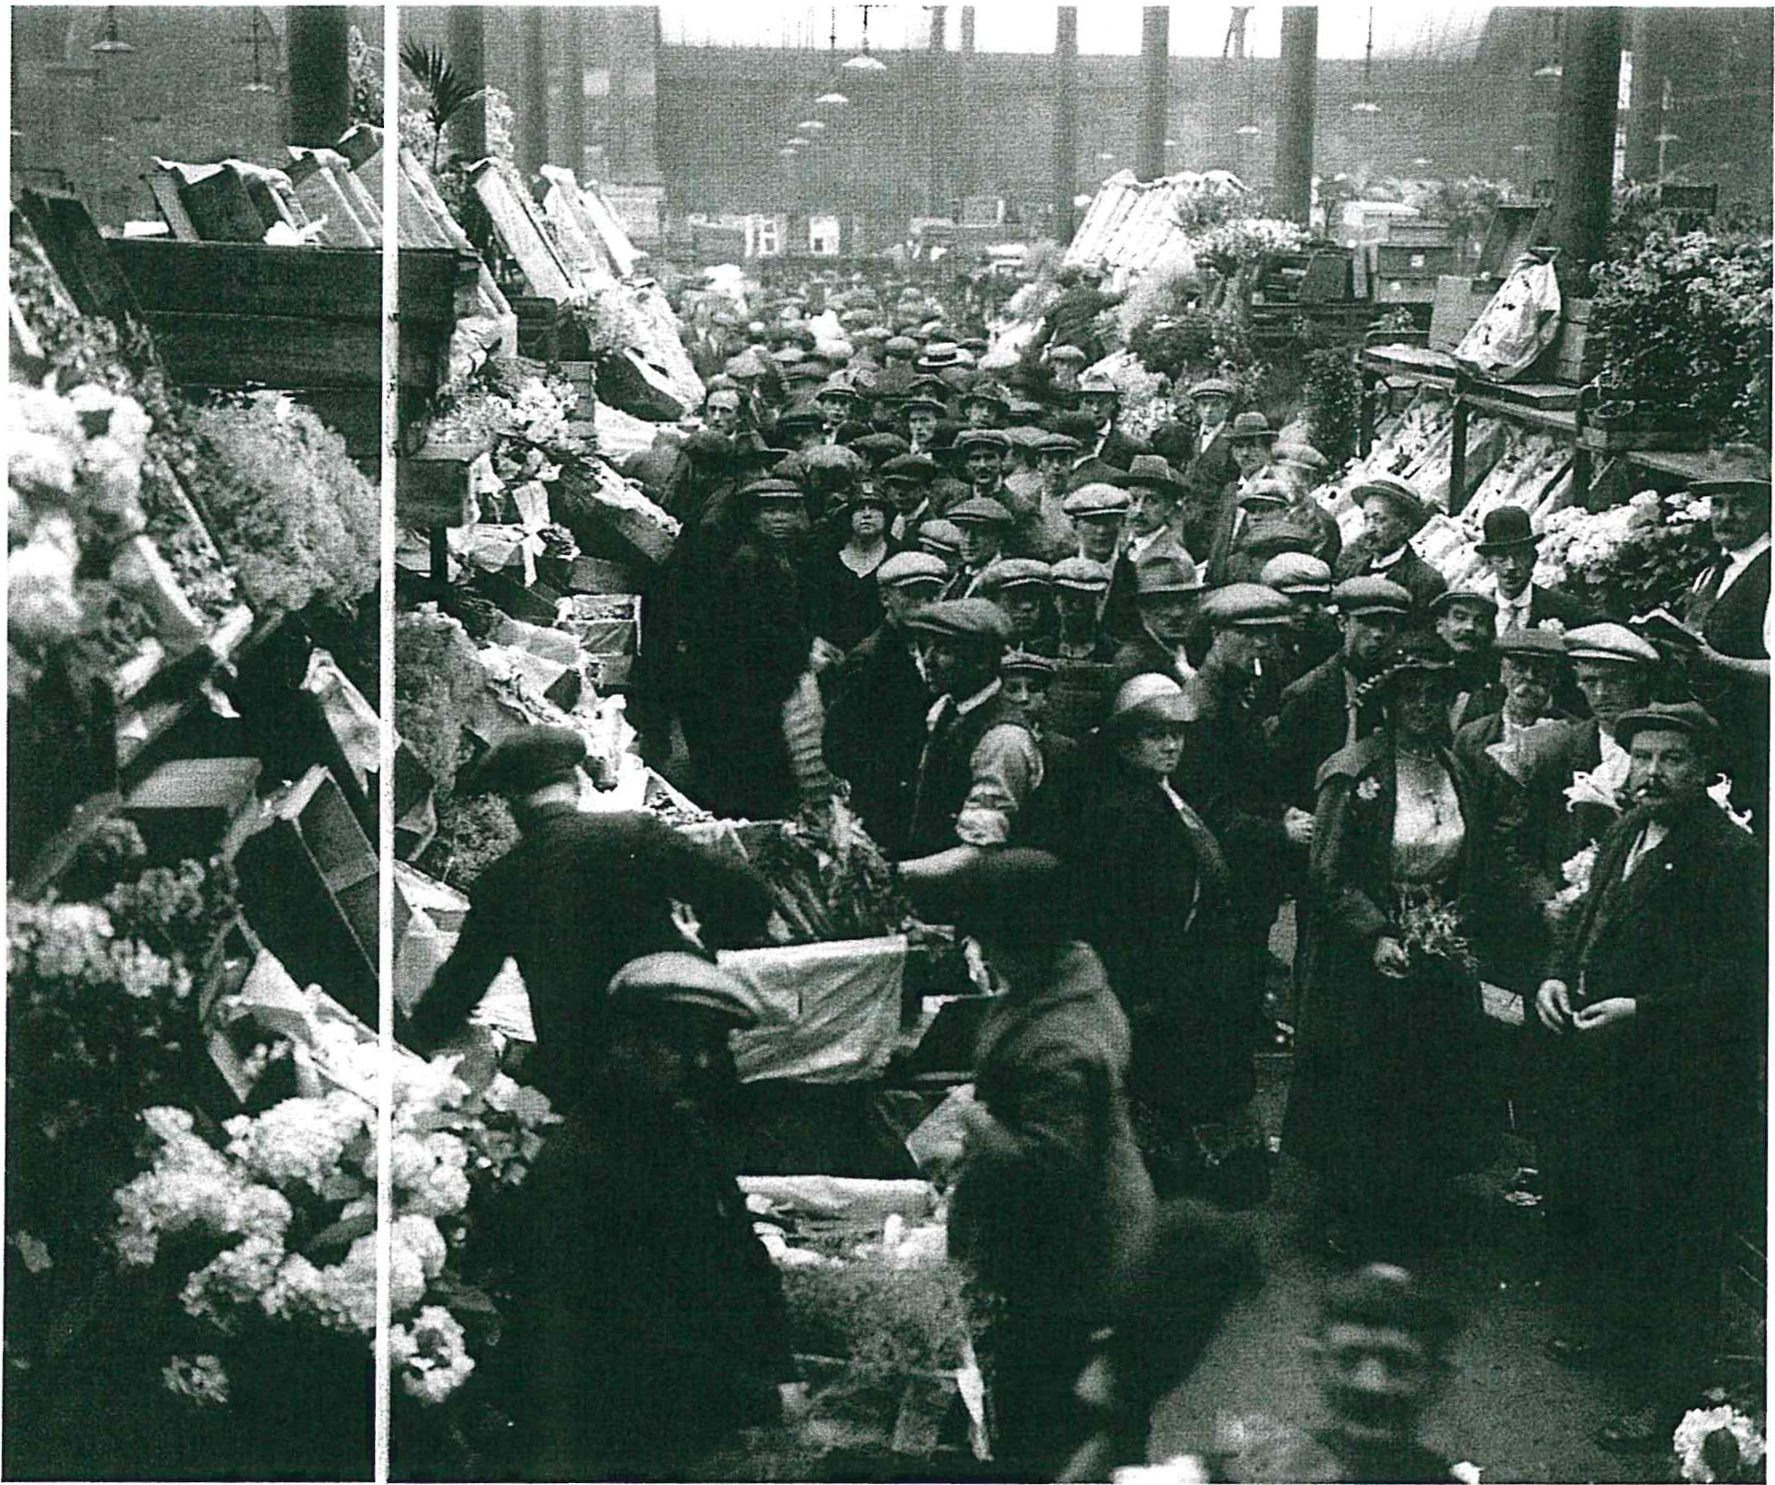and iron wheels on srone pavement. The smell must have been over­ whelming too, especially in fetid slums reeking of human and animal waste, as suggested in such street names as Fowle Lane and Stinking Alley. The stench of the slums on a rainy morning, wrote one 19th-century urban traveller, "is enough to knock down a bullock."
With the explosive growth of Victorian London came a commen­ surate growth in the commercial activity of Covent Garden, the fruit­ basket of the Empire. It was said that you could find pineapples in Co­ vent Garden any day of the year, more readily than you could find them in the countries in which they grew. Flower girls like Liza Doolittle would . come to Covent Garden in the early morning, have breakfast and a gossip at a tea-cart, and buy cheap fresh-cut flowers after the florist shops had picked chem over. Shaw makes it clear that Liza's London revolves around Covent Garden. He cells us chat she was born in the slums of Lisson Grove, about a kilometer northwest of here, and lives in a single shabby room off Drury Lane a few blocks to the east. We learn that she spends her days selling flowers at Tottenham Court Road a few blocks to the north, and her evenings back in Covent Garden waiting for a last burst of customers to emerge from the .theatre.
"It's real, the life of the street," Higgins hisses at Eliza in their final scene together, and he compares her to the discarded vegetables that would have been constantly underfoot in Covent Garden. Unlike Hig- · gins' world of inherited wealth and privilege, the street-vendor's life was "real" in the capitalist commercial sense, with investment, profit and loss; and in the Edwardian world that predated the British welfare state, there were real consequences of hunger and cold if you couldn't afford to buy food, clothing and shelter. Still, Eliza was better off than many thousands of others: she had a room, ;he had her youth, and she had ambition and talent that enabled her to seize opportunities that hap­ pened along.
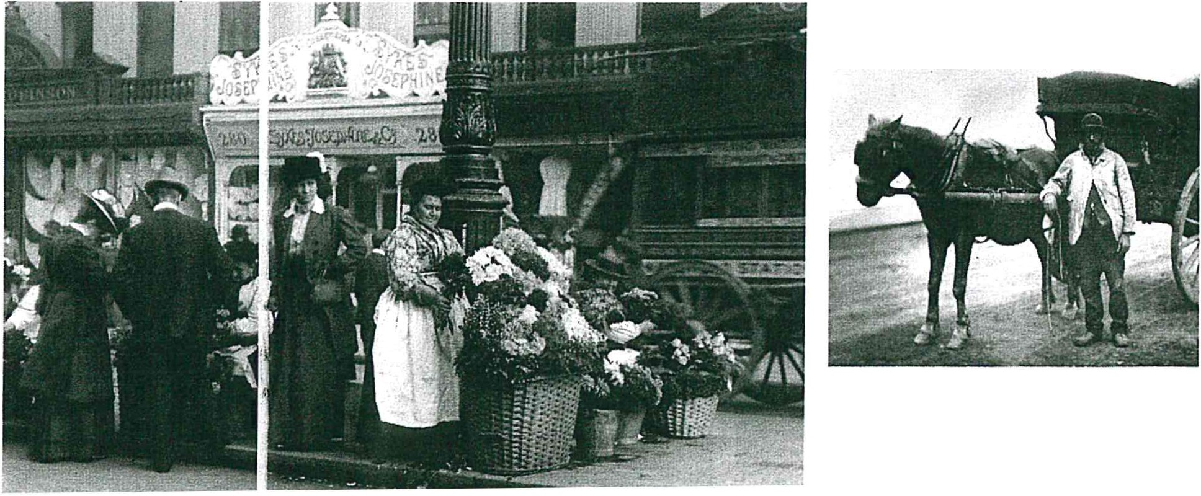In Pygmalion Henry Higgins creates an entirely new person our of

CLOCKWISE FROM TOP: FLOWER SELLERS AT THE LC
STALLS IN COVENT GARDEN MARKET, 1925 (HULTO DUSTMEN (VICTORIA & ALBERT MUSEUM I BRIDGEJY
I IRR ARV\· S:I nw,o C::CI I CD IM DC:r.CJ..IT C'TDC:CT '1n'11
the promising clay of Eliza Doolittle. In his own life the upstart Shaw played both Higgins and Eliza, creator and creation, transforming himself from a superfluous poorly-educated Irish immigrant (there were more Irish in London than there were in Dublin) into a journalist, wit, polit­ ical reformer, and one of history's greatest dramatists. A Londoner him­ self, GBS knew Eliza's London extremely well, and the place-names that trip off his characters' tongues - Selsey, Hoxton, Hanwell, Earl's Court, Lisson Grove - would have held instantly recognizable connotations for his audience. Late-Victorian London was one of the few places in the world where one could make the startling transformation in one's own life that Mr Shaw and Miss Doolittle did. It was a world soon to be trans-­ formed in its turn, shaken to the core by the plague of two European wars and the flames of the Blitz, before building itself anew - again - atop its own ashes.

DENIS JOHNSTON IS AUDIENCE OUTREACH DIRECTOR FOR THE SHAW FESTIVAL, AND HAS COMPILED
AND EDITED OUR HOLJSF PROC:RAMMS:<; S:-nD T S: DAC::T C"I C\/Ct..l VC A DC UC DC:rlr'.O.ITIV .,-,.. .. ,...non,,.........

