Extra Credit for Fall 2016
Overview: This is the time of the year when many students’ minds turn to thoughts of how they might boost their grade. Well, here are a few things you can do, though I’m only offering a total of 30 points for the whole semester. Turn them in as soon after the event as possible.
What to Write: In all cases I’m going to want a 1-page typed (MLA format) report of your experiences. Show me that you both went and thought about what you saw. Relate it to something we’ve read, if possible. Attach a “souvenir” such as a ticket, program, or photo of the event. This can be part of the 1-page report but either keep the photo small or extend the essay half a page or so to compensate.
What you get: Generally I offer up to 10 points per assignment, more if it is a more challenging or time-consuming task. I know this isn’t much, but of course you also get an enhanced educational experience and often free food and/or entertainment, as well.
NOTE: Most of these are once-only opportunities, so note the dates!
- Mon 26 Sept. 6 PM-7:30 PM: First Presidential Debates—televised live on campus! King Library (TeenHQ) or the Starbucks Lounge in the Student Center. (Note: I’ll accept an analysis/report of them even if you don’t see them on campus, but you’ll learn more from the public experience.)
- Check out the list of visiting writers who are sponsored by the Center for Literary Arts http://www.litart.org/. Their talks are in King Library unless otherwise noted. Usually lasts an hour, usually free, usually include refreshments.
- October 19, 7pm Luis Valdez--SJSU alumnus and award-winning playwright, author of Zoot Suit and La Bamba, at this gala fundraiser in the newly refurbished Hammer Theatre (downtown).
- November 15, 7pm –Vendela Vida is the award-winning author of five books. She co-wrote the screenplay for the 2009 film Away We Go.
- December 7, 7pm – Reading and Discussion join the CLA and the Steinbeck Center for readings by this year’s Steinbeck Fellows Xochitl-Julisa Bermejo and Gary Singh.
- 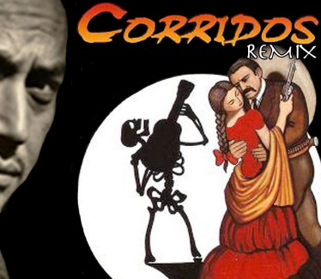 Corridos Remix Directed by Kinan Valdez November 8, 9, 10, 11, 12 @8pm. The Hammer Theatre Center. For other Theater Department performances: http://www.sjsu.edu/trft/trft_production_calendar/
- 6 Oct, 6:30 PM – 8:00 PM SJSU Student Union Theater (downstairs, same plaza as Starbucks) All Campus Reads Just Mercy event: What does Just Mercy mean to those with personal experience with the criminal justice system? Hear perspectives on the transition from incarceration to community from formerly incarcerated people and SJSU Justice Studies professors. Moderated by Raj Jayadev, Director of Silicon Valley DeBug.
- For other Just Mercy events: http://www.sjsu.edu/reading/events_discussions/
Ongoing: Tuesday nights, 8:30-10:00 International House Coffee Nights: Coffee night is a relaxed social gathering for I-House residents and visitors. residents work together to offer a variety of snacks and beverages from around the world and often choose a theme for the evening. A few examples of themes are Pirates, Under the Sea, Black and White, Camping, Moon Festival, and International Night. http://www.sjsu.edu/ihouse/life/activities/coffee-nights/
- Sunday, October 23 9:30 a.m. to 1 p.m.--Internationally-inspired Pancake Breakfast will be held at the International House. http://www.sjsu.edu/ihouse/
- Friday, November 18 from 1-4:30 p.m. International House Quiz/Scavenger Hunt

For other ideas, check the Events Calendar, and if you see something interesting, run it by me before you go—send an email.
https://events.sjsu.edu/EventList.aspx?fromdate=9/26/2016&todate=10/2/2016&display=Week&view=DateTime

