The Opinion Pages | Op-Ed Contributor

Angelina Jolie: Refugee Policy Should Be Based on Facts, Not Fear
By ANGELINA JOLIE FEB. 2, 2017
Photo
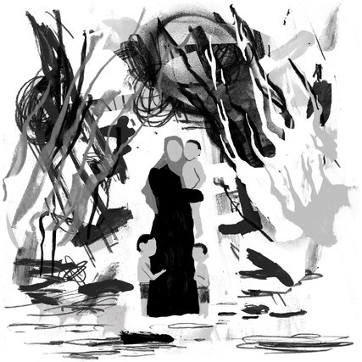
Credit Keith Negley
Refugees are men, women and children caught in the fury of war, or the cross hairs of persecution. Far from being terrorists, they are often the victims of terrorism themselves.
I’m proud of our country’s history of giving shelter to the most vulnerable people. Americans have shed blood to defend the idea that human rights transcend culture, geography, ethnicity and religion. The decision to suspend the resettlement of refugees to the United States and deny entry to citizens of seven Muslim-majority countries has been met with shock by our friends around the world precisely because of this record.
The global refugee crisis and the threat from terrorism make it entirely justifiable that we consider how best to secure our borders. Every government must balance the needs of its citizens with its international responsibilities. But our response must be measured and should be based on facts, not fear.
As the mother of six children, who were all born in foreign lands and are proud American citizens, I very much want our country to be safe for them, and all our nation’s children. But I also want to know that refugee children who qualify for asylum will always have a chance to plead their case to a compassionate America. And that we can manage our security without writing off citizens of entire countries — even babies — as unsafe to visit our country by virtue of geography or religion.
Refugees are in fact subject to the highest level of screening of any category of traveler to the United States. This includes months of interviews, and security checks carried out by the F.B.I., the National Counterterrorism Center, the Department of Homeland Security and the State Department.
Furthermore, only the most vulnerable people are put forward for resettlement in the first place: survivors of torture, and women and children at risk or who might not survive without urgent, specialized medical assistance. I have visited countless camps and cities where hundreds of thousands of refugees are barely surviving and every family has suffered. When the United Nations Refugee Agency identifies those among them who are most in need of protection, we can be sure that they deserve the safety, shelter and fresh start that countries like ours can offer.
Photo
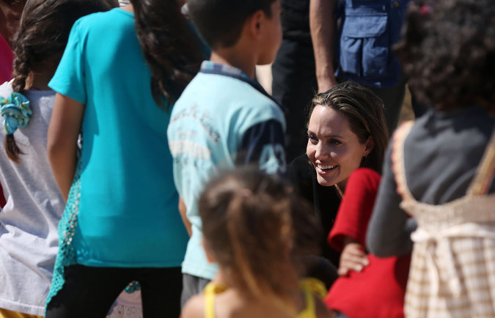
Angelina Jolie at a camp for Syrian refugees in Jordan, in September. Credit Jordan Pix/Getty Images
And in fact only a minuscule fraction — less than 1 percent — of all refugees in the world are ever resettled in the United States or any other country. There are more than 65 million refugees and displaced people worldwide. Nine out of 10 refugees live in poor and middle-income countries, not in rich Western nations. There are 2.8 million Syrian refugees in Turkey alone. Only about 18,000 Syrians have been resettled in America since 2011.
This disparity points to another, more sobering reality. If we send a message that it is acceptable to close the door to refugees, or to discriminate among them on the basis of religion, we are playing with fire. We are lighting a fuse that will burn across continents, inviting the very instability we seek to protect ourselves against.
We are already living through the worst refugee crisis since World War II. There are countries in Africa and the Middle East bursting at the seams with refugees. For generations American diplomats have joined the United Nations in urging those countries to keep their borders open, and to uphold international standards on the treatment of refugees. Many do just that with exemplary generosity.
What will be our response if other countries use national security as an excuse to start turning people away, or deny rights on the basis of religion? What could this mean for the Rohingya from Myanmar, or for Somali refugees, or millions of other displaced people who happen to be Muslim? And what does this do to the absolute prohibition in international law against discrimination on the grounds of faith or religion?
The truth is that even if the numbers of refugees we take in are small, and we do the bare minimum, we do it to uphold the United Nations conventions and standards we fought so hard to build after World War II, for the sake of our own security.
If we Americans say that these obligations are no longer important, we risk a free-for-all in which even more refugees are denied a home, guaranteeing more instability, hatred and violence.
If we create a tier of second-class refugees, implying Muslims are less worthy of protection, we fuel extremism abroad, and at home we undermine the ideal of diversity cherished by Democrats and Republicans alike: “America is committed to the world because so much of the world is inside America,” in the words of Ronald Reagan. If we divide people beyond our borders, we divide ourselves.
The lesson of the years we have spent fighting terrorism since Sept. 11 is that every time we depart from our values we worsen the very problem we are trying to contain. We must never allow our values to become the collateral damage of a search for greater security. Shutting our door to refugees or discriminating among them is not our way, and does not make us safer. Acting out of fear is not our way. Targeting the weakest does not show strength.
We all want to keep our country safe. So we must look to the sources of the terrorist threat — to the conflicts that give space and oxygen to groups like the Islamic State, and the despair and lawlessness on which they feed. We have to make common cause with people of all faiths and backgrounds fighting the same threat and seeking the same security. This is where I would hope any president of our great nation would lead on behalf of all Americans.
Angelina Jolie, a filmmaker, is the special envoy of the United Nations High Commissioner for Refugees. A version of this op-ed appears in print on February 3, 2017, on Page A27 of the New York edition with the headline: A Refugee Policy Based on Facts, Not Fear.

