Desert Flower:

The Extraordinary Journey of a Desert Nomad
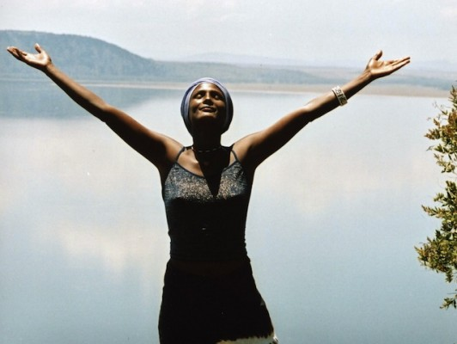
Photo credit: COPYRIGHT Waris Dirie portrait by Karl Holzhauser/ Desert Flower Foundation
Background and Supplemental reading
The basic plot/brief review of the book, from Publisher’s Weekly:
Joining the current rage for model memoirs (see review above) is Dirie, a native of Somalia, who has for more than a decade stalked the world's catwalks and appeared in numerous glossy magazines. This, however, is no fluff-job dictated into a tape recorder on transatlantic flights, then recomposed by a hired gun back in New York. Rather, it is a striking account of a personal odyssey that began in the Somali desert, where Dirie grew up without shoes, living amid nomadic tribes and tyrannized by patriarchal strictures. As a pubescent girl, Dirie was circumcised--a procedure described here in chilling detail--before escaping an arranged marriage to stay with an aunt in Mogadishu. Landing a job as a house servant in London, Dirie struggled to launch a modeling career while dodging British immigration authorities and the dreadful results of marriages of convenience. At the end of this affecting and at times very entertaining book, Dirie's metamorphosis from desert nomad into jetsetting nomad culminates in a post as a human rights ambassador to the UN, where, these days, Dirie campaigns for the eradication of female circumcision and women's rights around the globe. It's easy to forget that Dirie's memoir is a book about someone whose success has come from posing for the camera. Indeed, it is Dirie's remarkable lack of narcissism or entitlement that makes her so captivating a raconteur. Photos. Editor: Billy Kelly; agent: Christie Fletcher/Carol Mann Agency; author tour. (Sept.) FYI: Foreign rights have sold in 10 countries.
Results of the book and film, from the “Our Achievements” page on the Desert Flower Foundation website:
The publication of the book and the results of the research had consequences. The international media discussed the issue as 500,000 women affected by FGM live in Europe without treatment, without education to stop to continue the practice. All of a sudden, FGM was not an African problem alone but it happened right next door in Europe. The European Union took FGM in Europe for the first time in history on their agenda and invited Waris Dirie and the Desert Flower Foundation team to present their study during the council of ministers on February 6th 2006. The European ministers were shocked and promised to take immediate action. Almost all European countries implemented or tightened laws against this crime and initiated campaigns.

The biggest Campaign against FGM worldwide
The most spectacular campaign started with the BBC, Scotland Yard and the Desert Flower Foundation in 2007 in the UK. Scotland Yard discovered more than 20,000 girls in the UK are threatened by FGM every year during summer holidays, more than in any other European country. The BBC produced in cooperation with Scotland Yard and the Desert Flower Foundation, a video to inform British citizens about the practice and the thread. 35,000 DVD´s were distributed in Schools, Universities, hospitals and police stations in the United Kingdom. It was the biggest Campaign against FGM until then in the UK.
The Desert Flower Foundation released a special mail address for FGM victims, girls threatened by FGM and people who wanted to support the campaign. During the first year, 10,000 emails arrived in the office of our foundation. In 2008 the Desert Flower Foundation developed with German agency Heymann Brandt de Gelmini the first large Social Media campaign against FGM supported by video, this was given to many TV stations around the globe. More than 400 million people saw the campaign and the Desert Flower Foundation received the German Social Media award for best campaign in 2010.
http://retteeinekleinewuestenblume.de/en/our-achievements.html
______________________________________________________________________________
Modern laws limiting or banning the practice
Further information: Prevalence of female genital mutilation by country
As of 2013 legislation banning FGM had been passed by 33 countries outside Africa and the Middle East.^{[201]} As a result of immigration the practice spread to Australia, New Zealand, Europe, North America and Scandinavia, all of which outlawed it entirely or restricted it to consenting adults.^{[n 24][215]} Sweden outlawed it in 1982, the first Western country to do so.^{[216]} Several former colonial powers, including Belgium, Britain, France and the Netherlands, followed suit, either with new laws or by making clear that it was covered by existing legislation.^{[217]}
https://en.wikipedia.org/wiki/Female_genital_mutilation#Overview
Continuing Controversy Tolerance versus human rights
Anthropologist Eric Silverman wrote in 2004 that FGM had "emerged as one of the central moral topics of contemporary anthropology." Anthropologists have accused FGM eradicationists of cultural colonialism; in turn, the former have been criticized for their moral relativism and failure to defend the idea of universal human rights.^{[243]} According to the opposition's critics, the biological reductionism of the opposition, and the failure to appreciate the practice's cultural context, undermines the practitioners' agency and serves to "other" them – in particular by calling African parents mutilators.^{[244]} Yet Africans who object to the opposition risk appearing to defend FGM.^{[245]} Feminist theorist Obioma Nnaemeka – herself strongly opposed to FGM ("If one is circumcised, it is one too many") – argues that the impact of renaming it female genital mutilation cannot be underestimated:
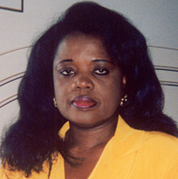
Obioma Nnaemeka: "Westerners are quick to appropriate the power to name ..."^{[246]}
In this name game, although the discussion is about African women, a subtext of barbaric African and Muslim cultures and the West's relevance (even indispensability) in purging the barbarism marks another era where colonialism and missionary zeal determined what "civilization" was, and figured out how and when to force it on people who did not ask for it.^{[247]}
Ugandan law professor Sylvia Tamale argues that early Western opposition to FGM stemmed from a Judeo-Christian judgment that African sexual and family practices – including dry sex, polygyny, bride price and levirate marriage – were primitive and required correction.^{[248]} African feminists "do not condone the negative aspects of the practice", writes Tamale, but "take strong exception to the imperialist, racist and dehumanising infantilization of African women."^{[248]}
https://en.wikipedia.org/wiki/Female_genital_mutilation#Overview
Interviews with Waris Dirie
Waris Dirie comments briefly on the film: Link
Video with BBC Hard talk (24 min) https://www.youtube.com/watch?v=z5RtVv5wQsQ

Ventures Africa: Interview with former Super Model- Waris Dirie
If you have seen the movie, Desert Flower, then you are probably already familiar with Waris Dirie’s remarkable story. A former super model, now an author and activist, Waris Darie was born in Gallacaio desert, Somalia, in 1965. She rose from a subservient state, at age thirteen, when she escaped a forced marriage to a 60-year-old man.
After fleeing, she lived in Mogadishu for a while before moving to London, further away from home. She made a living serving as a housemaid and doing other menial jobs. It was during this time that she was spotted by Terence Donovan, a British fashion photographer. She posed for a few photography shots with Donovan, and rose to become one of the world’s most celebrated super models, working with different high profile designers and labels. Patricia Turnier of Megadiversities.com writes,
Waris Dirie worked for these brands: André Courrèges, Chanel ‘Allure’ fragrance, Express Jeans, H&M, Levi’s, L’Oréal, Oil of Olay, Prescriptives make up, Revlon and so on. She did many fashion shows, such as “Ready to wear – Spring/Summer 1996 (John Galliano, Ralph Lauren”, “Ready to wear – Autumn/Winter 2000 (Xuly Bet)”. She did the cover of the 1987 Pirelli calendar. She also appeared in prominent magazines like Elle, Glamour, Vogue and Marie Claire.
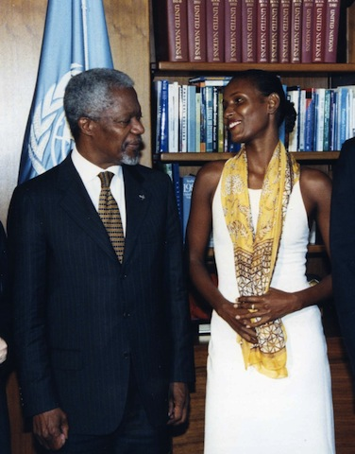
Waris with Kofi Annan, former UN Sec-General
Waris, which means desert flower in Somali, says of her modelling career “it was not my dream come true…it all just happened.” She did not allow the experience fade away as a fortunate stroke of serendipity. Modeling for her became a springboard to talk about her passion- Female Genital mutilation. Waris currently runs different advocacy projects through her foundation- “Desert Flower Foundation.” She has also authored several books, including Desert Flower, an autobiography, which was adapted to a movie. From being a runaway, Waris landed on the runway. The experience was not an easy feat. Nothing came off as easy as it sounds in written form. But her determination has kept her going.
Of course, not everyone who rebels against “tradition” live to tell his or her story. But for Waris, not only is she able to recount her story, she has continue to maximize every opportunity to empower and liberate others as well. In 2005, Waris became the first woman to be nominated for Young Global Leader by the World Economic Forum. She has also received other awards including the “Woman of the Year Award” by Glamour Magazine (2000), the “Africa Award” of the German government (1999), as well as the “Corinne Award” by the umbrella association of the German bookselling trade (2002).
In this interview, Waris Dirie sheds light on her life, career and projects- speaking up for African women and women everywhere. Enjoy!
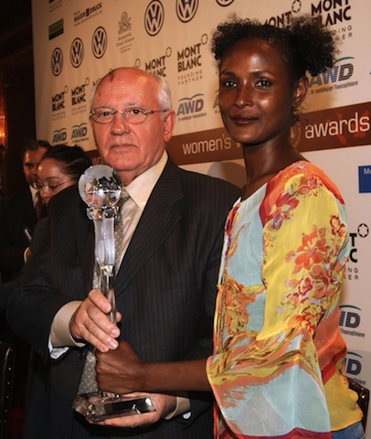Waris at the World Woman Award with former Russian President Mikhail Gorbatschew
Why do you describe yourself as “always a nomad”? Waris: Because despite living in “western world” for so many years, deep down I feel that my heart belongs to desert where I grew up, and that will never ever change.
You have been speaking against FGM and officially launched your organization now called Desert Flower Foundation in 2002. What has been your most fulfilling achievement since its launch? Waris: When I started my Foundation, few people knew about the cruel practice of FGM and its consequences. The main goal for me was to raise the worldwide awareness, so that everyone would know about this cynical child abuse.
I therefore started to raise awareness through media coverage, to lobby against FGM with political leaders and other NGO´s to make people aware of the practice. And the response has been great! Thank to these campaigns, many African and European countries adopted or strengthened law against FGM, which was an important first step and a great achievement!
But my biggest goal, the worldwide eradication of FGM, is still to be achieved!
Why do you think some cultures resist the idea of abolishing FGM? Is it any more political than it is cultural? Waris: I believe that FGM is first and foremost a cultural issue or at least people´s belief that FGM is part of their culture. The problem is that the practice is very deeply rooted in different societies, where it has been practiced for thousands of years. Women are only willing to undergo this terrible procedure because without it, they are considered “dirty” or impure and they will not be accepted by any man as their wife. And because women are absolutely economically dependent on their husbands or fathers, they have no other choice than to undergo the cut.
What other root factors do you think is responsible propelling the practice? What should people be addressing when advocating against such a harmful practice? Waris: As I said, it is people´s belief that FGM is part of their culture, tradition or religion. But let me say this loud and clear: FGM has nothing to do with religion, culture or tradition. It is nothing but the most cruel form of suppressing women and the most cynical form of child abuse. But of course people justify the practice by saying that it is part of their culture or that their religion demands that they mutilate their daughters. But this is not true. No religion in the world demands FGM; in fact, FGM is the breach of the most basic rules of many, if not all religions.
First, the communities need to be educated about FGM; about its health consequences and about the often untrue and misleading beliefs they have. My mother thought that she did the best for me, because in the society she grew up all women are genitally mutilated. She thought the whole world is practicing FGM, so she did not know better. That is the reason why we cannot simply tell these people that it is wrong, or prohibited by law, but we have to explain why!
And second, women of Africa need to become independent from their fathers or husbands, they should be able to work and have their income to be able to make their own decisions about their lives and their bodies. And that is what I currently work on in my new project.
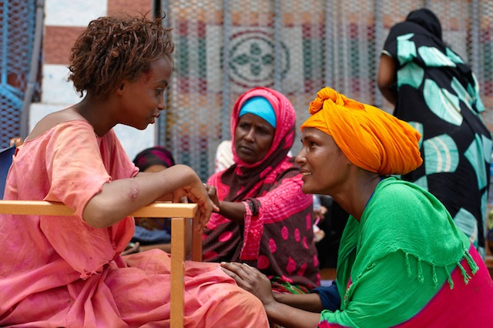
Waris at the Filmset in Djibouti with Soraja and her mother
Tell us more about the project “Together for African Women.” What are you trying to achieve through this project? Waris: The main purpose of this Project is to empower the women of Africa in communities where FGM is practiced, to provide them with work, their own income and vocational training. I am convinced that a confident, independent woman who has her own income will not choose to mutilate her daughters just so that they can be married for money.
If you were not running Desert Flower Foundation, what else would you love to pour your energy into? Waris: My dream has always been to have my own farm in the middle of African nature which would employ and help African girls and women.
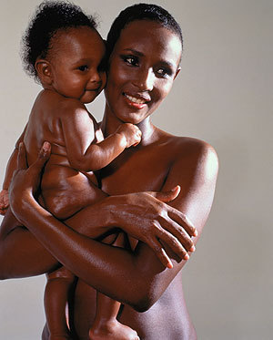
How do you combine being a mother with your other social roles? Do you ever feel overwhelmed? Waris: It is not easy, but I do my best to find a balance. When I´m at home, I want to spend quality time with my children and I don’t want to be disturbed. Sometimes, it´s not possible of course and when I travel because of work, I take my little boy with me. Being mother is a mission. It is the most beautiful and at the same time the most difficult thing to do.
You definitely made an incredible mark as a model, if you were going to walk the runway for the last time, whom would you like to work with (designer) and why? Waris: It would unquestionably be one of the African designers. Africa has so much potential and can produce incredibly beautiful fabrics and fashion. It is such a shame that its potential is not used to the fullest. I sincerely hope that this will change one day
You recently described modelling industry as a very tough industry. At what point in your career did you realize it was and how did you manage to stay on top? Waris: From the time I started, I knew that modelling is very tough industry, especially for nomad girl, who was not used to conventions of western world. But to be honest, I never tried too hard to stay on the top; because it was not my dream come true…it all just happened.
Do you consider the modelling career more fleeting than other careers? If yes, why and if no, why not? Waris: Yes definitely, modelling was always something momentary for me; I was just waiting for the right moment to speak out about FGM. Having gained fame and attention as a model, I knew that my statement on this issue would be heard.
Talking about exit strategy, from your experience when do you think is the safest time to exit full time modelling? Waris: I don’t think there is any “safe” time to leave the modelling world. For me personally, after all efforts I had undertaken and all catwalks I walked down, it was not so important for me anymore to keep my career going. I knew a lot of important people in the fashion world and I was able to choose job offers at that time. And then suddenly I was very excited about becoming a mother and that was the best decision I ever made in my whole life.
As an outsider looking in, what disparities do you see between older models and the next generation of top African models? Waris: I don’t see too much of a difference between the generations of models. I think they are still the beautiful and sometimes shy African girls who want their dream of becoming a super model to come true.
Some people may describe your life and your career as an epitome of serendipity. Do you see it that way? Waris: I do believe that everything happens for reason… that I was meant to survive everything I did so that one day I could speak out about this torture and fight for little girls out there who are not able to fight on their own!
What inspired you to write the book “Desert Flower?” Did you think it was going to receive the level of accolade it did? Waris: I wanted to reach people through my story; I wanted them to know about the pain and suffering that thousands of girls and women have to go through every day. I did not believe in such an amazing response it received, but I was sincerely happy and thankful for it!
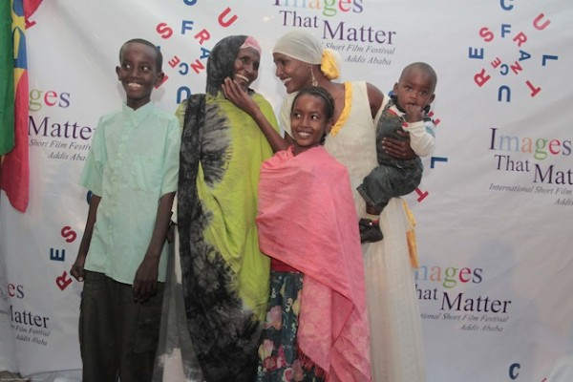
Waris with her family on the Premiere of the movie “Desert Flower” in Addis Ababa
How did you feel during the adaptation of the book into a movie? Has its premiere and reviews met your expectations? Waris: It was a very emotional but fulfilling experience. It was difficult for me to see my own childhood, my own family and my life on a huge movie screen. But I agreed to making this movie because I knew that it would reach much more people than the book did, and that is exactly what happened. I was deluged with e-mails from so many people throughout the world telling me that they saw the movie and [were grateful that I made] them aware of FGM. Many of these people wanted to do something about the crime and help in any way. Making the movie was absolutely right and all the difficulties and hard work were certainly well worth it after it was said and done.
If you could change anything about your life, what will it be? Waris: Of course it would be the day when I was mutilated as a little girl. It was the worst moment of my life, something I can never forget. No innocent little girl should go through this kind of unnecessary cruel pain.
Who is your favourite model of African descent and why? Waris: I am not able to choose one favourite. All African models are beautiful amazing women, whether from outside or from the inside. I just wish more African girls and women could use their beauty and potential in this world.
What three things would you want the world to always remember you for? Waris: I would like the world to remember me for my fight against FGM and for the women of Africa, and then I would like to be remembered as survivor who never gave up…as I wish the people in this world would never give up on their dreams, their hopes and their life happiness.
To learn more about the Desert Flower Foundation, please visit the official website by clicking here Follow Waris on Twitter: @Waris_Dirie and FaceBook
http://venturesafrica.com/interview-with-former-super-model-waris-dirie/

