Some Key Poets of World War I: From Romanticism to Protest

Overview: Below are brief biographies and a few representative poems from some of the most influential poets of the WWI era who wrote about the war (among other things). All of the material found here is from a really great site called The Poetry Foundation, which every English major (and cultured person in general) should be familiar with. I didn’t want to clutter the page with quotation marks, but everything here is from the site, word-for-word, except this paragraph and the last bit at the end about the play Not for Heroes. This site offers a wealth of further information about all of these poets and others of their day, including Vera Brittain.

Rupert Brooke 1887–1915
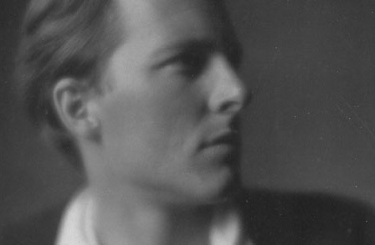
Few writers have provoked as much excessive praise and scornful condemnation as English poet Rupert Brooke. Handsome, charming, and talented, Brooke was a national hero even before his death in 1915 at the age of twenty-seven. His poetry, with its unabashed patriotism and graceful lyricism, was revered in a country that was yet to feel the devastating effects of two world wars. Brooke's early death only solidified his image as "a golden-haired, blue-eyed English Adonis," as Doris L. Eder notes in the Dictionary of Literary Biography, and among those who lauded him after his death were writers Virginia Woolf and Henry James and British statesman Winston Churchill. In the decades after World War I, however, critics reacted against the Brooke legend by calling his verse foolishly naive and sentimental. Despite such extreme opinions, most contemporary observers agree that Brooke—though only a minor poet—occupies a secure place in English literature as a representative of the mood and character of England before World War I.
Brooke's early years were typical of virtually every English boy who was a member of a well-to-do family. He attended a prestigious boarding school—Rugby, where his father was a headmaster—studied Latin and Greek, and began to write poetry. It was taken for granted that Brooke would go on to one of the great English universities, and accordingly he entered Cambridge in 1906. [. . . .] [After graduation, he spent some time in Tahiti, writing mostly nature poems.] Despite the apparent happiness that Brooke found in Tahiti, he decided to return to England in the spring of 1914. Within a few months of his return, World War I began. Like most men of his age and class, Brooke immediately volunteered for service in the war. He joined the Royal Navy Volunteer Reserve [. . . .]
A more realistic poetry grew out of the war's latter stages and supplanted Brooke's verse as the most important literary expression of the war. Poets such as Wilfred Owen, Siegfried Sassoon, and Robert Graves captured the terror and tragedy of modern warfare; next to their poetry, Brooke's war sonnets seem "sentimental and unrealistic," notes Lehmann. For several decades after his death Brooke's poetry—though always popular—was dismissed by critics responding both to the consequences of two world wars and to the pessimistic poetry that dominated the age, of which T. S. Eliot's The Waste Land is the prime example. But more recent critics, while admitting that Brooke's poetry lacks depth, maintain that his verse does have significance. In Rupert Brooke: The Man and the Poet, Robert Brainard Pearsall does not deny the "slightness in mass and idea" of Brooke's work but avers that "all technical criticism droops before the fact that his verse was lyrical, charming, and companionable." Other critics, including Eder and Edward A. McCourt, argue that Brooke's poetry—especially the "Nineteen Fourteen" sequence—is important as a barometer of England between 1910 and 1915. As Eder states, "Brooke's war sonnets perfectly captured the mood of the moment."

Peace By Rupert Brooke
Now, God be thanked who has matched us with his hour,
And caught our youth, and wakened us from sleeping!
With hand made sure, clear eye, and sharpened power,
To turn, as swimmers into cleanness leaping,
Glad from a world grown old and cold and weary;
Leave the sick hearts that honor could not move,
And half-men, and their dirty songs and dreary,
And all the little emptiness of love!
Oh! we, who have known shame, we have found release there,
Where there’s no ill, no grief, but sleep has mending,
Naught broken save this body, lost but breath;
Nothing to shake the laughing heart’s long peace there,
But only agony, and that has ending;
And the worst friend and enemy is but Death.

The Soldier By Rupert Brooke
If I should die, think only this of me:
That there’s some corner of a foreign field
That is for ever England. There shall be
In that rich earth a richer dust concealed;
A dust whom England bore, shaped, made aware,
Gave, once, her flowers to love, her ways to roam;
A body of England’s, breathing English air,
Washed by the rivers, blest by suns of home.

And think, this heart, all evil shed away,
A pulse in the eternal mind, no less
Gives somewhere back the thoughts by England given;
Her sights and sounds; dreams happy as her day;
And laughter, learnt of friends; and gentleness,
In hearts at peace, under an English heaven.

Poetry Out Loud Note: This poem has had two titles: “The Soldier” and “Nineteen-Fourteen: The Soldier”. The student may give either title during the recitation.
Source for both Brooke poems: Poetry (April 1915).

Wilfred Owen 1893–1918
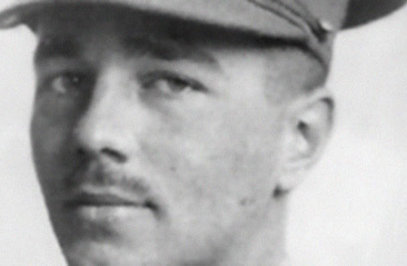
Wilfred Owen, who wrote some of the best British poetry on World War I, composed nearly all of his poems in slightly over a year, from August 1917 to September 1918. In November 1918 he was killed in action at the age of twenty-five, one week before the Armistice. Only five poems were published in his lifetime—three in the Nation and two that appeared anonymously in the Hydra, a journal he edited in 1917 when he was a patient at Craiglockhart War Hospital in Edinburgh. Shortly after his death, seven more of his poems appeared in the 1919 volume of Edith Sitwell's annual anthology, Wheels, a volume dedicated to his memory, and in 1919 and 1920 seven other poems appeared in periodicals. Almost all of Owen’s poems, therefore, appeared posthumously: Poems (1920), edited by Siegfried Sassoon with the assistance of Edith Sitwell, contains twenty-three poems; The Poems of Wilfred Owen (1931), edited by Edmund Blunden, adds nineteen poems to this number; and The Collected Poems of Wilfred Owen (1963), edited by C. Day Lewis, contains eighty poems, adding some juvenilia, minor poems, and fragments but omitting a few of the poems from Blunden’s edition.

Dulce et Decorum Est By Wilfred Owen
Bent double, like old beggars under sacks,
Knock-kneed, coughing like hags, we cursed through sludge,
Till on the haunting flares we turned our backs,
And towards our distant rest began to trudge.
Men marched asleep. Many had lost their boots,
But limped on, blood-shod. All went lame; all blind;
Drunk with fatigue; deaf even to the hoots
Of gas-shells dropping softly behind.

Gas! GAS! Quick, boys!—An ecstasy of fumbling
Fitting the clumsy helmets just in time,
But someone still was yelling out and stumbling
And flound’ring like a man in fire or lime.—
Dim through the misty panes and thick green light,
As under a green sea, I saw him drowning.

In all my dreams before my helpless sight,
He plunges at me, guttering, choking, drowning.

If in some smothering dreams, you too could pace
Behind the wagon that we flung him in,
And watch the white eyes writhing in his face,
His hanging face, like a devil’s sick of sin;
If you could hear, at every jolt, the blood
Come gargling from the froth-corrupted lungs,
Obscene as cancer, bitter as the cud
Of vile, incurable sores on innocent tongues,—
My friend, you would not tell with such high zest
To children ardent for some desperate glory,
The old Lie: Dulce et decorum est
Pro patria mori.

NOTES: Latin phrase is from the Roman poet Horace: “It is sweet and fitting to die for one’s country.” Source: Poems (Viking Press, 1921)

Anthem for Doomed Youth By Wilfred Owen
What passing-bells for these who die as cattle?
— Only the monstrous anger of the guns.
Only the stuttering rifles' rapid rattle
Can patter out their hasty orisons.
No mockeries now for them; no prayers nor bells;
Nor any voice of mourning save the choirs,—
The shrill, demented choirs of wailing shells;
And bugles calling for them from sad shires.

What candles may be held to speed them all?
Not in the hands of boys, but in their eyes
Shall shine the holy glimmers of goodbyes.
The pallor of girls' brows shall be their pall;
Their flowers the tenderness of patient minds,
And each slow dusk a drawing-down of blinds.

Siegfried Sassoon 1886–1967
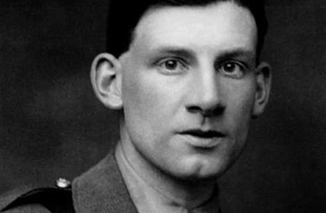
Siegfried Sassoon is best remembered for his angry and compassionate poems of the First World War, which brought him public and critical acclaim. Avoiding the sentimentality and jingoism of many war poets, Sassoon wrote of the horror and brutality of trench warfare and contemptuously satirized generals, politicians, and churchmen for their incompetence and blind support of the war. His later poems, often concerned with religious themes, were less appreciated, but the autobiographical trilogy The Complete Memoirs of George Sherston won him two major awards.
[. . . .]
Following the outbreak of the First World War, Sassoon served with the Royal Welch Fusiliers, seeing action in France in late 1915. He received a Military Cross for bringing back a wounded soldier during heavy fire. After being wounded in action, Sassoon wrote an open letter of protest to the war department, refusing to fight any more. "I believe that this War is being deliberately prolonged by those who have the power to end it," he wrote in the letter. At the urging of Bertrand Russell, the letter was read in the House of Commons. Sassoon expected to be court-martialed for his protest, but poet Robert Graves intervened on his behalf, arguing that Sassoon was suffering from shell-shock and needed medical treatment. In 1917, Sassoon was hospitalized. [. . . .]
Speaking of Sassoon's war poetry in a 1981 issue of the Spectator, P. J. Kavanagh claimed that "today they ring as true as they ever did; it is difficult to see how they could be better." Looking back over Sassoon's long literary career, Peter Levi wrote in Poetry Review: "One can experience in his poetry the slow, restless ripening of a very great talent; its magnitude has not yet been recognised.... He is one of the few poets of his generation we are really unable to do without."
http://www.poetryfoundation.org/bio/siegfried-sassoon

Repression of War Experience By Siegfried Sassoon
Now light the candles; one; two; there's a moth;
What silly beggars they are to blunder in
And scorch their wings with glory, liquid flame—
No, no, not that,—it's bad to think of war,
When thoughts you've gagged all day come back to scare you;
And it's been proved that soldiers don't go mad
Unless they lose control of ugly thoughts
That drive them out to jabber among the trees.

Now light your pipe; look, what a steady hand.
Draw a deep breath; stop thinking; count fifteen,
And you're as right as rain ...
Why won't it rain? ...
I wish there'd be a thunder-storm to-night,
With bucketsful of water to sluice the dark,
And make the roses hang their dripping heads.

Books; what a jolly company they are,
Standing so quiet and patient on their shelves,
Dressed in dim brown, and black, and white, and green,
And every kind of colour. Which will you read?
Come on; O do read something; they're so wise.
I tell you all the wisdom of the world
Is waiting for you on those shelves; and yet
You sit and gnaw your nails, and let your pipe out,
And listen to the silence: on the ceiling
There's one big, dizzy moth that bumps and flutters;
And in the breathless air outside the house
The garden waits for something that delays.
There must be crowds of ghosts among the trees,—
Not people killed in battle,—they're in France,—
But horrible shapes in shrouds--old men who died
Slow, natural deaths,—old men with ugly souls,
Who wore their bodies out with nasty sins.

* * *
You're quiet and peaceful, summering safe at home;
You'd never think there was a bloody war on! ...
O yes, you would ... why, you can hear the guns.
Hark! Thud, thud, thud,—quite soft ... they never cease—
Those whispering guns—O Christ, I want to go out
And screech at them to stop—I'm going crazy;
I'm going stark, staring mad because of the guns.
Source: Counter-attack, and Other Poems (1918)
http://www.poetryfoundation.org/poem/248318

Vera Mary Brittain 1893–1970
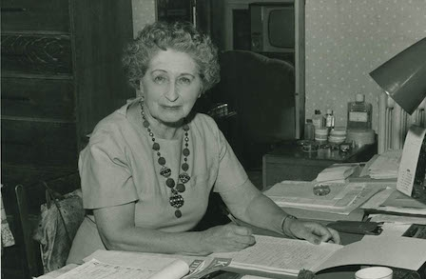
Vera Brittain’s reputation centers on her achievements as an influential British feminist and pacifist and on her famous memoir of World War I, Testament of Youth: An Autobiographical Study of the Years 1900-1925. That work has never been out of print since first published in 1933, and its influence has been strengthened by a 1979 BBC television adaptation and new paperback editions. During her lifetime Brittain was also known internationally as a successful journalist, poet, public speaker, biographer, autobiographer, and novelist. Interest in her writings, personality, and relationships (notably her close friendship with Winifred Holtby) has grown steadily, especially among feminist critics, and the publication in 1995 of a noteworthy biography by her friend and literary executor Paul Berry with Mark Bostridge has now provided scholarship with an authoritative account of her life and achievements.
http://www.poetryfoundation.org/bio/vera-mary-brittain

August, 1914 By Vera Mary Brittain
God said, “Men have forgotten Me:
The souls that sleep shall wake again,
And blinded eyes must learn to see.”

So since redemption comes through pain
He smote the earth with chastening rod,
And brought destruction's lurid reign;

But where His desolation trod
The people in their agony
Despairing cried, “There is no God.”

Roundel By Vera Mary Brittain (“Died of Wounds”)
Because you died, I shall not rest again,
But wander ever through the lone world wide,
Seeking the shadow of a dream grown vain
Because you died.

I shall spend brief and idle hours beside
The many lesser loves that still remain,
But find in none my triumph and my pride;

And Disillusion's slow corroding stain
Will creep upon each quest but newly tried,
For every striving now shall nothing gain
Because you died.

Epitaph On My Days in Hospital By Vera Mary Brittain
I found in you a holy place apart,
Sublime endurance, God in man revealed,
Where mending broken bodies slowly healed
My broken heart
Source of all 3 Brittain poems: Verses of a VAD (1918)
http://www.poetryfoundation.org/bio/vera-mary-brittain#about
_____________________________________________________________________________
Note: There is an interesting play about the relationship between Siegfried Sassoon and Wilfred Owen called Not About Heroes. You can listen to a radio performance of it on You Tube: https://www.youtube.com/watch?v=d90_rH4kETc

