Will Weaver: Author of “A Gravestone Made of Wheat”

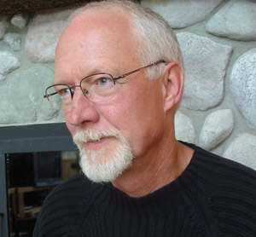
Biography By Will Weaver
Again, thanks for your interest in my work. I grew up on a small dairy farm in Minnesota, and had no idea I'd become a writer one day. However, I enjoyed history and English classes in high school, and had some great teachers who encouraged me. Outdoor life (hunting, fishing) plus team sports (basketball, baseball) were also a big part of my life, so when started college at Minnesota State University in Saint Cloud, I really had no clue as to my life’s direction.
After two years I transferred to University in Minneapolis as an "undeclared major," but eventually decided upon English. I graduated with my B.A. in English, and headed to California where I eventually landed in the Stanford Writing Program. It was there that I focused on studying and writing short stories, which a great place to start for any fiction writer.
My wife, Rosalie (from St. Paul), and I returned to the Midwest, where I took over my father's farm for a couple of years. I had this romantic idea that I could be a gentleman farmer/writer, but I had forgotten how much work farming was. I transitioned to college teaching at nearby Bemidji State University, where I taught writing and literature for twenty-four years. I loved every day (well, almost every day) of teaching, but gradually my writing won out. Today I'm a full time writer, which allows me more time to travel, visit schools and libraries, and share what I've learned about writing–and teaching writing. Be sure to check out my "Write Right" blog if you're an aspiring fiction writer or just like literary talk.
My career is proof that you don’t have to grow up in a family of writers to become one. We each find our own path, and I wish you good luck with yours.

Press Kit Will Weaver writes fiction for adults and young adults. He was born in northern Minnesota in 1950 and grew up on a dairy farm. His novels and short stories have earned the praises of reviewers from coast-to-coast for their unflinching realism. The New York Times Book Review called A Gravestone Made of Wheat, "a graceful collection, one that views America's heartland with a candid but charitable eye."
Red Earth, White Earth, Mr. Weaver's debut novel, was published in 1986 by Simon & Schuster and was produced as a CBS television movie in 1989. A Gravestone Made of Wheat & Other Stories (Simon & Schuster, 1989) won many awards, including the Minnesota Book Award for Fiction. Several of the stories were performed on National Public Radio. The title story was produced as the independent feature film Sweet Land starring Ned Beatty. In October, 2006, Sweet Land earned rave reviews in its national theater release. "A triumph...a movie of extraordinary tenderness" (Entertainment Weekly, 10/18/06). In February, 2007, Sweet Land won the independent film industry's Spirit Award for Best First Feature, and is now out on DVD.
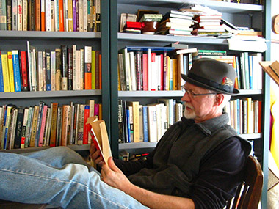
Will Weaver has written several successful novels for young adults. Striking Out, Farm Team, and Hard Ball (HarperCollins, 1993/95/98) were honored as Best Books for Young Adults by the American Library Association. Memory Boy (2001) is used widely in schools across the United States. Following Claws (2001), and one of Weaver's person favorites, his novel Full Service (Farrar, Straus & Giroux, 2005) won starred reviews and was also listed as an ALA Best Book for Young Adults.
Defect, winner of the 2008 Minnesota Book Award, is the story of a young man with a miraculous birth abnormality. His Motornovel Series focused on dirt track stock car racing includes Saturday Night Dirt (2008), Super Stock Rookie (2009), and Checkered Flag Cheater (2010).
The Survivors, his long-awaited sequel to Memory Boy was published in January, 2012. Teachers who follow Will Weaver’s work know of his many, compelling short stories for young adults, including “WWJD.” Found in various anthologies, they will soon be available in E-reading editions available to schools.
A recent judge for the National Book Awards, Weaver is currently finishing a new young adult novel set in the far future, and is a popular visiting author in schools across the country. http://www.willweaverbooks.com/pages/biography.htm

