Vân-Ánh Võ’s ‘Odyssey’ recalls plight of Vietnam’s boat people

By Aidin Vaziri Updated 1:49 pm, Monday, January 18, 2016
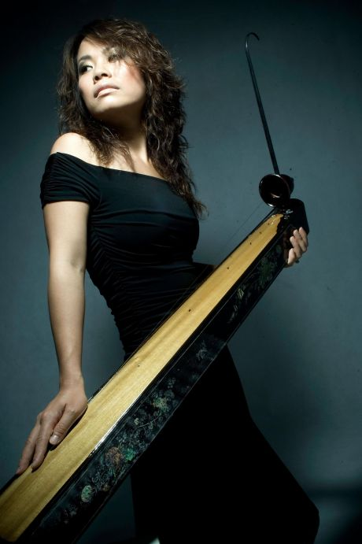
Photo: YBCA
Composer Vân-Ánh Võ (Vanessa Vo) premieres a new musical, "The Odyssey – from Vietnam to America" exploring the journeys of the boat people escaping war.
Vân-Ánh Võ, the Emmy Award-winning composer who performs under the name Vanessa Vo, was at rehearsals last week in a warehouse in Richmond, trying to remember the cues for her epic new stage production, “The Odyssey From Vietnam to America.” It wasn’t easy. As the lead composer, musician and focal point of the show, it felt like she had to be everywhere at once and, well, sometimes that just didn’t work out.
“It’s funny because yesterday I ran to a spot I wasn’t supposed to be and my instrument wasn’t there,” said Vo, whose main instrument is the dàn tranh, a traditional Vietnamese 16-string zither, but who also plays the dàn bau monochord, the dàn tam thap luc 36-string hammered dulcimer and several other pieces.
Four years in the making, “Odyssey,” which premieres at the Yerba Buena Center of the Arts on Friday and Saturday, Jan. 22-23, brings to stage the struggle of Vietnam’s boat people, the refugees who fled the country on small boats at the end of the war, making hazardous crossings across the ocean in the hopes of finding sanctuary on foreign shores.
“I want to portray the human spirit — the resilience we can have to pass the most difficult time in life,” she said.
Vo came up with the concept a decade earlier, when she first moved to the United States in 2001 from her native Hanoi, in the north, and started meeting the men, women and children from the south who were forced out of the country as a result of the conflict.
“I learned what the people from the other side had to go through,” said Vo. “I also shared my own story about growing up after the war. They thought the north was much better, but it’s not true. We have to go through the same thing. War destroyed everything. We were poor. My family didn’t have much to eat.”
Vo, who now lives in Fremont, started work on “Odyssey” shortly after her 2012 collaboration with the Kronos Quartet on a piece called “All Clear.”
Marking the 40th anniversary of the end of the Vietnam War, she composed the score for traditional 18th century Vietnamese instruments and her contemporary chamber ensemble, featuring cellist and conductor Alex Kelly, ethnomusicologist Philip Blackburn and video artist Ian Winters.
Vo, who won an Emmy for the soundtrack of 2008 documentary “Bolinao 52” and provided the score for the Sundance Film Festival best documentary and 2003 Academy Award nominee of “Daughter of Danang,” is known for pushing boundaries with her work, and this one is no exception.
“I interviewed more than 60 people,” Vo said. “I listened to their stories. My concentration is on the texture and sounds that the boat people remember — what they hear that instantly puts them back to the time they were on the trip. What sound would tell them they have hope and what can help them to stay alive? All the textures the boat people remember like the boat engine, seagulls and the lullabies that they would hum from when they were a small child.”
During the 40-minute set, Vo and her collaborators attempt to musically and visually invoke these journeys.
“Music, especially instrumental music — you can actually open up a bigger imagination to the audience in that it will have a sense of courage, resilience, hope, even despair,” Vo said.
Kelly admits he has “heard a lot of music, but I’ve never heard these sounds before.”
“That’s what made me excited about it. There’s a full range of expression. Even though these are events from some time ago, it feels very current and applicable to what’s happening now, with the refugees and tragedies,” he continued, referring to the Syrian and Afghan refugees making headlines. “There’s the sadness that Vietnamese instruments express so well.”
Following its premiere at the Yerba Buena Center for the Arts, Vo is scheduled to perform “Odyssey” at the Kennedy Center in Washington, D.C., where she last appeared after the 2013 release of “Three-Mountain Pass,” a collection of her compositions and arrangements, and National Sawdust, the new music venue in Williamsburg, Brooklyn.
Vo is also scheduled to headline this year’s edition of Oakland Symphony’s “Notes From Vietnam” at the Paramount Theatre on Feb. 12.
Aidin Vaziri is The San Francisco Chronicle’s pop music critic. E-mail: avaziri@sfchronicle.com Twitter: @MusicSF
Vân-Ánh Vanessa Võ and the Va’v — The Odyssey From Vietnam to America: 8 p.m. Friday-Saturday, Jan. 22-23. $15-$30. Yerba Buena Center for the Arts, 701 Mission St., S.F. www.ybca.org.
http://www.sfgate.com/music/article/V-n-nh-V-s-Odyssey-recalls-plight-of-6767138.php

