N. Arbouz
Professor Sparks
English 1B
5 March 2014
Burt’s Buzz
Face masks are now sold out in Beijing; the choking pollution that blocks the sun in almost every major city in China has created a massive market shortage for face masks in those cities. People have been advised to stay indoors. The rapid pace of urbanization and the exploitation of lenient environmental-protection laws by domestic and international corporations in China serves as an example of what many environmentally-conscious companies, domestic and international, are striving to avoid. The “green-revolution” is on the front-burner as consumers in the global market become increasingly aware of what they buy can severely impact the environment. One company that strives to make the planet a better place by implementing a business model with “a triple bottom line: people, profit, planet” is Burt’s Bees. This company offers consumers unique all-natural skin-care and beauty products that have been proven to be effective and popular. Through their website, Burt’s Bees captivates its audience with intriguing information about its environmentally-conscious vows, transparency about its products. Overall, it is a simple yet highly effective, beautifully illustrated site for the conscientious consumer looking for earth-friendly products.
Undoubtedly, Burt’s Bees’ main audience for its website, in terms of gender, are females because of the website’s selection of products used primarily by women, such as lipcolor. Furthermore, the site is full of emotionally-engaging visuals of women, children, and flowers, The only male pictured is Burt, the founder, and that’s mostly in the logo. The first visual that appears on the homepage is a large photograph of a photogenic, make-up free woman with a caption placed beside flowers that states “Find Your Skin’s Perfect Match.” By placing images of women all over the website, the company attempts to make the female consumers feel welcomed and specifically catered to. These gender-specific marketing strategies can be viewed as a strength because of potential increased revenue from women or a weakness because of the lack of attention given to potential male consumers in a highly stigmatized market for men. Nonetheless, these strategies illustrate Burt’s Bees’ deep understanding of the skin-care market and its consumers: even male skin-care products are often bought by women.
Furthermore, Burt’s Bees also appeals to skin-care consumers who are aware of the environmental impacts of conducting business on a very large scale through their “Sustainability” link found at the top of their well-organized home page. Once you click on the “Sustainability” link, an image with a bee box appears with a slogan that reads “Sustainability- doing the right thing is the right thing to do.”
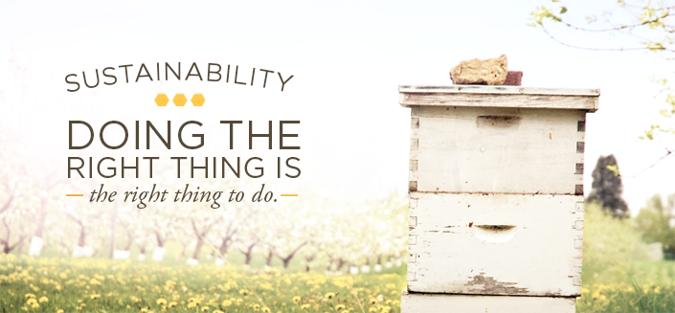

The nature-friendly images in the “Sustainability” section, as well as throughout the website, create an atmosphere of environmental-friendliness. Below the image are links titled “Operational Footprint,” “Packaging,” “Communities and Partnerships,” “Sourcing,” and “Sustainability Reports.”
To examine the foundations of its commitments to the environment and to see how it provides evidence to back up its claims (logos), let’s take a closer look at the first of these. On Burt’s Bees “Operational Footprint” page, the company claims to replicate the actions of their most revered species: the bee. As stated on the page, Burt’s Bees wants to leave the environment the same, if not better, than it was when they arrived to create its all-natural products. Part of this is Burt’s Bees policy to not send any waste to landfills. Underneath a picture of a sunny, forested valley placed at the top of the “Operation Footprint” section, the company states, “We can proudly say that, with over 350 employees in three facilities, not a single piece of garbage goes to the dump. Not one. Really. How? Each month, our employees diligently volunteer to check over 400 recycling and composting bins, ensuring everything is sorted properly. Any leftover waste that cannot be composted or recycled is transformed into biomass-based fuel or electricity.” This is just one of the many examples of how the site provides data and explains its procedures to portray their ethical and environmentally-conscious business methods. Consumers know that very few companies can claim that they do not send any waste to a landfill, and Burt’s Bees is keen on relaying this information.
Another way Burt’s Bees caters to environmentally-conscious customers on its website is by offering 99% to 100% natural skin-care and beauty products for sale, as well as fluent, concise explanations about their reasons for innovating products of such a high standard of quality. Directly to the left of the “Sustainability” link on top of the home page, sits a link titled “Our Nature”; this link portals consumers to where they can easily find product-information about the chemistry, ingredients, and standards involved in Burt’s Bees products. The second sub-link underneath “Our Nature” is titled “Kitchen Chemistry,” which is described by Burt’s Bees as a “complex science applied to simple, wholesome ingredients, promoting skin health in ways even we couldn't dream of just a few decades ago. The products we make today have come a long way from those first tins of lip balm—but even as our processes become more sophisticated, we are as committed as ever to our homegrown roots, to the backyard beeswax that made us who we are.” With this statement, Burt’s Bees allows its customers to feel knowledgeable about Burt’s Bees products no matter how much money the company has made or how large the company has grown. Today, a consumer often expects a company’s rapid growth to lead to an inevitable decrease in the quality of the products they supplied. Burt’s Bees, with clever diction, such as “Kitchen Chemistry,” provides assurance that the company will always stick to its use of nature’s ingredients.
The website’s logos appeal also contributes to its pathos appeal, using facts to inspire feelings of trust and safety. This is evident on links to the site’s comprehensive “Nature Ingredients Guide,” with an ingredient glossary for those who are even more interested in the ingredients’ definitions. Here the site allows consumers to feel safe and healthy when using the company’s products because of the unprecedented transparency in the information pertaining to the ingredients utilized. What customers might find even more reassuring about using Burt’s Bees’ creations is that Burt’s Bees claims it would not use any ingredient in its products that the employees would not want on their own skin. This claim is intended to induce the audience with a feeling of relatability with the reliable and honest values that Burt’s Bees holds.
Overall, BurtsBees.com, through interesting yet brief explanations of its products and processes and a simple yet aesthetically pleasing website layout, masterfully projects to its audience the company’s groundbreaking approach to succeeding as an environmentally-friendly, healthful, and all-around ethical business. When consumers purchase from Burt’s Bees, they can feel that are investing not only in Burt’s Bees but also investing into the future of the planet. Not only do they protect the planet and their consumers with their sustainable and eco-friendly business practices, but they also donate 105 of every purchase to the Burt’s Bees Greater Good Foundation, as they announce on the homepage. Clicking on this link leads to some evidence that this is a substantial part of the company’s operations, not just “green-washing”: “Since its inception, the foundation [in 2007] has issued $1.2 million in grants. In 2014 alone, the foundation donated $293,000 in proceeds to nonprofit organizations.” Below this are brief descriptions with links to more information about seven different charities they support, including the famous Habitat for Humanity and the less well-known Inter-faith Food Shuttle, based in Burt’s Bees’ own community in North Carolina.
I don’t want to sound like a zealot, but this site has convinced me that the “bad-guy” corporations, instead of aiming for “dollars-only” profits, need to learn from Burt Bees’ “triple bottom line: people, profit, planet.” Burt’s Bees says that you cannot have one kind of profit without the other two.
Word count (1313)
Note: This was already a very good paper, but I revised it a bit to whittle it down and include a visual, which wasn’t in the assignment when this student was writing. I also added a paragraph about the company’s “good guy” credibility and made each paragraph’s point a little clearer.

