The Opinion Pages | Op-Ed Contributor

A New Level of Refugee Suffering

Angelina Jolie on the Syrians and Iraqis Who Can’t Go Home
By ANGELINA JOLIE JAN. 27, 2015
Photo
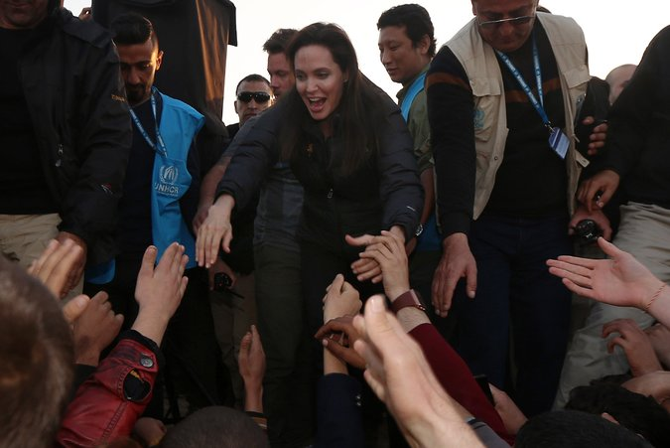
Angelina Jolie at a refugee camp in Iraq's Dohuk province on Jan. 25. Credit Safin Hamed/Agence France-Presse — Getty Images
KHANKE, Iraq — I HAVE visited Iraq five times since 2007, and I have seen nothing like the suffering I’m witnessing now.
I came to visit the camps and informal settlements where displaced Iraqis and Syrian refugees are desperately seeking shelter from the fighting that has convulsed their region.
In almost four years of war, nearly half of Syria’s population of 23 million people has been uprooted. Within Iraq itself, more than two million people have fled conflict and the terror unleashed by extremist groups. These refugees and displaced people have witnessed unspeakable brutality. Their children are out of school, they are struggling to survive, and they are surrounded on all sides by violence.
For many years I have visited camps, and every time, I sit in a tent and hear stories. I try my best to give support. To say something that will show solidarity and give some kind of thoughtful guidance. On this trip I was speechless.
What do you say to a mother with tears streaming down her face who says her daughter is in the hands of the Islamic State, or ISIS, and that she wishes she were there, too? Even if she had to be raped and tortured, she says, it would be better than not being with her daughter.
Photo
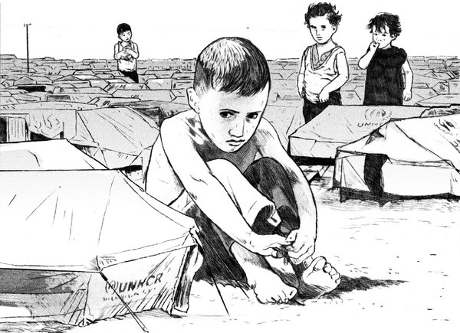
Credit Ruth Gwily
What do you say to the 13-year-old girl who describes the warehouses where she and the others lived and would be pulled out, three at a time, to be raped by the men? When her brother found out, he killed himself.
How can you speak when a woman your own age looks you in the eye and tells you that her whole family was killed in front of her, and that she now lives alone in a tent and has minimal food rations?
In the next tent, I met a family of eight children. No parents. Father killed. Mother missing, most likely taken. The 19-year-old boy is the sole breadwinner. When I comment that it is a lot of responsibility for his age, he just smiles and puts his arm around his young sister. He tells me he is grateful he has the opportunity to work and help them. He means it. He and his family are the hope for the future. They are resilient against impossible odds.
Nothing prepares you for the reality of so much individual human misery: for the stories of suffering and death, and the gaze of hungry, traumatized children.
Who can blame them for thinking that we have given up on them? Only a fraction of the humanitarian aid they need is being provided. There has been no progress on ending the war in Syria since the Geneva process collapsed 12 months ago. Syria is in flames, and areas of Iraq are gripped by fighting. The doors of many nations are bolted against them. There is nowhere they can turn.
Syria’s neighbors have taken in nearly four million Syrian refugees, but they are reaching their limits. Syrian refugees now make up 10 percent of Jordan’s population. In Lebanon, every fourth person is now a Syrian. They need food, shelter, education, health care and work. This means fewer resources available for local people. Far wealthier countries might crack under these pressures.
Stories of terror, barrel bombs and massacres have acquired an awful familiarity. There is a great temptation to turn inward, to focus on our own troubles.
But the plain fact is we cannot insulate ourselves against this crisis. The spread of extremism, the surge in foreign fighters, the threat of new terrorism — only an end to the war in Syria will begin to turn the tide on these problems. Without that, we are just tinkering at the edges.
At stake are not only the lives of millions of people and the future of the Middle East, but also the credibility of the international system. What does it say about our commitment to human rights and accountability that we seem to tolerate crimes against humanity happening in Syria and Iraq on a daily basis?
When the United Nations refugee agency was created after World War II, it was intended to help people return to their homes after conflict. It wasn’t created to feed, year after year, people who may never go home, whose children will be born stateless, and whose countries may never see peace. But that is the situation today, with 51 million refugees, asylum-seekers or displaced people worldwide, more than at any time in the organization’s history.
Much more assistance must be found to help Syria’s neighbors bear the unsustainable burden of millions of refugees. The United Nations’ humanitarian appeals are significantly underfunded. Countries outside the region should offer sanctuary to the most vulnerable refugees in need of resettlement — for example, those who have experienced rape or torture. And above all, the international community as a whole has to find a path to a peace settlement. It is not enough to defend our values at home, in our newspapers and in our institutions. We also have to defend them in the refugee camps of the Middle East, and the ruined ghost towns of Syria.
Angelina Jolie is a filmmaker, special envoy of the United Nations High Commissioner for Refugees and co-founder of the Preventing Sexual Violence Initiative.
A version of this op-ed appears in print on January 28, 2015, on page A23 of the New York edition with the headline: A New Level of Refugee Suffering. Today's Paper|Subscribe
http://www.nytimes.com/2015/01/28/opinion/angelina-jolie-on-the-syrians-and-iraqis-who-cant-go-home.html?_r=2

Ben Carson: The U.S. Must Not Accept Any Syrian Refugees
Dr. Ben Carson Nov. 17, 2015

Americans must stop viewing Islamic extremism through the lens of political correctness
The carnage in Paris last Friday reminded us all of the evil of Islamic extremism. President Barack Obama has promised to “bring these terrorists to justice.” Yet his administration appears altogether oblivious to the threat posed by an influx of refugees from war-torn Syria into the U.S. homeland. Furthermore, in the war against Islamic extremism, the President cannot even bring himself to confront the enemy by its name.
This Monday, I sent letters to Senate Majority Leader Mitch McConnell and Speaker Paul Ryan urging Congress to terminate all public funding for ongoing federal programs that seek to resettle refugees from Syria into the U.S. I also call on the American people to stop viewing Islamic extremism through the lens of political correctness.
We now know that several teams of ISIS terrorist attacked six different locations in Paris, killing at least 132 people and wounding hundreds more. We have also learned that one of the terrorists responsible for this grotesque attack may have left Syria posing as a migrant and was able to gain safe entry to France, Belgium and perhaps other central European countries.
Given the tragedy in Paris last Friday, the U.S. simply cannot, should not and must not accept any Syrian refugees. Unfortunately, the Obama administration has pledged that the U.S. would accept an additional 45,000 new refugees, mostly from Syria, from 2016 to 2017. This must not happen. Instead of half talk and feel-good promises, the U.S. must defend itself with sound security measures.
Paris offers a bloody reminder that we must not be afraid to confront those who harbor the jihadist views that have spread violence and hatred around the world.
Although President Obama and presidential candidates from the Democratic Party prefer to describe radical Islam as just a form of extremism, the rest of us should remember that jihadists who have spilled blood on our soil before and must never be allowed to do so again.
If we thought Islamic extremism is a phenomenon reserved for foreign lands, terrorists have made sure to expose our naiveté. From London to Paris, Sydney to Madrid, Fort Hood to Chattanooga, radical Islamists and their lone wolf followers have inflicted their savagery across the civilized world. Paris now offers the latest gruesome reminder of radical Islam’s barbarism.
Given this troubling reality, and given the bloodbaths that have been perpetrated in the name of Islam in the modern era, I announced a few months ago that I personally would not support having a Muslim president in the White House if he or she had not renounced Islamic extremism, Sharia law or the tenets and practices of Islam that are in conflict with the Constitution.
Certainly, not every Muslim subscribes to jihadist ideology. Throughout my career, I have worked with superb Muslim Americans. Many more have served America honorably by joining the U.S. military, fighting for America overseas, working with federal and local law enforcement to combat radicalization in their own communities and publicly denouncing the violent or misogynist teachings of radical Islamists.
For their decency and courage, we should be grateful. Unfortunately, their own communities have often viciously vilified them as heretics and infidels.
The reality is that the threat of radical Islam and the corrosive influence of Sharia law here in the U.S. is not just a figment of our imagination. The U.S. must defend itself by preventing the infiltration of terrorists who pose as refugees to enter our land. To do anything less is foolish.
Dr. Ben Carson is a Republican candidate for president.
http://time.com/4116014/paris-attacks-ben-carson/

