Inside The World's Most Ambitious Eco-City By Dan Baum May 21, 2013
Why would a petro-state erect a solar-powered eco-metropolis in the middle of the Arabian desert? To change the world.
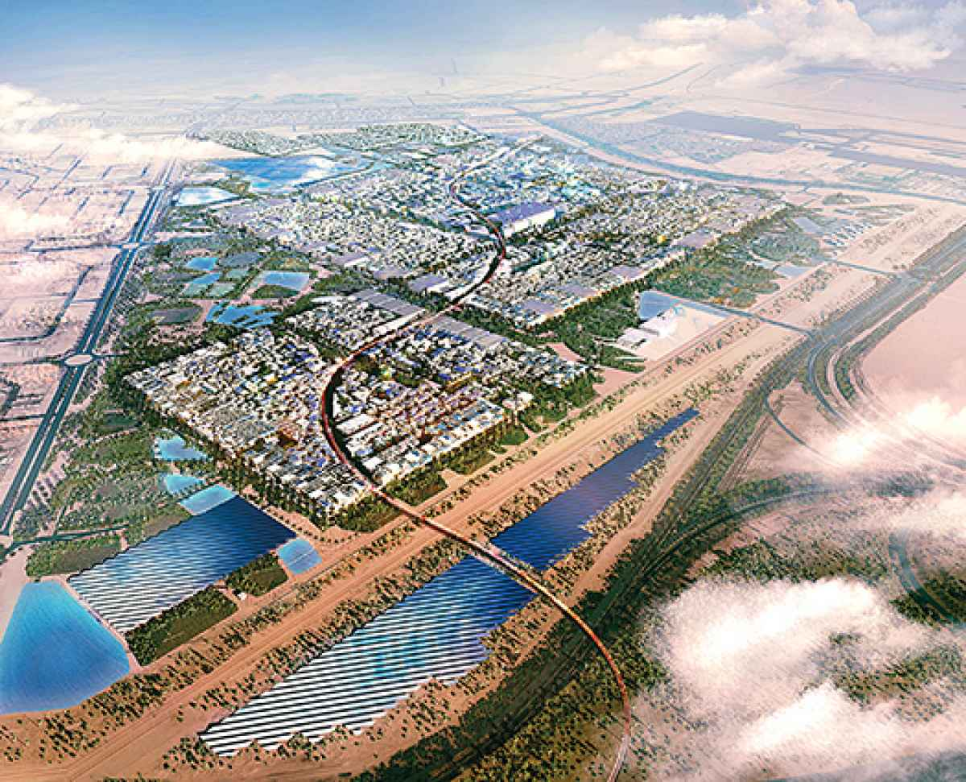
Courtesy Foster + Partners Taming The Desert
When completed in 2025, Masdar City will pack 40,000 inhabitants into two square miles of carbon-neutral buildings.
At first glance, Masdar City appears a mirage. From a distance it looks like a single multicolored building, standing lonely on the horizon. Part of the illusion is due to the city's strange setting: next to Abu Dhabi airport, just across the highway from the Arabian Gulf, in a deeply inhospitable stretch of desert. Between it and downtown Abu Dhabi lie 20 miles of the most wasteful urban development I've ever seen—a featureless plain studded with ostentatious walled houses the size of the Supreme Court and crisscrossed by empty six-lane boulevards. But the illusion is also a matter of density. Masdar City, an $18-billion experiment, will hold 40,000 residents in only two square miles.
As the world's most ambitious eco-city, Masdar does not allow cars. Visitors must instead leave their vehicles in a giant garage at the city's northern edge. As I pulled in, a trim Westerner wearing a dark suit despite the heat stepped from the shade to introduce himself. Stephen Severance, a 45-year-old American, is the city's program manager. He came to Masdar four years ago, after working at the consulting firm Booz Allen.
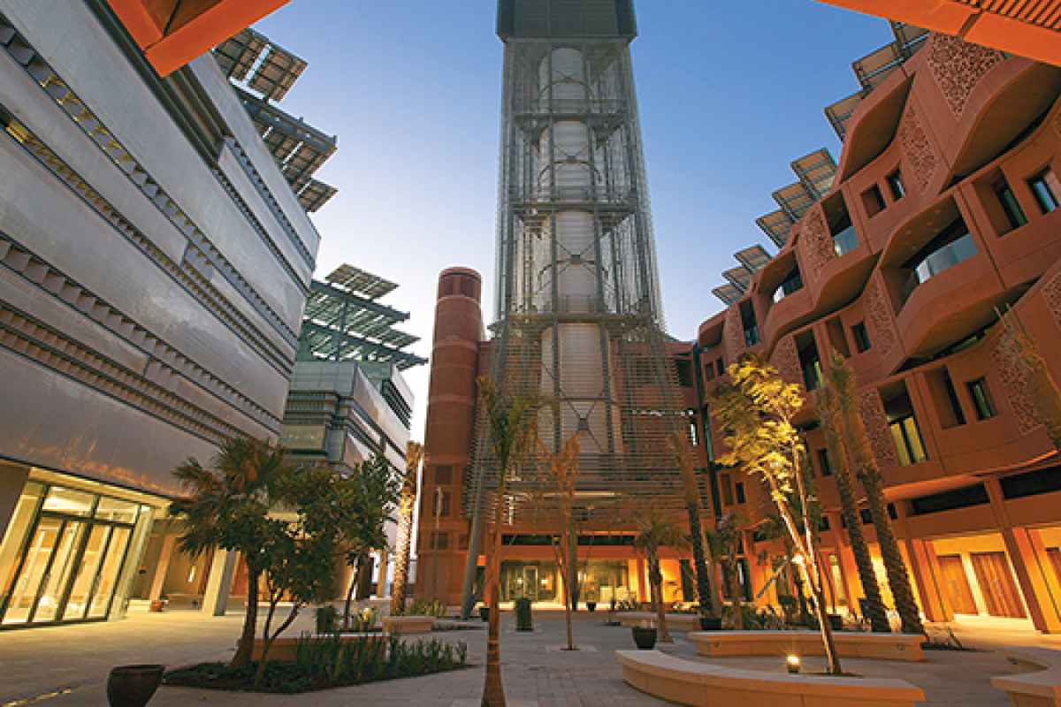
Courtesy Foster + Partners; Nigel Young Wind Catcher
The 148-foot-tall tower beside the Masdar Institute directs cool wind from above the city into a courtyard to create a perpetual breeze.
Severance led me past ranks of parked cars to a set of smoky glass doors, which opened with a whoosh upon a marble lobby. Beyond a second glass wall, Masdar's Personal Rapid Transit pods, or PRTs, sat waiting. The little white driverless cars function as an ecological upgrade for passengers who have ditched their outmoded internal-combustion machines. Severance and I took seats facing each other, the automatic door slid closed, and the little pod began scooting through what looked like a gigantic basement at 15 miles an hour. It ran almost silently on rubber tires, following magnets buried in the floor and using proximity sensors to avoid collision.
Under the original plans, the PRTs were supposed to provide transportation across all of Masdar City, Severance explained. But to make space for them beneath the buildings, engineers would have needed to construct the entire city on 20-foot-tall pedestals. They built the existing center of Masdar City in this way—about a third of a square mile—but elevating the whole metropolis was unaffordable. The rest of Masdar will be built at ground level, and its transportation infrastructure remains undetermined: electric buses, perhaps, or solar-powered carts.
Severance gestured at the pod. "This is a little, I don't know, Jetsons," he said. "It was a nice idea, and we've proven that it works. We're running right now on solar power. These cars get where they're going and don't run into each other." But the PRT line that Severance and I boarded was the only functioning one, he told me, and the PRTs follow only one route: from the garage to Masdar Institute, about half a mile.
As the pod slid into its parking space, an electronic voice reminded us to take our belongings. We stepped into the lobby of the PRT terminal underneath the institute and followed a sweeping spiral staircase to an open-air courtyard at street level. A half-dozen mid-rise buildings rose in a cluster, separated by a tight maze of connected courtyards. One building, a terra-cotta–colored apartment house, is home to the 119 students of the Masdar Institute—the city's only residents so far. Another, wrapped in a steel facade, houses the institute itself. Severance led me on a tour of the small and strange collection of businesses that make up the commercial district, among them a sushi restaurant, a coffee shop, a mini supermarket, a travel agency, and a cellphone-company office.
This small, artificial pocket of urbanity didn't feel like the seed of a true metropolis, but that's the plan. Over the next 12 years, this little cluster of buildings will grow into two square miles of dense mixed-use real estate. A recycling plant is already under construction. There will be a functioning smart grid and improved power generation and distribution. The city will draw residents on the promise of quiet walkable streets and a sustainable lifestyle. By 2025, Severance told me, Masdar, Arabic for "source," will have transformed itself from university campus and commercial mishmash to a working city of the future. * * *

THE EXPERIMENT BEGINS
In 2006, the government of Abu Dhabi, the largest and most oil rich of the United Arab Emirates, announced that it intended to spend $22 billion to become a leader in renewable energy. Abu Dhabi is the very definition of a petro-state. About the size of South Carolina, it holds the world's sixth-largest oil reserves—20 percent more than Russia. The U.A.E., a nation that contains fewer people than the Los Angeles metropolitan area, has the third-highest ecological footprint per capita in the world.
Unlikely as it seemed, the government of this tiny state on the southern shore of the Persian Gulf proposed to do something no other nation had seriously attempted. It would build a carbon-neutral, zero-waste city from the ground up on an empty piece of desert. The entire city would be an experiment, a clean-technology incubator on a grand scale, powered by renewable energy projects. A graduate-level, sustainable-technology research university in partnership with MIT would serve as the idea factory, and a fleet of driverless electric cars would shuttle the inhabitants from place to place. Over every building, engineers would mount huge photovoltaic roofs. The initial drawings looked like fantasy. The Entire City Would Be An Experiment, A Clean-Tech Incubator On A Grand Scale.
For such a pillar of the oil economy to express such an interest in renewable energy reeks of either penitence—like the munitions tycoon Alfred Nobel sponsoring a peace prize—or outright fraud. But as the years passed, the project became real. High-efficiency apartment houses, offices, and businesses began to rise. The driverless electric cars materialized—and they worked. The fledgling city consumed less electricity than its solar arrays generated, and the Masdar Institute of Science and Technology assembled a faculty of 76 PhDs, 13 of them from MIT. Even at the height of the financial crisis, as renewable energy projects stalled around the world, Masdar City moved forward. In 2009, the International Renewable Energy Agency made the unlikely selection of Abu Dhabi as its world headquarters. Then, in 2011, the Masdar Institute graduated its first class of 70 master's students. But it
wasn't until 2012, when the German technology giant Siemens was putting the finishing touches on its new Middle East headquarters in Masdar City, that the experiment morphed from grand gesture to something much more significant: a new and viable model for renewable energy development on a massive scale.
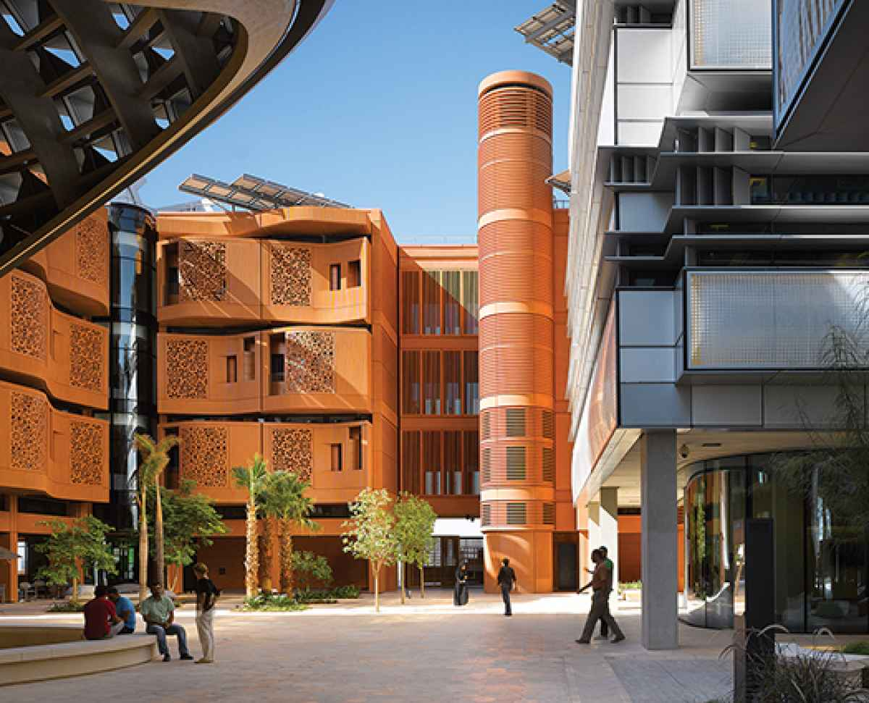
Courtesy Foster + Partners; Roland Halbe Green Campus
Most development in Masdar is centered around the Masdar Institue (steel facade) and its dormitories (clay facade).

But even a city of the future, muscled into existence by oil money and sheer will, was not immune to the troubles of the present. The financial crisis of 2008 forced planners to scale back their ambitions. After the crash, Masdar shaved about $4 billion from its budget, and engineers had to abandon the most futuristic features. The elaborate solar-collecting roofs disappeared from the drawing board; instead, they'll situate photovoltaic arrays at the edge of town. The PRTs devolved from a citywide system to a parking-garage shuttle. Complicating matters, Masdar had originally intended to desalinate its own water using the sun, but the local well water turns out to be three times as salty as the Gulf's. Desalinating it would require significantly more energy than planned and, perhaps worse, would create a gigantic brine-disposal problem. Instead, Severance told me, Masdar will aggressively monitor the use of water. Compared with the bold vision Masdar once was, the adjusted plans can't help but disappoint. * * *

THE NEW ENERGY MODEL
Oil made settled life possible in Abu Dhabi. The Trucial Coast Oil Development Company discovered the first commercial oil field here in 1960. At the time, the settlement was little more than a collection of camels and bedouin tents, a port where men in loincloths waded through the surf to unload dhows by hand. Then, in less than half a century, oil brought the Emirates from abject poverty to the world's sixth-highest GDP per capita. Abu Dhabi is now a roaring metropolis filled with flamboyant skyscrapers—a
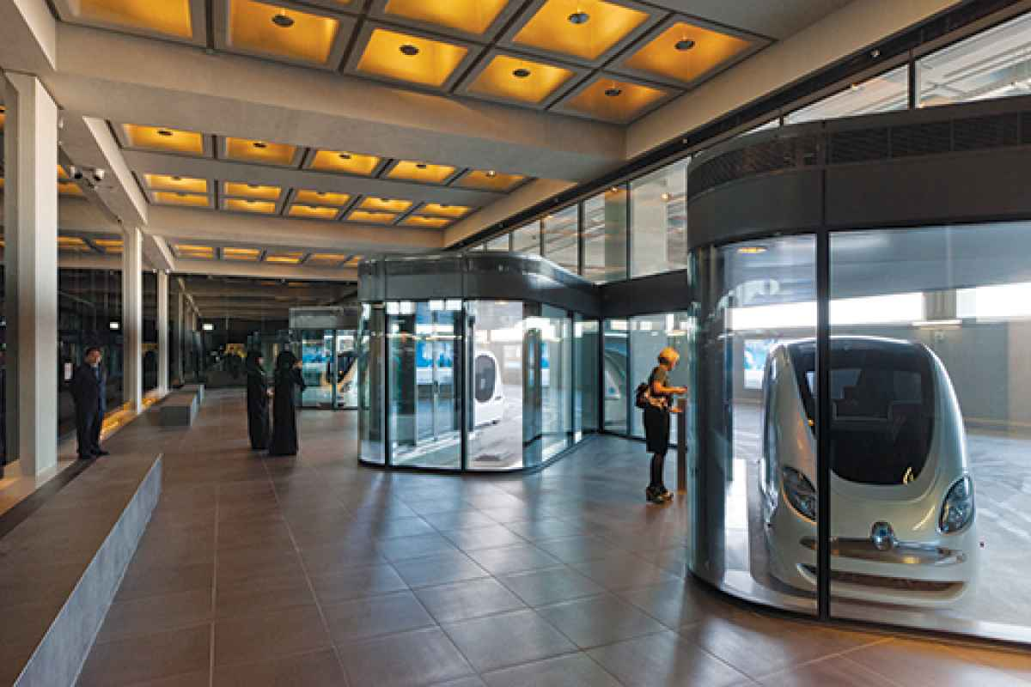
Courtesy Foster + Partners; Nigel Young Oil-Free
Cars are not allowed in Masdar. The Personal Rapid Transport (PRT) pods travel underground from the city's edge to the Masdar Institute.
tower shaped like a giant coin standing on edge, another like a 40-story videogame joystick. Commuters drive Ferraris and Jaguars. Malls stock Piaget and Versace.
Yet Emiratis are planning for a post-oil world. In 2002, the Emirates' crown prince, Sheikh Mohamed bin Zayed al-Nahyan, ordered the creation of Mubadala Development Corp., an investment firm owned by the government and dedicated to diversifying the nation's economy beyond oil and gas. In 2005, Mubadala's 31-year-old energy chief, Sultan al-Jaber, set off on a seven-month tour of renewable energy projects in such places as South Korea, Germany, and Silicon Valley and reached a very futuristic conclusion. Renewable technology, he determined, was far more mature and practical than the investment world at the time seemed to believe. But the various interests necessary to develop it were not coordinated. Scientists were discovering new materials and technology that stalled before reaching market. Companies tried to market clean-energy products at a steep cost disadvantage to fossil fuels, and government regulators hadn't a clue how to support them. "There wasn't a true champion across the world for renewable energy," Jaber told me. "In Oil And Gas, The Question Is 'Why Innovate?' Here
It Is 'Why Not Innovate? Why Do It In The Normal Way If You Don't Have To?' "
Masdar is intended to unify those elements by addressing everything there is to know about renewable energy—from the technology of generation and consumption to the economics of financing projects to the politics of getting them approved. "We're trying to capture the whole thing," said Bader al-Lamki, the 38-year-old director of Masdar Clean Energy, which builds and owns solar projects in Abu Dhabi and elsewhere and has a big stake in a gigantic offshore wind farm near Great Britain. Lamki and I were sitting in a temporary building at the edge of the Masdar City construction site; he adjusted the red-and-white ghotra draped around his head and neck and nodded to a South Asian gentleman in a blue smock serving us tea. "In other places, people are focusing on only one part," he said. "Here, we integrate the whole value chain."
Lamki's division is one of four components of Masdar, the others being the Institute of Science and Technology; Masdar Capital, which bundles investors' money into projects; and the centerpiece city itself. Already, the organization has led renewable energy projects in Spain, Tonga, Mauritania, and elsewhere in the Emirates. One of Lamki's most surprising prospects is in Saudi Arabia, which expects to have to triple its electricity production in the next 20 years. The Saudis already consume within their borders almost a third of the oil they produce, which is in large part due to air conditioning. They're talking with Lamki's group about trying to meet some of their future demand with power from the sun, the one resource the country has in greater abundance than oil. * * *

MAKING SOLAR WORK
If it's to prove anything, Masdar must get solar power right. Abu Dhabi, where the temperature reaches 120°F and every drop of water must be desalinated, now burns so much natural gas to generate power that it has become a net importer. With Masdar, the country is trying to show that it can create huge quantities of electricity without fossil fuels.
Masdar has spawned a handful of solar projects so far, but the largest is a concentrated solar power plant about a hundred miles from the city; on my second day, I drove out to see it. This part of the Arabian Peninsula looks less like the billowing-dune set of Lawrence of Arabia than like a vast plain of kitty litter. Crossing it in a rented marshmallow of a Kia was a 90-minute experiment in sensory deprivation. Airborne dust so obscured the horizon that the beige desert blended seamlessly with a beige sky.
Humans have generated heat by concentrating the sun's rays at least since Archimedes reportedly used mirrors to torch a Roman fleet attacking Syracuse in the third century B.C. Masdar's plant contains 192 parabolic-mirrored troughs, each a little longer than a football field and nearly 20-feet wide. A glass-clad steel pipe full of oil runs above each trough, at the focal point of the parabola. In the five minutes it takes electric pumps to push a gallon of oil up one trough and down another, the gathered rays of the sun heat that oil to a blistering 740°F. After leaving the troughs, the hot pipes pass through a chamber of water. The heat from the oil converts the water to steam, which turns a turbine. The cooled oil then flows back to the mirrored troughs for reheating. Computer-operated hydraulic pistons constantly rotate the mirrors to trace the sun's arc across the sky.
After a safety briefing in a trailer, I donned a hard hat, joined a group of engineers, and was shuttled by truck into the reflector field. One of the troughs was pointed sideways for maintenance, so we walked along it to get a good look. By the time we reached the end, the heat was so intense that it had all but set the backs of our pants on fire.
Concentrated solar technology has been around for decades, but the Masdar plant was, when I visited last December, the biggest such project in the world. (This year, it will be surpassed by one near Phoenix and one in northern Nevada; several more, as much as four times the size of Masdar's, are under construction worldwide.) It is growing fast, with almost two gigawatts—enough to power up to two million homes—expected online worldwide by the end of 2013 and four times that under contract. That's small compared with other renewables, such as photovoltaic power, which generated 20 times as much electricity worldwide at the end of 2010, and wind, which generated 100 times as much that same year. But concentrated solar has advantages that wind and PV lack. Of the three, it alone generates heat, which, in addition to providing power, can be used to do things like desalinate water. And unlike photovoltaic, concentrated solar power plants can also contribute power much more cheaply at night because they store energy as heat instead of in expensive batteries. A Masdar-affiliated company built three concentrated solar power plants in Spain that use molten salt as its medium, improving heat capture and storage even further.Masdar Is A Model For Innovation, A Place Dedicated To The Generation Of Sustainable Ideas.
"Masdar wanted to make this simple and big, the first of its kind in the Middle East," said Laurent Longuet, the plant's project manager. Longuet came from the French oil-and-gas company Total and found the transition to the renewables world a pleasant shock. "Oil guys are very conservative," he said. "In oil and gas, the question is 'Why innovate?' Here, it's 'Why not innovate? Why do it in the normal way if we don't have to?' "
As we spoke, Longuet surprised me by conceding that his plant, though brand-new, is essentially obsolete. One of the concentrated solar power plants that Masdar built in Spain uses clustered mirrors around a central tower instead of parabolic troughs, which generates much higher temperatures. Also, between the time Longuet started building the Masdar plant in July 2010 and the day he switched it on in December, Chinese companies so flooded the market with inexpensive photovoltaic panels that concentrated solar lost a lot of its cost advantage. "If this turns out to be a transitional technology, that's okay," said Abdulaziz al-Obaidli, a wiry young Emirati engineer on Longuet's staff. "We're learning about optics. We're learning about metallurgy, astronomy, fluid dynamics, thermodynamics, manufacturing processes. It's not just about power generation." Obaidli also pointed out that the plant, obsolete or not, works. It can continue generating electricity for decades with, essentially, zero fuel costs. * * *

INSIDE THE ENERGY LABS
The more time I spent at Masdar, the more I realized that every aspect of the city is a research project. Cloaked in a brushed steel facade, the Masdar Institute is a warren of electronics-cluttered benches, humming machinery, and glass dividers covered with algorithms scrawled in grease pencil. Each lab focuses on a different kind of technology. In the Bio-Energy and Environmental Lab, students are developing microbial fuel cells that could generate power while remediating waste. In the Smart Technology for Electric Vehicles and Automotive Systems lab, they are designing integrated networks that could connect drivers and vehicles to road and traffic conditions. There are labs that focus on artificial intelligence, nano-materials, nano-scale energy storage, solar cells, and more.
In the microsystems lab, I met Jerald Yoo, a professor of engineering from South Korea. Sitting at a bench littered with bits of wire and tools, he held up a black T-shirt with a silvery pattern silk-screened on it. "Printed circuits," he said. Someday, he said, circuitry embedded into our clothes will constantly monitor our health, perhaps sending regular updates to our phones. That could have big implications for those with health conditions; for example, Yoo told me, bandages with his circuits could detect seizures 10 seconds before they happen. With that much warning, he said, a current can be applied to suppress the seizure. I asked how his project related to Masdar's goal of an energy-sustainable future. "The circuits have to consume extremely little energy," he said. "Masdar's mission is not only how to produce energy sustainably but also how to consume the least energy to do the work."
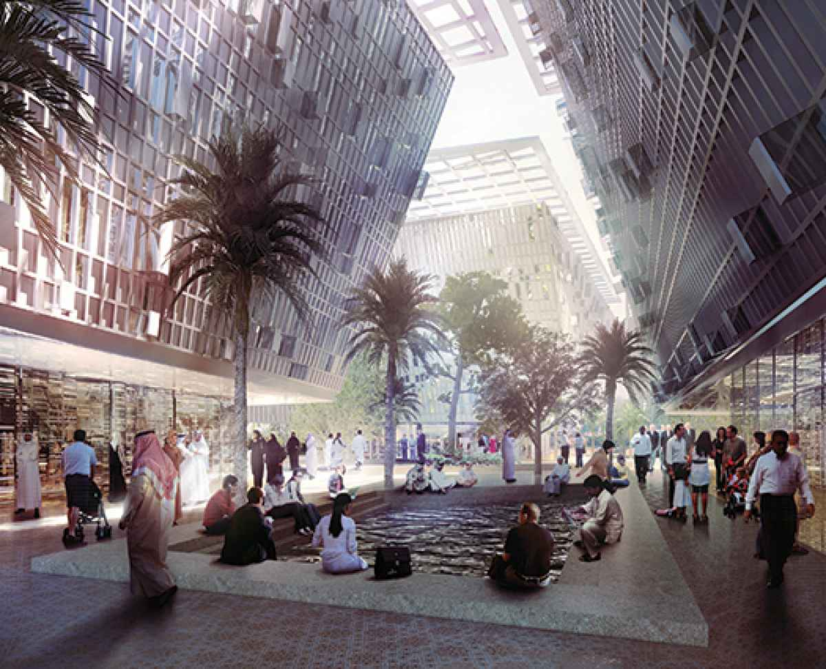
Courtesy Foster + Partners Masdar City
The institute's marquee project is a gigantic tower of mirrors on the edge of town called the Beam Down Solar Thermal Concentrator. The device not only concentrates solar rays to generate heat but will one day also split light into various wavelengths for scientific experiments, thermal energy production, and even more efficient energy generation. Its mastermind is Matteo Chiesa, a young Norwegian professor of nano-science who doused me with a fire hose of technical jargon in the apparent belief that I, too, held a PhD in applied mechanics. I nodded politely as he paced his office in a T-shirt and sandals, pulling on his long, wild hair. He struck me as a little stir-crazy. Chiesa has been in Masdar for five years—he claims to have been the institute's 37th employee—and in that time, he and his colleagues have published more than 60 scientific papers. I asked him whether he liked being here. "Happiness means death," he said. Until other residents beyond the students and faculty at the institute begin to call Masdar home, the place and its inhabitants will remain pretty isolated.
* * *
THE IMPOSSIBLE CITY

One particularly blazing afternoon, I joined Stephen Severance on a stone bench in the center of Masdar City. I wanted an impression of life in the city of the future. What struck me first was the almost shocking

quiet of the place, devoid, as it was, of horns, idling trucks, and sirens. Then, I noticed the temperature. It was much cooler here than in downtown Abu Dhabi. For one thing, we were out of reach of the sun. Severance pointed out that the designers had angled the densely packed buildings to maximally shade one another and the courtyards in between. Pedestrians like us could sit in comfort and the buildings themselves require less air conditioning. Also keeping us cool was a stiff breeze. Severance stood and motioned me across the courtyard to a hollow tower on steel legs—a vertical tube 20 feet across and five stories high. The tower acts as a wind catcher, drawing in cool breezes from above the city and directing them down to the courtyard. The street-level breezes it generates are constant and virtually free. It's not a modern invention—wind towers are likely Persian in origin and were used centuries before oil brought wealth to this part of the world. Engineers at Masdar improved upon the tradition by mounting computer-operated louvers at the top of the structure to maximize efficiency; the panels open and close according to prevailing winds. They also added misting units to cool the air even further.
On my way back to the hotel in Abu Dhabi, I made a wrong turn and ended up at the Al Wathba camel-race track, an eight-kilometer oval etched onto the hard, brown floor of the desert. From where I stood, in a grandstand built for thousands, the track disappeared into the distant haze.
I wandered down to the bedlam of the starting gate, expecting to be shooed away; instead, a beaming youth bearing a silver urn offered me tea in a china cup. As the camels lined up for the day's third race, I noticed that they had on their backs not human riders but a metal contraption with a three-foot stick poking out the back. I struck up a conversation with a nearby cameraman, who turned out to be covering the race for Egyptian television. He explained that camel owners had pressed generations of children into service as jockeys, but after enough of them fell off and were trampled to death, the federation that regulates the sport ordered them replaced with robots.
The camels were lean and long-legged—genetically engineered at tremendous expense for speed and endurance. As they took off with their weird slow-motion gait, a phalanx of SUVs roared after them on a track, weaving for position and blaring their horns in a jumbled, parallel race. Each vehicle contained a trainer, shouting at his camel through a loudspeaker attached to the beast's robot and stabbing at a button to remotely rap the beast with the three-foot stick. The trainers were in turn taking orders from the camels' owners, who were watching at home on television and barking instructions via cellphone. The strategy, the cameraman explained, is to use the stick only when the camera is not on one's own camel, because a camel seen on television as needing the stick is a less valuable camel than one that is not.
In the explosion of wealth and unchecked development that is Abu Dhabi, where ancient technology anchors a futuristic city and where robots ride camels, Masdar attempts to corral it all into a plan. Critics can complain that Masdar's goals have been tempered, but that doesn't make them irrelevant. If designers had not scaled back during the financial crisis, it would have signaled that the project was little more than a pricy plaything for an oil-rich emir. Instead, Masdar is bound to real-world economics, which means that it can teach real-world lessons. "You can talk about environmental sustainability all you want," Lamki had told me, "but there has to be economic sustainability too."
No one I spoke to during my visit to Masdar was under the illusion that the city was perfect. The world is not about to tear down its infrastructure and start over with walkable, solar-powered, smart-grid cities. In that regard, Masdar will never be a model for development. It is instead a model for innovation, a place dedicated more to the generation of sustainable ideas than sustainable technology. In creating an irreproducible city—isolated, expensive, and nearly empty—the architects of Masdar may be building a better place for us all.
Writer Dan Baum lives in Boulder, Colorado, and is the author of Gun Guys: A Road Trip.
http://www.popsci.com/science/article/2013-05/city-light from Popular Science

Masdar City: New Urban Energy Future and Climate Change Solution?

By Jared Anderson 3/6/ 13
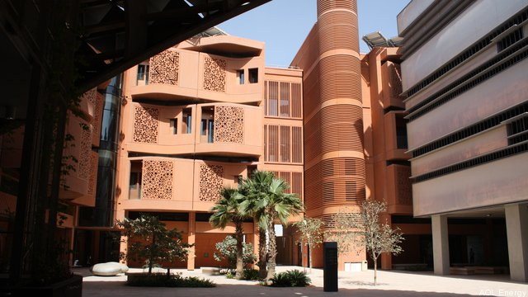
The United Arab Emirates has one foot firmly planted in tradition and the other stretching toward new ground. The UAE was built on traditional fossil fuels – an Opec member since 1967, home to the world’s 7th largest oil and natural gas reserves and the first Middle Eastern country to export LNG – the country is also a regional and global renewable energy pioneer. The UAE recently inaugurated the largest thermal solar power plant in the world, Shams 1, and the Arabian Islamic nation is about to begin producing nuclear power, a significant accomplishment given the region’s geopolitical complexity. Against that backdrop, the UAE has embarked on an aggressive experiment into urban sustainability designed to rely upon and pioneer cutting edge renewable energy technology with a project called Masdar City.
But is Masdar just an expensive gamble bankrolled by oil wealth, or a visionary approach to sustainable urban development that could help turn down the climate change dial? The answer most likely falls somewhere in between. Lessons learned along with technology solutions developed as part of this unique project could be applied in other parts of the developing and developed world to assist governments seeking to reach greenhouse gas reduction targets.
Masdar City is named for the government-owned renewable energy company – Masdar, meaning “the source” in arabic – which is a subsidiary of the massive government investment vehicle Mubadala Development Company. Upon completion, the city will be a technology cluster complete with research laboratories, residential housing and commercial space for 40,000 permanent residents and 50,000 daily commuters. It will be completely powered by renewable energy – 20% of which will be generated on site – and have a limited carbon footprint.
The developers are using state of the art building materials, passive and intelligent design techniques along with ancient Islamic architectural features to achieve an unprecedented level of energy efficiency. High and low heat density materials are used to take advantage of the desert sun so as to minimize heat gain and maximize cooling breezes. Passive building technology accounts for 60% to 80% of Masdar City’s energy savings, Christopher Sorensen, head of strategic global partnerships recently told a group of journalists during a media tour. Surface temperatures in Masdar City at the heart of summer when 130° F is a common occurrence are significantly cooler than adjacent Abu Dhabi where asphalt and traditional concrete absorb and hold the sun’s heat, Sorensen said.
Airflow in maximized inside and out of the library building by designing it with a baseball cap-like roof that shades the sun-facing façade while catching and swirling desert breezes in a shady area on the other side. Centrally-located circular stairs inside also help keep air circulating, thus limiting the energy needed for air conditioning, Sorensen explained.
Some of the world’s leading energy technology companies including GE, Siemens and SK Energy have chosen to build their regional headquarters in Masdar City. Siemens’ state of the art Middle East HQ building uses shading on the façade designed to optimize natural light transfer to the interior, while limiting the amount of direct sunlight emitted through the windows, which helps with cooling and reduces the energy-intensive air conditioning burden.
“A public transport system of electric buses, electric cars, and other clean-energy vehicles will provide transport within the city, while Abu Dhabi’s light rail and Metro lines will pass through the center of Masdar City, providing transport within the city and serving as a link to the wider metropolitan area,” according to the website. “Masdar City also has initiated an electric car pilot with Mitsubishi Heavy Industries to test a point-to-point transportation solution for the city that uses Mitsubishi Motor’s i-MiEV, five-door hatchbacks.”
Masdar has a 10 megawatt PV solar field installed in 2009 – still the largest in the Middle East – that currently supplies more energy than required, allowing the excess to be fed into Abu Dhabi’s public power grid. Blowing sand and dust is a problem for solar in desert locations because it collects on the panels reducing their efficiency, so Masdar has been working with other companies to engineer surfaces with pores smaller than the dust particles causing them to slide right off, “like a child on a play slide,” said Sorensen. Scientists at Masdar Institute are conducting research into light/matter interaction and working on coatings that repel sand or bacteria for use on solar panels and other applications.
But none of this comes cheap. The project has benefitted from historically high oil prices in recent years – the average annual Opec basket price has remained above $100 per barrel since 2011 – which has helped finance Masdar City’s development. The total cost is estimated at $18-$19 billion, according to the website. “It’s an expensive experiment,” Sorensen told Breaking Energy.
If Masdar can pioneer, prove up and deploy new technology that decreases in cost with economies of scale and can be applied to other parts of the world, the experiment will likely be deemed a success regardless its initial of cost. The project’s funding, which largely comes from the UAE government, appears somewhat dependent on the price of oil. A price collapse similar to that of late 2008 and 2009 when the Opec basket fell as low as $34/bbl could challenge the project’s capital structure.
Nevertheless, Masdar City is groundbreaking endeavor in a part of the world with skyrocketing population growth that needs energy efficient housing, cooling, water desalination and renewable energy solutions as energy consumption starts bumping up against oil and gas production jeopardizing exports so vital to Gulf country economies. As the global population continues increasing, all sources of energy will be required and projects like Masdar City can help advance renewable energy technology, which is projected to make up an increasing share of the global energy mix.
Full disclosure: Masdar paid Breaking Energy’s air travel and hotel costs while in the UAE.
http://breakingenergy.com/2013/03/20/masdar-city-new-urban-energy-future-and-climate-change-solution/

Abu Dhabi To Build First Full Eco-City
Posted in Energy Economy | Energy Industry | Environment and Sustainability
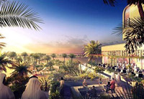
When we talk about the Middle East Asia, we imagine harsh terrain, blazing sun and sand dunes. Abu Dhabi is a part of the United Arab Emirates. Its currently hostile area is being developed as the world’s first carbon neutral city in the coming 5 to 10 years. This city will be a green example that will not be constructed using polluting technologies and fossil fuels. The greatest irony is this city would be located in a country that is a leading producer of fossil fuels. Its architects and designers claim that the city will be powered up by various forms of renewable energy, including solar and wind power.
The scorching heat during daytime in the desert will not be easy. This time architects decided to take the intense heat from the blazing sun into their stride. They want to make sun their ally not an adversary. They will incorporate many new solar technologies into the city, including centralization devices. These devices would concentrate sunlight gathered by mirrors into a central tower. This tower would then send a 1-meter-thick stream of light into various generators, for generation of power. The whole city will be dominated by a large LED, which will be affixed onto the rooftop of a wind turbine. The city is christened as Masdar City.
If Masdar city’s LED tower is showing blue light then it means that all the power levels in the city are running accordingly.If the LED is showing red light that means renewable sources of power are unable to generate sufficient power for the time being. Cars will not be allowed in the Masdar city. Therefore inhabitants of Masdar will not suffer from pollutions caused by carbon dioxide. Masdar city will be free of large structures such as skyscrapers. The architects want to reduce the amount of baking needed to make the cement. If you want to go from one place to another walk or use underground transport system. It can be Personal Rapid Transit, featuring podcars. These vehicles will not be driven by man. They will ply using magnetic lanes to a destination of the passenger’s choosing.
Masdar is not a distant dream. Some of the work regarding this city has already progressed. The construction cost of this city would be between $15 and $30 billion dollars. This project is funded by the ruler of Abu Dhabi, Sheikh Khalifa bin Zayed Al Nahyan. Designers of this city will also use some of the technologies inspired directly from lunar base concepts. This technology will help in heat dissipation, shade, breezes and clean air for all Masdar inhabitants.
http://www.alternative-energy-news.info/abu-dhabi-eco-city/
- 6 comments
- Alternative Energy

Join the discussion…
locojhon • 6 years ago
Eco-city?
How about future Eco-disaster?
As in where do they get their food for the greater population they are stimulating?
And what do they do with their wastes?
Not to mention, how will they support themselves after peak oil reduces their developmental income?
The market for sand isn't all that great...
Greenwashing--nothing more or less.
locoto
sreekumar • 6 years ago
Phil, good view. But, in my opinion money should be spent on population control through preventing the birth of unwanted children and providing financial and social security to those who choose to stay away from producing kids. By the word 'unwanted' I mean 'those kids that are not born out of parent's intentional efforts but as an effect of intercourse'.
Increase in world population cannot be afforded any more as much more fossil fuels will be burnt. The best solution is to control the root cause of this, that is, increasing population. It takes only a matter of minutes to cause the creation of a human being but the effect of the action results in large scale burning of fuels to meets its needs. Social engineering is the solution. All the efforts on technology would be no use unless stress is placed on controlling population. Encourage people who choose to go without children and spend money on supporting such enabling such a social structure. This will ensure healthy existence to those who live in this world and bring development to a sustainable level.
Phil • 6 years ago
It's great to see Abu Dhabi undertaking an eco project like this. But arguably this is a showcase from one of the richest nations on Earth. Maybe the money spent here would be better spent on producing real alternatives to oil, but why would they want to contribute to that policy!
amoline • 6 years ago
Of course it may serve difficult for Abu Dhabi to sustain this type of Eco-city considering the fact that it is hard to grow grass in a desert. That being said, this could be shown as an example for energy policy makers in the U.S. We are not going to get away from fossil fuels anytime soon. Many countries have already carefully extracted their own resources to develop their economy, i.e. Norway and Saudi Arabia. Perhaps the U.S. could embrace a policy where the revenues from our own oil reserves could fund the green technologies that have the potential to transform our economy as well.
sreekumar • 6 years ago
Great concept... Best wishes
Jos Conil • 6 years ago
A great initiative by Abu Dhabi, which has to be appreciated, considering the fact that it comes from an oil producing nation.The article touches upon the aspects of power, transport and reducing cement usage,but it is silent on how this city is going to treat the wastes generated - both bio and solid.
Creating new cities on green principles is a good one, but the real challenge lies in making the existing cities go green

