Fake news, ads dupe Internet-savvy students, study finds
By Marissa Lang, San Francisco Chronicle November 21, 2016
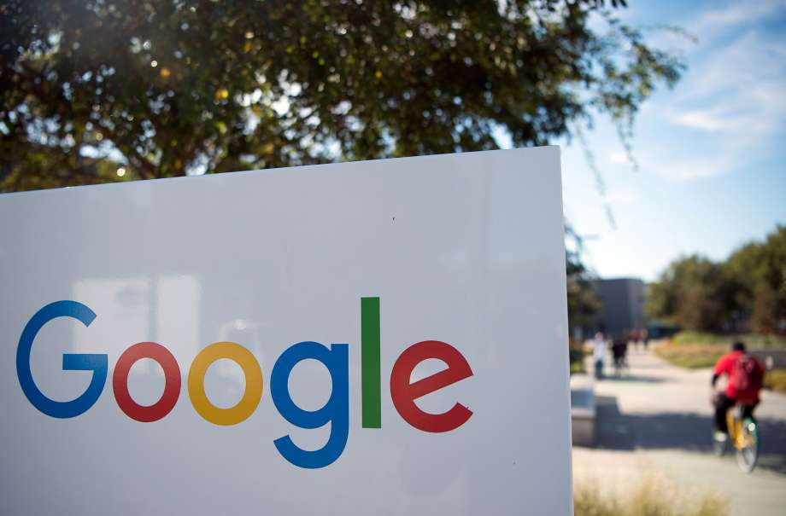
This file photo taken on November 4, 2016 shows a man riding a bike past a Google sign at the Googleplex in Menlo Park, California. Google and Facebook moved November 15, 2016 to cut off advertising revenue to bogus news sites, acting after criticism of the role fake news played in the US presidential election. "We've been working on an update to our publisher policies and will start prohibiting Google ads from being placed on misrepresentative content, just as we disallow misrepresentation in our ads policies," a Google statement to AFP said. / AFP PHOTO / JOSH EDELSONJOSH EDELSON/AFP/Getty Images
Internet powerhouses have for days been scrambling to come up with a way to answer those who blame them for an onslaught of fake news and false information that permeates the Web and, some believe, may have affected the course of the presidential election.
Their most recent strategy, announced Friday by Facebook and Monday by Google, would stop grouping websites that peddle falsehoods alongside legitimate news outlets.
But even that may not be enough,
Teenagers are thought to be fluent in the ways of the Web. Yet students from middle school through college are easily duped by unreliable sources and deceptive advertisements peppered throughout news sites and social media feeds, according to a Stanford University study.
The study, which measures how teenagers assess information they encounter online, is the biggest of its kind, surveying more than 7,800 students. It may, scholars said, illuminate how shallow our society’s understanding is of information found on the Internet.
Sam Wineburg, a professor at Stanford’s Graduate School of Education and lead author of the study, said even among college students, the “ability to discern truth from falsehood on the Internet is bleak.”
Asked to research the U.S. health care system, more than 40 percent of middle school students said they would use statistics from an online comment by “Joe Smith.” The statistics, which are false, did not cite a source or provide context. And yet less than half of the students rejected the information as patently unreliable. The vast majority of middle schoolers — 82 percent — also could not distinguish an advertisement masquerading as a news story, researchers found.
When presented with a big, colorful chart sponsored by the oil company Shell versus a screenshot of an article from the Atlantic, high school students overwhelmingly argued that Shell’s post was the more reliable of the two “because it provided more data and information” than the article did. Only about 15 percent of students noticed the paid post was sponsored by Shell and said the science article was the more trustworthy source.
This inability to evaluate information persists even after students are accepted to major colleges and universities — including Stanford, Wineburg said.
The “great majority” of college students tasked with evaluating information from the American College of Pediatricians, a conservative advocacy group that has been named a hate group by the Southern Poverty Law Center for its vehement opposition to women’s and LGBT rights, were unable to suss out the group’s bias, even when given the chance to independently check the group’s credentials. Some even cited the professional-looking website of the organization as reason to trust its pseudo-science.
“These issues are the new basic skills,” Wineburg said. “When we all consumed a printed newspaper that was vetted by people who produce the content, we could rely upon others for fact-checking, but that’s not the age we’re in.”
Students — along with many adults — are largely unable to discern truth from fiction because they have never been taught how, said academics. Even when a video or written article that looks trustworthy is labeled as “sponsored content,” people may not know what that means.
This gap in understanding has given rise to programs like the News Literacy Project, which brings journalists into classrooms to help students understand the difference between reliable and unreliable sources.
“There is simply no reason why this shouldn’t be a part of a high school curriculum,” said said Gabriel Kahn, a professor at the University of Southern California’s Annenberg School for Communication and Journalism. “This is Civics 101 for the 21st century. It has massive implications for our democracy.”
In the wake of the 2016 election, many blamed social media for falsely equivocating real news with falsehoods. Fake news typically falls into one of two categories: those that seek to manipulate people, spread misinformation and sow mistrust of traditional media, and those that use sensational — and false — stories to attract enough readers to make money through advertising.
Last week, Google announced that it would no longer allow websites that peddle falsehoods as fact to use its online advertising services. Facebook has done the same. But social media experts have said it likely won’t do much to stop fake news and false information from spreading.
In the past several days, both companies have taken it a step further: Google and Facebook announced that they’ll stop labeling such sites as news.
Google, which on the top of its main search tab offers a list of articles under the header “In the news,” will change that title to “Top stories,” to remove the implication that they are all news items. Google’s “news” tab offers news stories that are vetted more closely than on its main page.
Facebook CEO Mark Zuckerberg, meanwhile, presented a seven-point plan that includes fitting fake news with a warning label once it has been confirmed false.
“We’ve been working on this problem for a long time and we take this responsibility seriously,” Zuckerberg wrote in a post on his own Facebook page Friday, just days after he claimed it was “extremely unlikely” that fake news and hoax posts on social media had altered the election’s outcome. “Historically, we have relied on our community to help us understand what is fake and what is not.”
That might be part of the problem, experts said. Users may not know what’s real or not — especially when their main source of news is Facebook itself.
Marissa Lang is a San Francisco Chronicle staff writer. Email: mlang@sfchronicle.com Twitter: @Marissa_Jae

Fake news in the news
- Mark Zuckerberg outlines Facebook's ideas to battle fake news
- Digital media’s flood of past data threatens to drown democracy
- Technology companies must take responsibility for fake news
- Websites troll Zuckerberg after he downplays fake news problem

