SundayReview | Contributing Op-Ed Writer We Need Optimists
JULY 25, 2015
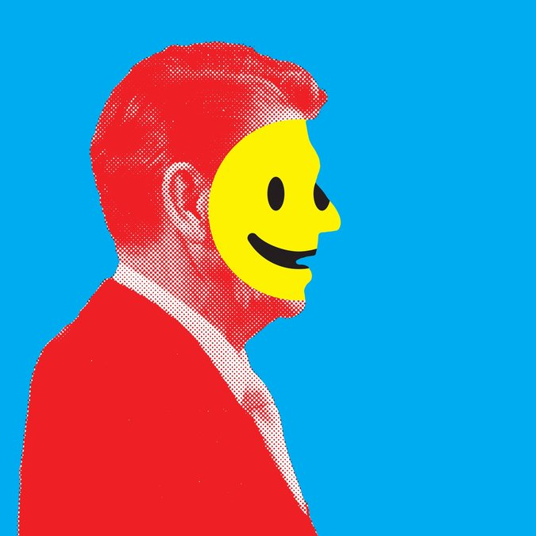
Credit Illustration by Johnny Selman; photograph by Associated Press

This story is included with an NYT Opinion subscription.
MY wife, Ester, and I had just endured a difficult parent-teacher conference for one of our teenage children. It was a grades issue. The ride home was tense, until Ester broke the silence. “Think of it this way,” she said. “At least we know he’s not cheating.”
That’s an optimist. We need more optimism in America today — especially in our politics.
Are you an optimist or a pessimist? At the personal level, optimism clearly seems superior. Psychologists find that optimists generally enjoy better physical health than pessimists, and a greater ability to cope with setbacks. Optimists are happier than pessimists, as a rule.
On the other hand, optimism is not without cost. Research shows that optimists are more likely than pessimists to keep gambling after losing money. Optimism bias can be a contributing factor in car accidents, as drivers overrate their own abilities. Playing down the probability of disaster can lead us astray in other situations where assessing risk is vital, like choosing a profession or selecting a mate.
Photo
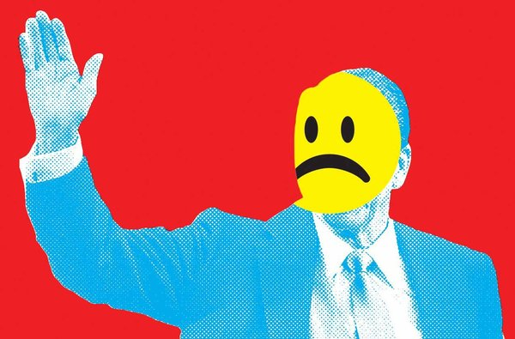
Credit Illustration by Johnny Selman; photograph by Associated Press
Optimism and pessimism have always competed in the American character. Think of it as Horatio Alger versus the Zombie Apocalypse.
On one hand, rags-to-riches confidence has always drawn entrepreneurs and immigrants to our shores and captured the popular imagination. The American attitude that all will be well often amazes our European friends — and not always in a positive way. In The New York Times in 2003, a former adviser to the president of France derisively declared that, “The United States compensates for its shortsightedness, its tendency to improvise, with an altogether biblical self-assurance in its transcendent destiny.”
But at the same time, Americans have often been attracted to apocalyptic predictions. In 1988, for example, a former NASA engineer named Edgar C. Whisenant published a book titled “88 Reasons Why the Rapture Will Be in 1988.” Scoff if you want; it sold millions of copies. When 1988 came and went and the end times did not materialize, Mr. Whisenant updated his prediction to 1989. And then 1993 and 1994.
While the citizenry may vacillate, leaders generally have to select one disposition or the other. Pessimism arouses fear and anger, while optimism inspires hope. Hope can accompany fear in times of extraordinary sacrifice (such as war), but this is rare. As a practical matter, a leader must choose.
Look beneath the platitudes that every candidate recites, and you’ll find politicians on both sides. Among both liberals and conservatives, there have been true optimists — like Presidents Reagan and Clinton — who seemed to exude faith in and affection for the American people. In recent times, however, right and left have more often produced competing pessimists who insist that the country is going down the tubes, the citizens are being stepped on, and everyone ought to be taking up torches and pitchforks.
“This is the most important presidential election of our lifetimes,” we hear year after year. If the other side wins, we can practically expect a jackbooted thug and a knock in the night. I exaggerate, but only a little. Witness the extraordinary political negativity of the past three weeks from presidential candidates on both sides.
Why on earth would a politician choose pessimism? Because it seems the smarter bet for connecting with a sour public. After all, the wisecracking cynic and smirking hipster are certainly more emblematic of popular culture today than the cockeyed optimist.
And there is a tangible, growing mainstream depression about the future of the nation that seems ripe for politicians to tap into. You simply can’t find a survey or poll that doesn’t show this. For decades, for example, Gallup has asked a large sample of Americans their view of “the way things are going in our country.” Averaging each month’s results for the year 2000, 37 percent said they were dissatisfied. So far in 2015, that number is 69 percent. In 2014, a Wall Street Journal/NBC poll revealed that 76 percent of Americans did not feel confident that “life for our children’s generation will be better than it has been for us.” This is 10 percentage points worse than the poll had ever recorded.
But we are paying a steep price for our politicians’ choosing the dark side. More than half of Americans said that our last presidential election was too negative, and complaints about the destructive, ad hominem discourse that dominates Washington have become a national cliché.
Furthermore, in taking the pessimism shortcut, our politicians are neglecting a major strategic advantage. Business studies identify optimism as a core trait of the most successful executives. And recently, social science has shown a big advantage for optimistic leaders. In 2013, for example, Dutch researchers published a study in The Leadership Quarterly showing that a positive, happy leader is judged to be 132 percent more effective than a dour, negative one.
A positive vision requires the hard work of winning over new friends, which means going where politicians have not been invited, and enduring less-than-adoring crowds. This is much harder than telling true believers what they already believe. But voters will reward candidates who have the talent and perseverance to do this. This isn’t wishful thinking or naïveté; just look to history.
Take the case of Ronald Reagan, the patron saint of the political party that most Americans currently see as the more negative of the two. Conservatives revere Reagan, but frequently misremember why he was so phenomenally effective. It was not a result of raging against liberals or fighting against big government. Reagan’s success came from his sunny optimism.
Reagan’s “Morning in America” campaign theme is an obvious example, but his optimism went much deeper, to his faith in Americans’ desire to fight for people. “Together, let us make this a new beginning. Let us make a commitment to care for the needy,” said Reagan at the 1980 Republican National Convention in Detroit as he accepted the nomination of his party. “We have to move ahead, but we’re not going to leave anyone behind.”
My own analysis of this speech found that “people” is Reagan’s most frequently repeated word, uttered 38 times. When we add in all the specific people he is fighting for — “families,” “children,” “the needy” and so on — the number more than doubles.
Reagan was not a cheerful milquetoast. He was perfectly capable of a vigorous fight — just ask the Soviets. But he studiously avoided being grim about it. He was Wordsworth’s happy warrior, “Whose high endeavours are an inward light / That makes the path before him always bright.”
I was 16 years old when Reagan was first elected. If I could have voted, I certainly would not have voted for him. When I was growing up in Seattle, no one I knew could stand him. But his optimism had an effect on me. Despite all of my biases and influences, I wanted a leader with this optimistic attitude. Secretly, I was not sorry he won.
Reagan’s optimism should not be understood ideologically; it was simply about people and our potential. He possessed an unflinching belief that all people — the poor, children, the elderly — were human assets, waiting to be developed so they could earn their success.
In contrast, pessimists see people as liabilities to manage, as burdens or threats that we must minimize. This manifests itself on the political left when we construct welfare programs that fail to boost unemployed Americans back into the work force. On the right, it shows up in strains of anti-immigrant sentiment or throw-away-the-key criminal sentencing.
Millions of Americans are frustrated by the environment of competing pessimisms in Washington today. Some say it is a result of the fact that the parties have never been further apart ideologically. They hark back to better times when there was more overlap between Democrats and Republicans.
I disagree. Maximum progress would come not from convergence on an unsatisfying centrism, but from a true competition of optimistic visions for a better future. Research suggests that optimists can find solutions where pessimists do not. And while competing optimists may disagree, sometimes fiercely, they don’t mistake policy differences for a holy war.
But let’s say that competition does not occur. What happens if one side unilaterally breaks out of the current negative equilibrium? I predict it will see victory — especially if the other side doubles down on pessimism and division.
Naturally, I might be wrong. But I would offer a political version of Pascal’s wager to a politician who is of a naturally Churchillian or Reaganite disposition: Let’s say you lose an election because you were your positive and joyful self.
Hey, at least you weren’t cheating.
Arthur C. Brooks is the president of the American Enterprise Institute, the author of the book “The Conservative Heart” and a contributing opinion writer.

