My True Nature products by creative mom

Carolyn Said

Updated 3:02 a.m., Friday, October 26, 2012
- 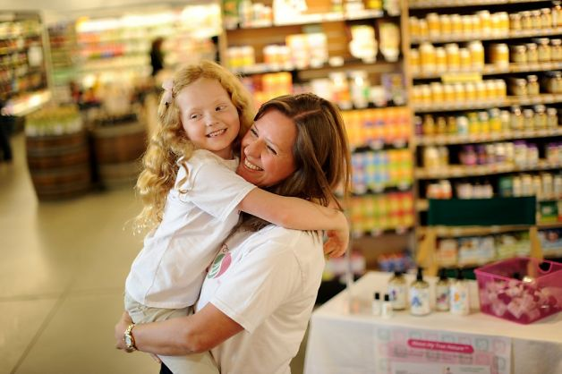
Kelly Boyd hugs her daughter Adeline, 6, while distributing samples at Berkeley Bowl. Photo: Noah Berger, Special To The Chronicle / S
Scampering through the aisles of Berkeley Bowl, Fletcher Boyd, age 7, buttonholed a woman pushing a toddler in a shopping cart and presented her with some small bottles.
"Would you like to try some natural kids' bath products?" he asked earnestly.
His sister Adeline, 6, chimed in: "For free."
Nearby, their mother, Kelly Boyd, stood at a small table stocked with sample bottles and brochures.
When Boyd, 42, a corporate securities lawyer, couldn't find organic, preservative-free skin cream for her babies' sensitive bottoms, she whipped up her own.
When the strain of juggling motherhood with a "work your tail off, crazy-hours career" became too much, she quit and became a "mompreneur."
Now her San Francisco company, My True Nature, markets her organic, locally sourced balms, bubble bath, soap and shampoo, racking up enough sales to generate a decent salary for her.
Boyd's story is a classic textbook - make that e-book - case study in how to start a business from scratch by leveraging social media and tapping into zeitgeist trends. The steps:
Find a need: "I have two very fair, strawberry blond children who have very sensitive skin," she said. "I couldn't find products that were free of synthetics and preservatives."
Fashion a solution: "I've always been a big cook, and making natural personal-care products is very similar to cooking," she said. "I started reading and taking classes. I really enjoy the creativity of it; it's crafty. I played around with formulations for a couple of years before I decided to turn it into a company."
Bootstrap financing: "I knew I didn't want venture funding because as a mom I wanted flexibility to focus on my kids; I don't want investors on my back trying to get my numbers up," she said. She and her husband, telecom sales executive Charlie Boyd, financed the company themselves, some of it on credit cards, putting in about $100,000 over the first few years, most of it for inventory. She said she's recouped that investment and is now profitable, with annual growth upward of 30 percent.
Market online: "There is no better time to start a company than now because there is so much free or close to free marketing available," she said. "It's all about the reviews - you can tell so much more readily than a couple of years ago what people really think about the products. That transparency helps smaller companies."
She sent hundreds of samples to mommy blogs, garnered good reviews and posted the links on her website, www.mytruenature.net.
Try it, you'll like it: "For bath products, you have to get people to try them," she said. "Daily deals helped me a ton. Mamapedia, MyHabit, Zulily and other sites are a great way to get people to try the products. You have to discount your product, but (it works out to) about the same as distributor pricing. It helped bring in cash to cover costs."
Ask for advice: Boyd tapped into a broad network of other mompreneurs through several online groups: Golden Gate Mothers' group for working moms called Works for Me; Women in Consulting; Savor the Success.
"I don't have time to go to meetings, but seeing other people's questions and the answers on the listservs helps a lot. There are only so many issues; the chances are that someone else is having the same problems you are. You can ask anything - what's the going rate for technical people, what are the typical margins for consumer products. They're a wealth of information."
Hire strategically: Boyd uses freelancers for all the job functions she can't fill herself. A broker who specializes in all-natural organic products helped get stores to carry her products. She pays a flat rate until store sales top a certain dollar amount, and then a percentage. How did she find the broker? By searching online and "asking everyone I know who's even tangentially involved" with related industries.
She found a graphic artist in the Netherlands by browsing online clip art. As needed, she hires a demo person and people to help with shipping.
Start small: The broker got about 100 West Coast natural groceries to carry the products, including Berkeley Bowl, New Leaf Market and Staff of Life. The downtown San Francisco Whole Foods will soon carry them as well.
Meanwhile, My True Nature also broke into Drugstore.com and Amazon.com, the former through the broker, the latter through a contact Boyd made at Amazon's flash-sales site MyHabit. E-commerce generates many more sales than stores, but a brick-and-mortar presence helps establish credibility.
"We found it works best to get into a few stores and really build up customer base and then go out from there," she said.
Go face to face: With trying the product being key, Boyd goes to the store with her demo table, often with her kids in tow, to hand out free samples. While she can hire others to do this, "I like doing it because you really get to know customers," she said. "We've heard all kinds of interesting stories. It's heartbreaking what some of these moms go through with their children and eczema or other skin problems."
Think local: Berkeley Bowl shoppers who stopped by Boyd's sample table often asked her where her products are made. She wanted to do everything locally, so she hired a contract manufacturer in Hayward and sourced the ingredients from local farms. Her bottles are 100 percent recycled plastic from a St. Louis company.
Aim broad: Boyd doesn't want to pigeonhole her products.
"I call them mainstream green," she said. "I try to get them to look and act like mainstream products. Even though they're 100 percent organic, and the packaging is made of recycled materials, I want them to look more like Hello Kitty."
Think ahead: The products' packaging features "bath time friend" characters such as Ollie the Octopus and Daisy the Skunk. Boyd and her graphic artist are working to expand the characters with a bath time book due out soon. A hooded towel and bath toys are also in the works, along with a bath time line for adults.
While Boyd still works 40 to 50 hours a week, it's nothing compared with her 80-hour workweeks as a lawyer.
Besides spending more time with her kids, she sees the business as an education for them.
"I love having them see how a small business runs," she said. "And they can earn money by helping me."

Start small: The broker got about 100 West Coast natural groceries to carry the products, including Berkeley Bowl, New Leaf Market and Staff of Life. The downtown San Francisco Whole Foods will soon carry them as well.
Meanwhile, My True Nature also broke into Drugstore.com and Amazon.com, the former through the broker, the latter through a contact Boyd made at Amazon's flash-sales site MyHabit. E-commerce generates many more sales than stores, but a brick-and-mortar presence helps establish credibility.
"We found it works best to get into a few stores and really build up customer base and then go out from there," she said.
Go face to face: With trying the product being key, Boyd goes to the store with her demo table, often with her kids in tow, to hand out free samples. While she can hire others to do this, "I like doing it because you really get to know customers," she said. "We've heard all kinds of interesting stories. It's heartbreaking what some of these moms go through with their children and eczema or other skin problems."
Think local: Berkeley Bowl shoppers who stopped by Boyd's sample table often asked her where her products are made. She wanted to do everything locally, so she hired a contract manufacturer in Hayward and sourced the ingredients from local farms. Her bottles are 100 percent recycled plastic from a St. Louis company.
Aim broad: Boyd doesn't want to pigeonhole her products.
"I call them mainstream green," she said. "I try to get them to look and act like mainstream products. Even though they're 100 percent organic, and the packaging is made of recycled materials, I want them to look more like Hello Kitty."
Think ahead: The products' packaging features "bath time friend" characters such as Ollie the Octopus and Daisy the Skunk. Boyd and her graphic artist are working to expand the characters with a bath time book due out soon. A hooded towel and bath toys are also in the works, along with a bath time line for adults.
While Boyd still works 40 to 50 hours a week, it's nothing compared with her 80-hour workweeks as a lawyer.
Besides spending more time with her kids, she sees the business as an education for them.
"I love having them see how a small business runs," she said. "And they can earn money by helping me."
Read more: http://www.sfgate.com/business/article/My-True-Nature-products-by-creative-mom-3982083.php#ixzz2BNZDMroE

