Capitalist Crusaders
By JEFFRIES BLACKERBY
December 5, 2010, 9:09 am 13 Comments
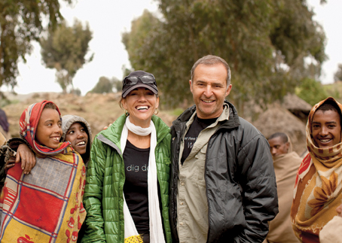Esther HavensFIELD AGENTS Donna and Philip Berber with residents of the Ambaras community in the Simien Mountains of Ethiopia.
Eleven years ago, Donna and Philip Berber had a Texas-size life — a booming tech company in Austin (Cybercorp), three sons and, “you know, flowers in my garden,” says Donna, who started A Glimmer of Hope, a foundation to help the rural poor in Ethiopia. Then, after seeing a video of his wife handing out bread to the hungry in Addis Ababa, Philip made a trip there himself and decided to “turn my back on my commercial career.” With $60 million from the recent sale of Cybercorp to Charles Schwab (for $488 million), he joined the foundation full time, and the couple (he’s Irish, she’s English) became pioneers of philanthro-capitalism. The Berbers’ endowment covers all of Glimmer’s operating costs, which has allowed the foundation to spend $40 million and counting to help alleviate poverty in Ethiopia. “One hundred percent of the money, not 50 or 80 percent, needed to get to the people,” says Philip, comparing Glimmer’s business model with that of other charities. “We had to start with a clean piece of paper.”
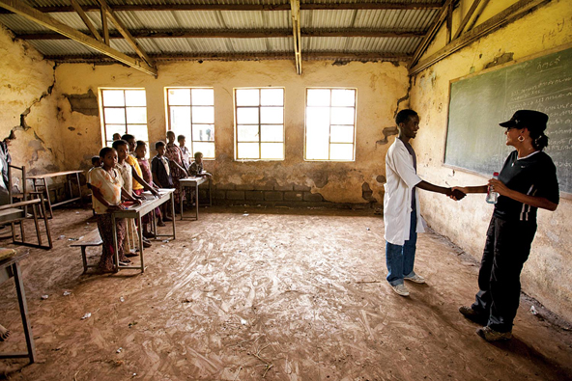A Glimmer of Hope Donna with schoolchildren in the village of Robit.
Their first project was a school in the town of Dembi Dolo, and since then, they’ve built 3,500 water and sanitation facilities, 190 health clinics and 53 vet clinics; completed 400 education projects; and, through the Clinton Global Initiative, given $2.4 million in microloans. We don’t leave a village until all those structures are up and running,” says Donna, adding that there’s more to measuring success than money. “ There is the human part of it as well: engaged philanthropy. What does it mean to give in a way that doesn’t make the giver feel hollow? We had to overcome the skepticism that constantly shrouds the giving world and show that there is another way, that there is emotional philanthropy alongside structured philanthropy.” Says Philip, “For us, it was important to be engaged, and it was important for our children to be engaged.”
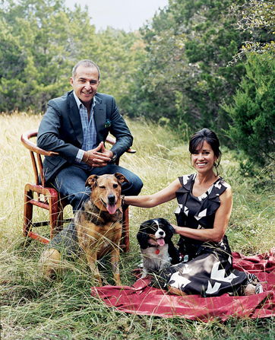Photograph by Susanna Howe. Fashion Editor: Ethel Park. Fashion Assistant: Adam Ballheim. Hair by Shin Arima. Makeup by Carla Palmer. The Berbers athome in Austin, Tex., this year. On Philip: Tom Ford jacket (sold as suit), $3,450, and shirt, $520. A.P.C. jeans, $165. Hermès pocket square, $130. On Donna: Oscar de la Renta dress, $1,890. Manolo Blahnik shoes, $785. Pomellato earrings, $6,000.

What They Gave This Year With $1 million raised at A Glimmer of Hope’s first public fund-raiser, the foundation provided nearly 13,000 people in the Ethiopian villages of Burbax and Girargie with 30 wells, a rainwater harvesting system, six schools and two health clinics. It is also financing microloans for 365 people.
What They’ll Give Next Year For the village of Robit, population 11,000, Glimmer will build a health center for $170,500, three schools for $550,000 and a library for $50,000; it will also finance $226,000 in water projects and $90,000 in microloans.
http://tmagazine.blogs.nytimes.com/2010/12/05/capitalist-crusaders/

