The Campus Reading Program Book for Fall 2012

Little Princes by Conor Grennan
http://www.sjsu.edu/reading/
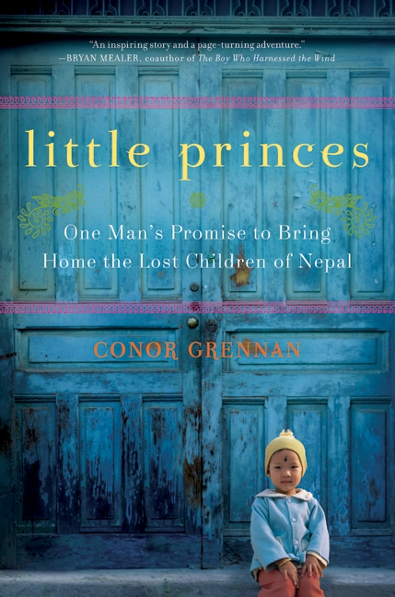 | Little Princes is an engaging, true story of author Conor Grennan's discovery of child trafficking in Nepal and what he did to address the problem. There will be many opportunities to engage with this book and connect with others on campus throughout the fall semester.
Book discussions in Clark Hall 100h:
- Thursday, October 11 3 - 4 pm
- Wednesday, October 17 Noon - 1 pm
- Monday, November 5 Noon - 1 pm
- Wednesday, November 14 1 - 2 pm
- Monday, December 3 2 - 3 pm
Hear author Conor Grennan speak about Little Princes and provide updates on his most recent
trip to Nepal. Open to the public. SJSU Student Union, Thursday, October 25, 4:00 pm.
Dialogue on "Human Trafficking: A Global Concern." Prof. Noam Perry, Justice Studies & Prof. Miranda Worthen, Health Science. MLK Library 255-257, Tuesday, November 20, 3:00-4:30 pm.
Another related event is part of the University Scholar Series; Dr. D'Andrade' will be discussing her research on reunification between children placed in foster care and their parents. Her presentation will be in MLK Room 225/229 on Wednesday, October 26th from 12 PM - 1 PM.

