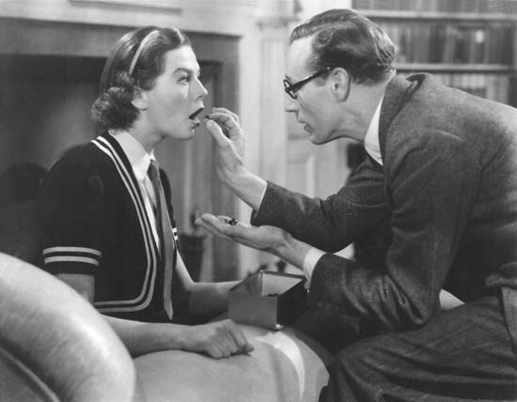 From the film: Eliza and Henry Higgins

The Pygmalion Effect: My Fair Lady and American Education By Ken Savage
Maybe putting marbles in students’ mouths and refusing to feed them until they do tasks correctly are a bit extreme, but the student-teacher relationship between Eliza Doolittle and Henry Higgins may in fact enlighten us on the celebrated methodologies of teaching in America’s schools today. Eliza is introduced as the poor, dirty-looking, Cockney-speaking “guttersnipe” who requests that Higgins teach her to speak like a proper lady. Higgins sees past her façade is able to see the potential in her despite the external signals she immediately gives off– her appearance, speech, and behavior. Though his teaching methods may be extreme and rather questionable, Higgins truly cares about the success of Eliza Doolittle. While Pickering keeps reiterating that Eliza is incapable of learning under such intense pressure and encourages Higgins to do simpler pronunciation exercises with Eliza, Higgins continues to push her believing that despite her previous circumstances that she is very much capable elevating herself in society. The result is astounding as Eliza demonstrates that sometimes simply believing in a student is the key to her unlocking her own self-esteem and success.
My Fair Lady, first performed in 1956, was progressive snapshot of classroom relations that foreshadowed sociological and educational research about how to reform the classroom and improve student performance in academics. In 1965 psychologist Robert Rosenthal and school principal Lenore Jacobson teamed up to study the effects of teacher expectations on student performance. The two took a sample of students from Oak School and after giving them a basic IQ test arbitrarily separated the students into two groups and designated one group as “growth spurters.” Rosenthal and Jacobson lied to teachers saying that after looking at the results of the Harvard Test of Inflected Acquisition, a test that does not exist, that the “spurters” group had the most intellectual promise. After one year and two years the students were given another IQ test, and Rosenthal and Jacobson discovered that the IQ’s from the group that was designated as intellectually superior had in fact increased immensely in comparison to the students from their so-called inferior counterpart. Moreover, teachers reported significant improvements in behavior and learning from the top group. These results led them to believe that expectancy advantage plays a huge role in the performance of students.
From this experiment and their research they coined the term Pygmalion effect (after George Bernard Shaw’s original play Pygmalion from which My Fair Lady was originated), which Rosenthal and Jacobson defined as a self-fulfilling prophecy. In other words, when teachers classify students as bright and expect great intellectual growth these students succeed and meet expectations while students who are not expected to perform as well fall under par due to discouragement and a lack of motivation. Essentially, the more you believe in your students and show them your belief in them, the more they achieve.
An important corollary of the Pygmalion effect is that teachers exhibit differential behavior when dealing with the two different groups based on their perceptions of each group’s capabilities. For example, it was observed that when teachers worked with the “spurters” group, they showed more unmistakable signs of their faith in them: smiles, nods of approval, patience in responding to and asking questions, a warmer tone of voice, compliments, and other forms of their unconscious communication of the high expectations set for them. These verbal and nonverbal cues reinforced their high achievements and teachers were found to push them harder, giving them more advanced assignments and speeding them through the curriculum. The opposite was exhibited when dealing with the second group. The verbal and nonverbal communication of teachers’ perceptions and attitudes toward students can be devastating to the said inferior group who do not receive the same attention, motivation, and care from teachers. Students pick up on these cues and can respond negatively by losing self-esteem, academic motivation, and interest in performing well. Rosenthal and Jacobson compiled all of their research and findings and published Pygmalion in the Classroom in 1968.
Higgins’ initial judgment of Eliza mirrors how teachers initially classify students into groups based on external signals, such as behavior in the classroom, appearance, and the proficiency of their speaking skills. However, differences in race, sex, and social class also fuel the Pygmalion effect. It is easy for one to make the generalization that a lack of resources and education based on a student’s position at the bottom of the social hierarchy that he or she is proportionally academically incapable. Students of color fall under this category, particularly African American and Latino males in urban communities. However, rather than categorizing students into groups and perpetuating an lack of academic motivation by dumbing down the curriculum and providing teachers who have expected failure, the Pygmalion effect calls for the development of disenfranchised, poor and minority students by increasing encouragement, maintaining high expectations, and perpetuating an optimistic learning mentality. Obviously, this change in expectations and perceptions of students is only the essence of how education reformers should revamp American schools. This mindset in tandem with tailored curriculums, specialized programs, more resources, a lower student teacher ratio, and other ways of helping teachers create an environment conducive to learning is the key to ensuring a great education for America’s students.
Despite Henry Higgins’ harsh treatment of Eliza, he never ceased to push Eliza and believed that she was capable of learning. In moments where Pickering doubts Eliza’s capabilities to stand her own ground and showcase her newfound mastery of speech, Higgins responds by saying, “Eliza can do anything.” With this line, My Fair Lady comically and beautifully portrays the Pygmalion effect as it was written by Shaw, exemplified by Higgins and proven by Rosenthal.

Explore More
- Keeping it Classy: Class Structures and Attitudes in the U.S. and Britain Today
- “Rain” vs. “Rine”: Phonetics, Regional Dialects, and Class in England
- Social Insecurity: Class Divisions of Edwardian England

An article from a theater program http://www.arenastage.org/shows-tickets/sub-text/2012-13-season/my-fair-lady/the-pygmalion-effect.shtml

