George Bernard Shaw – Life and Works
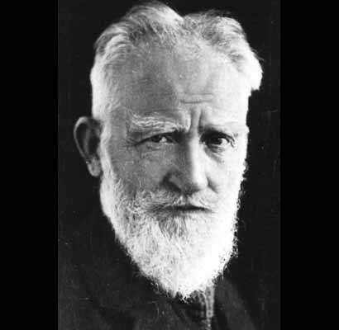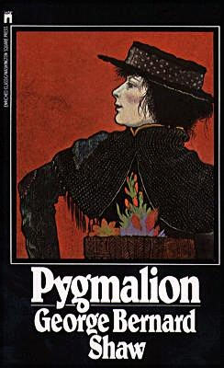
George Bernard Shaw (1856-1950) born in Dublin into a “shabby genteel” Protestant household. His father, George Carr Shaw, was a civil servant, grain merchant, and alcoholic, a kindly but ineffectual person who inspired Shaw to become a lifelong teetotaler.
Shaw disliked school and left it for good at 15, but he read voraciously and received an excellent musical education at home.
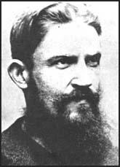 Young Shaw—Dashing Rebel let loose on London high society. His first job at 15 was in an estate agent's office, collecting rents, among other things.
At 20, he moved to London (1876). After a painful decade or so of poverty and hardship, when he wrote 5 rejected novels, he became an influential critic of music, theater, and art, helping to launch Henrik Ibsen’s career with The Quintessence of Ibsenism, 1891.
Fabian Society-- He achieved further fame and influence as a member of the Fabians, a socialist debate society. Overcoming a terrible shyness, he trained himself to be a devastatingly effective public speaker and debater, and he wrote their most influential treatises.
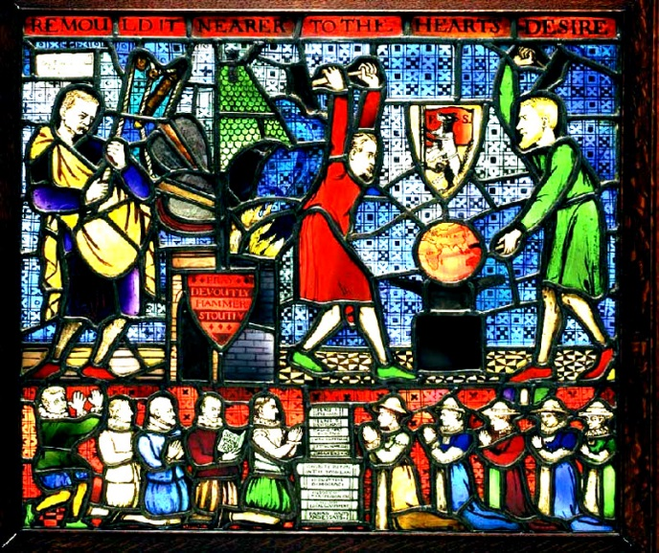 With some fellow Fabians he established the London School of Economics, where his portrait in stained glass still hangs. (That’s him in Irish green on the right.)
He started writing plays himself to show how it was done. Some of his most famous plays are Pygmalion, Mrs. Warren's Profession (his prostitution play), Arms and the Man, Major Barbara, and Saint Joan (for which he won the Nobel Prize) The Nobel website says “Shaw's radical rationalism, his utter disregard of conventions, his keen dialectic interest and verbal wit often turn the stage into a forum of ideas,” which continue to be relevant.
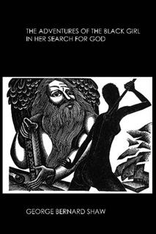 One of Shaw’s most intriguing but lesser-known works: Adventures of the Black Girl in her Search for God, a novella.
His most famous and influential play, by far, is Pygmalion (1912), whose heroine is a
Cockney flower girl turned “duchess” through the study of phonetics The multiple-award-winning musical version, My Fair Lady, was made after his death. He’d have hated it.
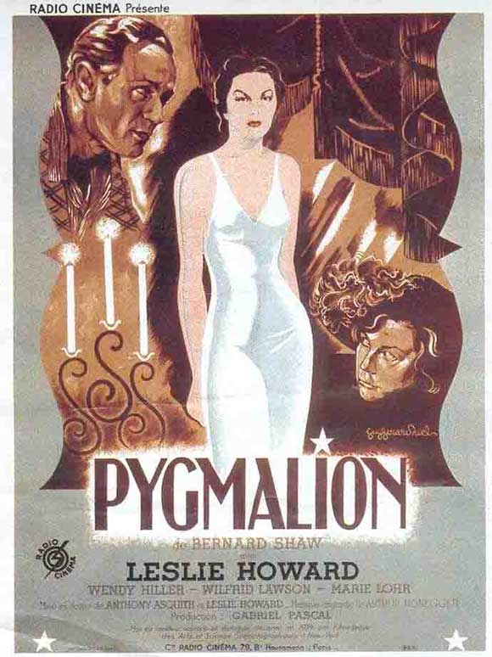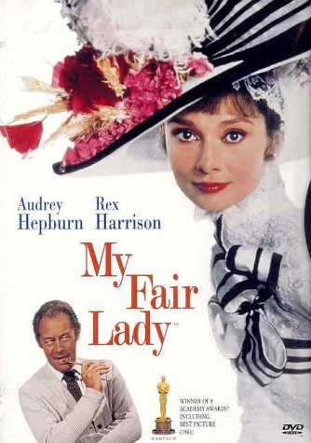
Shaw's complete works filled thirty-six volumes.
Also, some of his most interesting works are not listed above, including Commonsense About the War (1915), which made him extremely unpopular for a while.
He also wrote a fun melodrama set during the American Revolution which has been made into a film with Kirk Douglas as the anti-hero: The Devil’s Disciple.
His Irish plays, John Bull’s Other Island and O’Flaherty V.C. (just a one-act play but worth reading) are also not as well known as they deserve.
Shaw and Ireland: An excellent anthology called The Matter With Ireland, collects Shaw’s writings on his native land. Though a Protestant, Shaw was a resolute Republican, continually urging his countrymen to stick together and trust each other.
Pygmalion (the entire film) on You Tube: https://www.youtube.com/watch?v=tmdPj_XbF30

