Cuchúlainn in Contemporary Culture
Some short films:
An 18-minute live-action video about the boy Setanta (AKA Cuchulainn), has a “Game of Thrones” vibe. https://www.youtube.com/watch?v=Ky1ftQFox0M
There are also episodes of an animated story of Cuchúlainn with the spoken dialog in Irish: http://www.youtube.com/watch?v=xxy6EU-4IdY
A Comic Book Incarnation
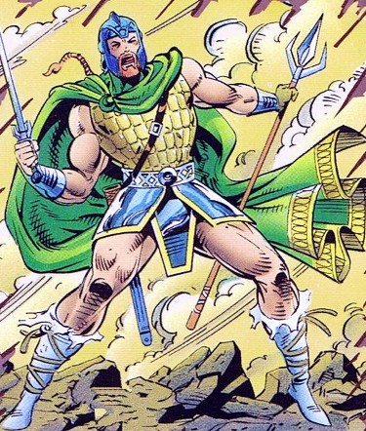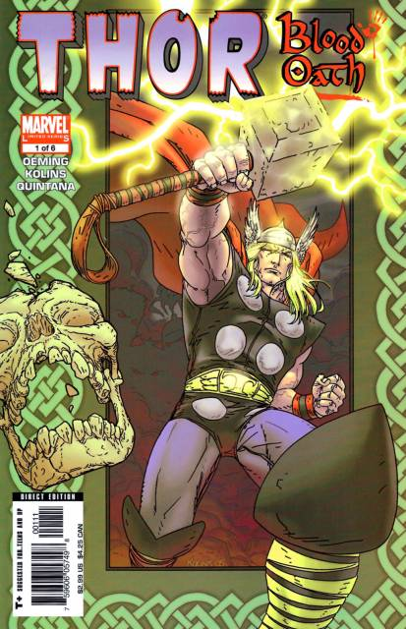
A figure of Irish Folklore, Cuchulainn is a Celtic warrior of unequal skill, Charged with protecting the ancient Book of Kells. Revived after years of slumber in the 31st century by the Guardians of the Galaxy, the Irish Wolfhound takes up spear and sword once again in the name of justice! http://marvel.com/universe/Irish_Wolfhound_(Earth-691)
- Real Name Cuchulainn
- Aliases Irish Wolfhound
- Identity Secret
- Citizenship Unrevealed
- Place of Birth Unrevealed
- First Appearance Guardians of the Galaxy Annual #3 (1993)
- Origin Using the Book of Kells, Doctor Druid raised his spirit to protect the Earth through infinity (Guardians of the Galaxy Annual #3 1993)
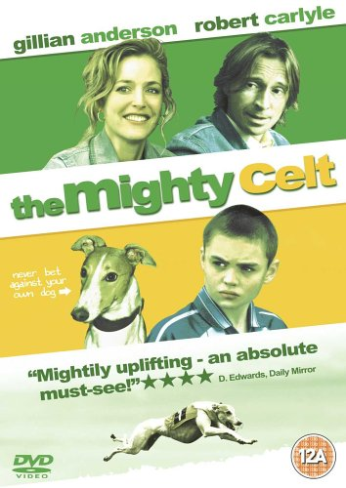
This indie Irish film set in Northern Ireland during the Troubles has an interesting take on using the ancient warrior hero’s image in an anti-violence film. A young boy whose parents lived through the worst of the Troubles is inspired by the comic-book version of Cuchulainn to get involved with dog-racing, but he decides not follow the warrior path, resisting those who still want to hurl bombs.
_________________________________________________________________
The Hound: An animator shows his vision for Cuchulainn—a pitch to investors (3 min): http://houndthemovie.com/mobile/mobile.php#movie
_________________________________________________________________

A recent (2013) graphic novel revamps the story once more:

Cu Chulainn gets a superhero makeover as myth goes graphic

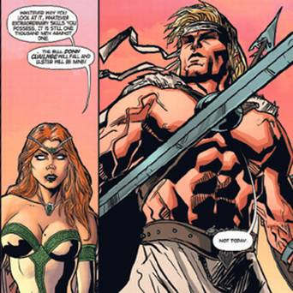
Cu Chulainn and Queen Maeve.
John Spain, Books Editor – 30 March 2013

ANCIENT myths have never been this sexy.
In a new book based on one of Ireland's oldest legends, Cu Chulainn is as ripped as Sylvester Stallone in his 'Rocky' days and Queen Maeve has a body like Lara Croft and tops that barely stay on.
It is more like a cross between 'Tomb Raider' and 'Game Of Thrones' than the gentle illustrations in the storybooks of Irish myths and legends we all read as children.
The new Cu Chulainn picture book is as ferocious, bloody and sexy as anything in a video game.
Published next week, 'Celtic Warrior – the Legend of Cu Chulainn' is a graphic novel that will shock traditionalists and delight teenage readers.
The tale is retold as an epic saga of greed, butchery and sorcery.
The stunning illustrations bring to life the story of the boy who was renamed after the giant guard dog he killed and who as a young man singlehandedly defended Ulster against the marauding army of Queen Maeve of Connacht.
This is the myth of the Tain Bo Cuailnge, the story of Queen Maeve's obsession to acquire the Brown Bull of Cooley.
The Tain story appeared in written form in 12th-century Irish manuscripts and was translated into English by poet Thomas Kinsella in 1969 and illustrated by Louis le Brocquy.
This new version is very different. The 128-page book is the work of Will Sliney, an awardwinning Cork-based illustrator who broke on to the worldwide scene illustrating graphic novels such as 'Star Wars', 'Farscape' and 'MacGyver'.
The story centres on the myth of The Tain, but we also get flashbacks to the hero's early life and how, having been born Setanta, he acquired the name Cu Chulainn (Hound of Culainn); how he was rewarded by Morrigan, the goddess of war, for saving her life; and how he acquired his supernatural abilities.
At the visceral climax of the story, Cu Chulainn stands alone against the thousands of warriors controlled by the enchantress Queen Maeve who is determined to capture the bull and claim the lands of Ulster. He dies like a true superhero.
Supernatural feats of strength, ferocious battles and the tragic destinies of Cu Chulainn and his brother Ferdia are recreated in this actionpacked retelling of one of the most famous stories from Celtic myth. The book finishes with the incident in which the dying Cu Chulainn is bound upright to a post so he can face his enemies – the image recreated in the statue that stands in the GPO. 'Celtic Warrior – the Legend of Cu Chulainn' will be published next week by O'Brien Press at €14.99.
http://www.independent.ie/irish-news/cu-chulainn-gets-a-superhero-makeover-as-myth-goes-graphic-29164535.html
This earlier graphic novel version with the dialog in Irish lists the production credits as Cartoon Saloon, which also produced Song of the Sea. The same group has also made a book about Deirdre, another story from the Tain.
Aistriúchán: Click here for an English translation of 'An Táin'

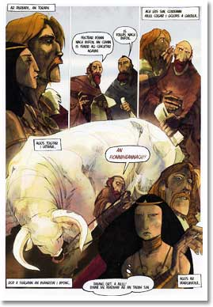 | 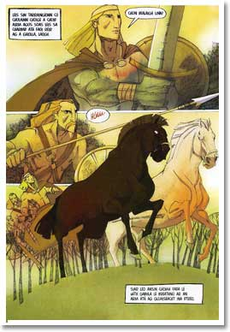

http://www.leabhar.com/tain.htm
Scríbhneoir / Writer: | Colmán Ó Raghallaigh
Líníocht / Drawing: | Barry Reynolds
Léiriú / Production: | The Cartoon Saloon, Cill Chainnigh:  Ross Murray - Production Manager

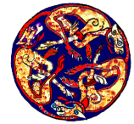 | Warriors, Heroes & Villains  Cúchulainn

http://www.sheeeire.com/magic&mythology/Warriors&Heroes/Warriors/Males/Cuchulainn/Page1.htm
This is a pretty well-made site with great graphics, lots of hyperlinks, charts.
Below is material from Wikipedia, some details about his importance in Irish nationalism and Ulster unionists.
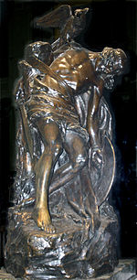
Statue of "The Dying Cuchulain" by Oliver Sheppard (1911), now at the GPO, Dublin
The image of Cú Chulainn is invoked by both Irish nationalists and Ulster unionists. Irish nationalists see him as the most important Celtic Irish hero, and thus he is important to their whole culture. A bronze sculpture of the dead Cú Chulainn by Oliver Sheppard stands in the Dublin General Post Office (GPO) in commemoration of the Easter Rising of 1916. By contrast, unionists see him as an Ulsterman defending the province from enemies to the south: in Belfast, for example, he is depicted in a mural on Highfield Drive, and was formerly depicted in a mural on the Newtownards Road, as a "defender of Ulster from Irish attacks", both murals ironically based on the Sheppard sculpture.^{[32]} He is also depicted in murals in nationalist parts of the city and many nationalist areas of Northern Ireland.^{[33]} The statue's image was also used on the ten shilling coin produced for 1966. The 1916 Medal the 1916-1966 Surviviors Medal and the Military Star for the Irish Defence Forces all have the image of Cú Chulainn on their Obverse.
A statue of Cú Chulainn carrying the body of Fer Diad stands in Ardee, County Louth, traditionally the site of their combat in the Táin Bó Cúailnge.^{[34]} A sculpture by Martin Heron, entitled "For the Love of Emer", depicting Cú Chulainn balancing on a tilting 20-foot pole, representing the feat of balancing on the butt of a spear he learned from Scáthach, was installed in Armagh in 2010.^{[35]}

Wikipedia on Irish mythology in Popular Culture (Cuchulainn section)
Animation In the second season of the Disney animated TV series Gargoyles, during the "Avalon World Tour" story arc's episode titled "The Hound of Ulster", Goliath's daughter Angela, their human friend Elisa Maza, and Goliath's gargoyle beast Bronx encounter a young Irishman named Rory Dugan, who turns out to be the reincarnation of Cu Chulainn. For a time Bronx accompanies the reincarnated Cu Chulainn as the titular "hound" of the legend, with the Banshee as Cu Chulainn's antagonist. The Banshee, one of Oberon's children in the Gargoyles episodes, also takes the form of a gigantic, centipede-like "death-worm" under the name of Crom(m)-Cruach to battle Cu Chulainn and the Gargoyles in the episode's climax. (Note: Cu Chulainn himself was actually known as "the Hound of Ulster": he slew Culann's guard dog and then offered his own services as "watchdog" in compensation, thereby becoming known as "Cu Chulainn", which means "Culann's hound"; he then defended Ulster and became known as "the Hound of Ulster". The Gargoyles episode title probably refers doubly to Bronx acting as Cu Chulainn's temporary "hound" and to Cu Chulainn himself.)
The King's Wake, a short animated film by John McCloskey, features Cu Chulainn and King Connor Mac Neasa.^{[1]}
In Fate/Stay Night, Cú Chulainn is summoned into the Lancer class, and his spear, Gáe Bolg, has the ability to unfailingly pierce the heart of its target.
Comics
- Cuchulainn, the Irish Wolfhound, has appeared in Marvel Comics' Guardians of the Galaxy.^{[2]}
- An Táin, Colmán Ó Raghallaigh and Barry Reynolds' Irish language graphic novel adaptation of Táin Bó Cúailnge, was published by Cló Mhaigh Eó of County Mayo in 2006.^{[3]}
- Patrick Brown's webcomic adaptation of the Táin, The Cattle Raid of Cooley, began serialisation in August 2008.^{[4]}
- Oghme Comics are in the process of adapting the story of Cúchulainn in graphic novel format, as a series of webcomics,^{[5]} as well as Illustrations of Characters^{[6]} from the Ulster cycle.
- Chulain appears as a minor antagonist in the Marvel Comics limited series Thor: Blood Oath.
Music
- Scottish composer Ronald Center wrote a symphony called The Coming of Cuchulain, first performed by the Scottish Orchestra, conducted by Warwick Braithwaite, in 1944.
- The tale of Cú Chulainn's wasting sickness provides the title of the Pogues's song "The Sickbed of Cuchulainn" from their album Rum, Sodomy, and the Lash.
- Jeff Danna's opening theme for the 1999 film Boondock Saints is named "The Blood of Cuchulainn".
- French hip hop group Manau has a song about Cú Chulainn called "Le Chien du Forgeron" ("The Smith's Hound").
- The first track on the album The Eternal Knot, written by Karl Jenkins for his Adiemus project, is called "Cú Chullain".
- The second verse of the Thin Lizzy song "Róisín Dubh (Black Rose): A Rock Legend" from the 1979 album Black Rose: A Rock Legend begins with the phrase "Pray tell me the story of young Cuchulainn, how his eyes were dark, his expression sullen, and how he'd fight and always won, and how they cried when he was fallen".
- The eighth track on the album Wild Frontier by Gary Moore, titled "Thunder Rising", speaks of the legend of Cú Chullain.
- Irish rock band Horslips' 1973 second album was titled The Táin, featuring Cú Chulainn's exploits, originally conceived as music for a stage adaptation of the poem.
- Cuchulainn is mentioned in or the subject of a few songs by the Celtic metal band Cruachan, including "Cuchulainn (The Hound of Culan)", "Cattle Raid Of Cooley" and "The Brown Bull of Cooley".
- The songs "Seven Fingers" and "When They Come to Murder Me" from the Black Francis mini-album SVN FNGRS are about Cú Chulainn.
- There is a song from the show Riverdance named "Caoineadh Cú Chulainn", meaning "The Lament of Cú Chulainn". It is played by Davy Spillane on the uilleann pipes.
- The German metal band Suidakra released an album called Crógacht, based on the story of Cúchulainn and Conlaoch.
- The symphonic metal band Therion released a song called "Cú Chulainn" on their 2010 album, Sitra Ahra.
- The first track of My Name Will Live On, an album by Italian epic doom metal band Doomsword is named "The Death of Ferdia", and tells the story of the duel fought between Cú Chulainn and his foster brother.
Novels
- In Henry H. Neff's series The Tapestry, Max MacDaniels is believed to be Cúchulainn reborn. He is later discovered to be a half brother.
A summary of the Cattle Raid of Cooley is told in the first book.
- In Laurel K Hamilton's Meredith Gentry series, it turns out one of the lead characters' fey lovers and oldest friend, Rhys, is actually a somewhat fallen and 'depowered' Crom Cruach.
Sport
- Cú Chulainn's name is popular in Gaelic games. A number of Gaelic Athletic Association clubs are named after him, including Dunloy Cúchullains in County Antrim,^{[7]} Cúchulainn Hurling Club^{[8]} and Mullaghbawn Cúchulainn's Gaelic Football Club in County Armagh, Cúchulainn Gaels in Omeath, County Louth,^{[9]} Setanta Hurling Club in Killygordon, Co. Donegal, Setanta Hurling Club in Ballymun, County Dublin, and Cúchulainns GFC based in Mullagh, County Cavan. Cuchulainn is also the name of a brand of Gaelic sportswear.^{[10]} Setanta Sports is the name an Irish broadcasting company specialising in sport, broadcasting in Ireland, USA, Canada and Australia, and formerly in Great Britain. Setanta College is the name of an Irish online sports college.
Scouting
- In Scouting Ireland, the highest adult award is the Order of CúChulainn.^{[11]} It consists of an award ribbon and a hound pendant.
Games
- The character is the protagonist in the adventure games Tir Na Nog and Dun Darach.
- In Final Fantasy XII, an esper is named Cúchulainn, and in Final Fantasy Tactics he is the first Lucavi demon players must defeat. Additionally, several Final Fantasy games contain a weapon named for Cú Chulainn's spear, the Gáe Bulg.
- Cúchulainn appears in several Megami Tensei games as a recruitable demon capable of being summoned by player characters to fight other enemies. Also, in Persona 3, it is possible to fuse him with a Nihil weapon to obtain his spear. He also appears as his Setanta form, usually a weaker demon than Cu Chulainn.
- He appears as Lancer, one of the Servants in the Holy Grail War in the Fate/stay night visual novel. He also appears in the anime, video games, movie, and manga based on the visual novel.
- In the adventure game Omikron: The Nomad Soul, a hero which the player eventually controls is named Kushulai'n.
http://en.wikipedia.org/wiki/Irish_mythology_in_popular_culture

