San José State University
Humanities & Arts/English & Comparative Literature

English 117B: Global Film, Literature and Cultures

2017 Summer Study Abroad in Ireland

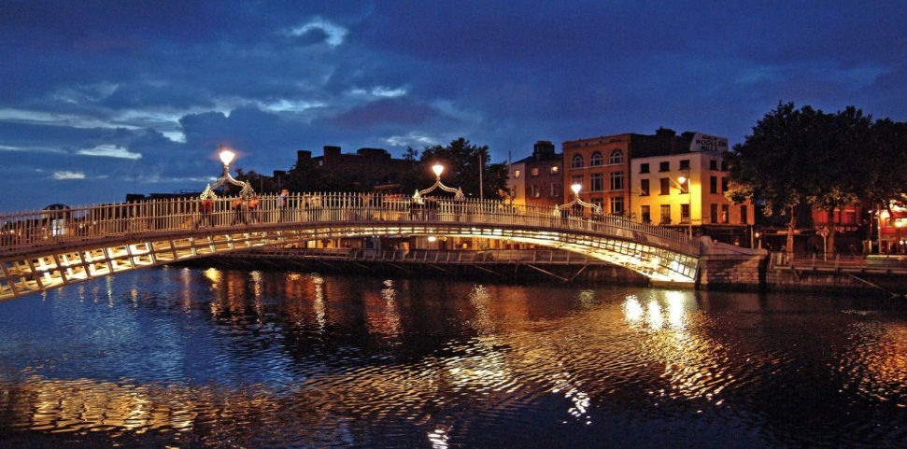

Itinerary in Ireland: July 9-20

Sunday - July 9, 2017
Morning: Arrive at Shannon Airport, meet with CISabroad On-Site Program Coordinator, Kate McConnell, and transfer to Galway by private coach service. Check into accommodations (Corrib Village, NUI Galway) on arrival.
Afternoon: Head into town, Lunch together (students to pay individually).
Evening: Group Welcome Dinner at McSwigan’s and CISabroad Orientation.
Meals: Dinner. Transportation: Airport to accommodations (private coach service); accommodations to dinner (walking)

Monday - July 10, 2017
Morning: 10-11 AM Guided walking tour of Galway
Afternoon/Evening: Free time to explore Galway and the surrounding area, with La Vida Local cultural activity suggestions available from CISabroad Coordinator
Meals: Breakfast. Transportation: walking

Tuesday - July 11, 2017
Morning: Class time (10:00 - 11:30) Discuss upcoming assignments, choose topics.
Afternoon: Free Time
Evening: 7PM: Film Fleadh Song of Granite (opening night gala)
Meals: Breakfast. Transportation: public transportation and walking

Wednesday - July 12, 2017
Morning: Class time (10:00 - 11:30) Discuss opening film, projects.
Afternoon 3:15-4:45 PM: Film Fleadh City of Ghosts
Evening: 6PM: Film Fleadh Rocky Ros Muc
Meals: Breakfast. Transportation: public transportation and walking

Thursday - July 13, 2017
Morning: Class time (10:00 - 11:30) Discuss yesterday’s films, projects
Afternoon: 4-5:30 PM: Film Fleadh In the Name of Peace: John Hume in America
Evening: Free Night: Recommended—Trad on the Prom (a dance performance)
Meals: Breakfast Transportation: public transportation and walking

Friday - July 14, 2017
Morning/Afternoon: Free Time
Evening: 6-8 PM: Film Fleadh I'm a Killer
Meals: Breakfast Transportation: public transportation and walking

Saturday - July 15, 2017
Free Day: Option to attend an additional day of the Film Fleadh or embark on independent excursions (Kylemore Abbeg, Cliffs of Moher, Aran Islands, etc - cost not included) Visit the Irish Tourist Office downtown by Eyre Square, or the website.
Meals: Breakfast Transportation: Accommodations to visits (public transportation and walking)

Sunday - July 16, 2017
Morning: Free time
Afternoon: 12-2PM: Film Fleadh New Irish Shorts 8 (animated)
Meals: Breakfast Transportation: Public transportation passes provided

Monday - July 17, 2017—Galway to Dublin
Morning: Transfer to Dublin by regional train
Afternoon: Arrive in Dublin, transfer to accommodations, 3PM Walking Tour
Evening: Free time
Meals: Breakfast, dinner Transportation: Accommodations to Galway Rail Station (public transportation and walking); Galway to Dublin (regional train); to visits in Dublin (public transportation and walking)

Tuesday - July 18, 2017
Morning: Excursion to Trinity College; visit the campus for a tour guided by a real Trinity College undergraduate, then see the legendary Book of Kells
Afternoon: Tour Dublin Castle, then see a film at the Irish Film Institute
Evening: Enjoy the famous Literary Pub Tour
Meals: Breakfast Transportation: public transportation and walking

Wednesday - July 19, 2017
Morning: 10AM: Visit to EPIC Museum
Afternoon: Free time
Evening: 6PM Farewell Dinner at the Brazen Head
8PM See Once at the Olympia Theatre
Meals: Breakfast Transportation: Accommodations to visits (public transportation and walking)

Thursday - July 20, 2017
Last Day: Check out of accommodations and transfer to airport for return flight home
Meals: Breakfast Transportation: Accommodations to airport (Airlink express)

************************************************************************
Accommodations and meals: Shared (2-3 students per room) occupancy housing in centrally located budget hotels [or college dorms] will be provided for students in each location. A private single ensuite room will be provided for the faculty member at the same or nearby locations. Breakfast will be provided daily and group welcome and farewell dinners are included.

Leadership Benefits: On-site representative throughout the entire duration of the program. The cost of one faculty member is built into the prices above with minimum group enrollment of 12 total participants. Faculty will receive all contract items.

Program Arrangements: Housing and meals as indicated above. All course related excursions and entrance fees listed on Page 2 of this agreement. Gratuities to bus drivers, guides and/or similar. CISI health insurance will be provided for all program participants and liability coverage will be provided for SJSU.

