ME 115 -- Centrifugal Pump Test Experiment

# Purpose

# The purpose of this experiment is to obtain the performance characteristics of a centrifugal pump. The performance curves obtained in this experiment will include pump head, power input, and efficiency as a function of flow rate for different pump speeds.

# Objectives

The objectives of this experiment are as follows:

* to investigate the relationship between pressure head, flow rate, power consumed and efficiency for a pump
* to observe and describing the limitations of centrifugal pumps
* to understand the use of a Venturi meter and differential pressure measurement to find flow rate

# 

# Apparatus

The experimental apparatus is in the Energy Conversion Laboratory in Room E113. . The TecEquipment H47 Centrifugal Test Pump Set is used in this experiment to investigate the performance and characteristics of a centrifugal pump.

The test equipment consists of a single centrifugal pump. A motor mounted in bearings drives the pump. The pump draws water from the integral reservoir. The water travels up through a valve and filter, through an inlet valve to the pump body, then out through a delivery valve. It then passes through a Venturi meter and returns to the reservoir for re-use. The adjustable inlet and delivery valves allow the creation of different operating conditions.

Instrument and control modules are located in the frame above and behind the pump. The instruments display the inlet pressure, delivery pressure and differential pressure across the Venturi. An electronic Motor Drive controls the pump speed. A strain gauge load cell measures the driving torque of the pump and a sensor measures pump speed. A display on the Motor Drive shows speed and torque and automatically calculates and displays true ‘shaft’ power. The differential pressure across the Venturi gives flow rate.

The pump has a transparent ‘window’ to allow easy observation of turning impeller and the water vapor bubbles that form in the pump during cavitation.

In this experiment, the following parameters are measured:

RPM Speed of the centrifugal pump in revolutions per minute

T Torque applied to the pump (Nm)

ΔP1 Differential Pressure across Venturi Meter (barg)

P2 Pump Inlet Pressure (barg)

P3 Pump Outlet Pressure (barg)

**Lab Organization**

In this lab, some of the groups will take data (Task 1), while the others begin some analysis (see Task 2 instructions below). When the first set of students finish Task 1, switch tasks. After everyone is finished taking data, you can go back to take more data or examine the equipment in more detail.

**Task 1**

**Procedure:**

Follow the procedure below. There will be a lab technician and/or instructor to assist you.

If running for the first time after several weeks of inactivity, follow Pre-Startup procedure below. Otherwise, skip to step to the Start-up section on next page.

Pre-Startup (priming the pump)

The pump must be filled (primed) with water before first use. ***Never run the pump without water. Doing so may result in permanent equipment damage.***

1. Switch off the motor drive isolator and make sure that all the pressure pipes are connected.
2. Undo the upper pipe connection just before the delivery valve, and then undo the lower pipe connection. Take care not to damage the sealing ring around the pump outlet.
3. Fully open the Pump inlet (suction) valve.
4. Pour water into the pump until the pump body is full and water comes back out of the hole. This may take several minutes.
5. Refit the loose pipework, and be sure to replace the sealing ring.
6. Turn the pump motor speed control to zero and open the delivery valve.
7. Reconnect the electrical supply and switch ON the mains isolator at the Pump Motor Drive.
8. Start the pump, and slowly turn the motor speed control to 2000RPM.
9. Water will start to circulate around the pipework and force out any trapped air. It may take several seconds.
10. Water is flowing when you see a pressure drop across the Venturi.
11. Turn motor speed control down to zero.
12. The equipment is now ready for use.

## Start-Up

1. Make sure the reservoir is filled with clean water.
2. Switch ON the mains isolator at the Motor Drive.
3. Fully open the pump inlet and delivery valves.
4. Start the motor, and increase speed to 3000 RPM.
5. Use the bleed line to bleed the pressure gauges.

## Experimental Procedure

1. Run the pump and adjust the pump speed to the desired rpm on the variable motor frequency controller panel.
2. Start at 3000 RPM.
3. Record differential pressure, flow rate, torque, outlet pressure, and inlet pressure measurements.
4. Start closing the delivery valve in steps of 0.2 bar (outlet pressure). At each step, adjust motor speed to maintain 3000RPM. Record data at different delivery valve positions.
5. Stop the test when venture pressure difference becomes less than 0.05 bar, as the venture will be at the lower limit of its accuracy.
6. Repeat step 3-5 only for different rpms (1500, 2000, 2500)
7. Fully open delivery valve once again, and set motor to 3000RPM.
8. Calculate pressure head for step 6.
9. Slowly begin to close inlet valve in increments of 0.1 bar (inlet pressure), and adjust delivery valve accordingly to keep constant head. Record data. At each step, adjust motor speed to maintain 3000RPM.
10. Stop the test when venture pressure difference becomes less than 0.05bar.

## Cavitation Demonstration

1. Fully open the pump inlet and delivery valves.
2. Run motor to maximum speed.
3. Gradually begin to close inlet valve. The pump noise will increase and water vapor bubbles will appear in the pump and in the reservoir around the outlet pipe. (NOTE: Do not run the pump cavitating for more than a few minutes at a time. This could result in permanent damage).
4. Fully open inlet valve.

## Shut-Down

1. Reduce motor speed control down to zero.
2. Press the motor stop button.
3. Switch OFF the mains insulator on the Motor Drive.

**Task 2**

# Calculations and Questions

1. Write the energy equation across the pump to get an expression for the pump head, *Hp*, in terms of *∆P*, *∆z*, and ∆(*V2*/2). Which terms can you neglect? Remember to calculate *Hp* in units of Pascals.
2. Calculate the input power to the pump from the motor (brake horsepower) as given by  
   *Win* = . What are the units? Convert units to horsepower.
3. Calculate the output power of the pump to the water (water horsepower) as given by   
   *W*out = *QHp*. What are the units? Convert units to horsepower.
4. The ratio of output power to input power is the pump efficiency, *ηp*.
5. Using the experimental data, determine *Hp*, *Win*, *Wout*, Q, and *ηp* for all flow rates for all pump speeds.
6. Present the results on a Table of Results.
7. Present the results from the performance tests (steps 1 – 6) in a graphical format plotting *Hp* vs *Q* for all pump speeds on one graph, *Win* vs *Q* for all pump speeds on another graph, and *ηp* vs *Q* for all pump speeds on a final graph.
8. Describe the shape of the experimental *Hp* vs *Q, Win* vs *Q* and *ηp* vs *Q* graphs and comment on the effect of pump speed.
9. Describe the relationship between efficiency, head, flow rate, and pump speed. What is the best efficiency for the pump?
10. Calculate the dimensionless flow parameters: CP, CH, and CQ for the test at 3000rpm. Plot CP vs. CQ and CH vs. CQ on the same graph, with two vertical axes.
11. Plot Flow Rate vs. Inlet Pressure for the suction test (steps 7-10). Comment on the results.
12. Look up the efficiency of large industrial pumps. How does it compare to the efficiency of the pump tested in this experiment? Why is there a difference?
13. Describe the physics behind cavitation. Why does it occur?

**Report:**

See lab greensheet for the link giving the required format.

# Equations

Basic Output Parameters

Pressure head

Assuming steady flow, the pump basically increases the Bernoulli head of the flow between inlet and exit. Neglecting viscous work and heat transfer, *z2* = *z1*, *V2* = *V*1, the net pump head is essentially equal to the change in pressure head (outlet pressure – inlet pressure).



Hydraulic Power

The hydraulic power is simply the power delivered to the fluid. Sometimes known as ‘water horsepower’.

*Wout* = *QHp*

Power input

The brake horsepower, the input power required to drive the pump is



where is the *ω* shaft angular velocity, *T* is the shaft torque, N is the shaft speed.

The efficiency of the pump is defined as



Dimensionless Pump Parameters

For a given pump design, the output variables *Hp* and brake horsepower should be dependent on discharge *Q*, impeller diameter *D*, and shaft speed *n* and other fluid properties and surface roughness ε. The dimensionless parameters are

Three pump parameters are

Flow coefficient: 

Head coefficient: 

Power coefficient: 

Flow Rate Calculation

To calculate the flow rate, Q [m3/s] from the pressure drop along the venture, use the following formula.

$Q=C_{d}A_{1}\sqrt{\frac{2∆p}{ρ\left(\frac{A_{1}^{2}}{A_{2}^{2}}-1\right)}}$

Where:

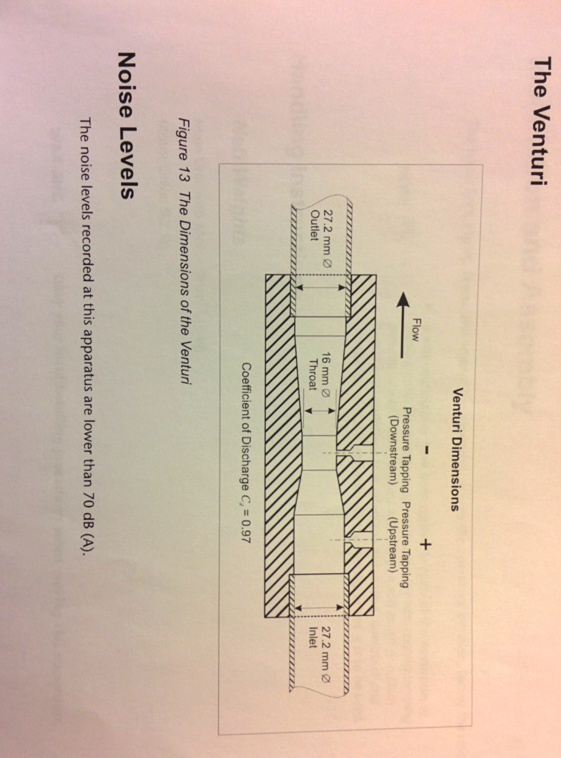

A1 = Venturi inlet area (m2)

A2 = Venturi throat area (m2)

Cd = Coefficient of discharge

ρ = Water density (kg / m3)

Δp = pressure drop across the venture (Pa)

|  |  |  |  |  |  |  |  |  |
| --- | --- | --- | --- | --- | --- | --- | --- | --- |
| Pump Inlet (Suction) Pressure [bar] | Outlet (Delivery) Pressure [bar] | Total Head, H [Pa] | Pump Speed, N [RPM] | Pump Torque, T [Nm] | Venturi Pressure Difference [bar] | Flow Rate, Q [L/s] | Total Power Input [W] | Efficiency (%) |
|  |  |  |  |  |  |  |  |  |
|  |  |  |  |  |  |  |  |  |
|  |  |  |  |  |  |  |  |  |
|  |  |  |  |  |  |  |  |  |
|  |  |  |  |  |  |  |  |  |
|  |  |  |  |  |  |  |  |  |
|  |  |  |  |  |  |  |  |  |
|  |  |  |  |  |  |  |  |  |
|  |  |  |  |  |  |  |  |  |
|  |  |  |  |  |  |  |  |  |
|  |  |  |  |  |  |  |  |  |
|  |  |  |  |  |  |  |  |  |
|  |  |  |  |  |  |  |  |  |
|  |  |  |  |  |  |  |  |  |
|  |  |  |  |  |  |  |  |  |
|  |  |  |  |  |  |  |  |  |