IBM Thinkpad 380XD Laptop Experiment

Purpose: The purpose of this experiment is to investigate the thermal characteristics of an older laptop that does not use a heat pipe and to brainstorm ways to improve the cooling system using a heat pipe.

Before starting to read this handout, turn on the laptop. Record the case temperature once every minute until it reaches a steady state value. Record how long it takes for the laptop to reach steady state.

Background: In recent years, several trends have made the cooling of laptops more challenging. First, clock speeds have increased dramatically. For example, IBM Thinkpad frequencies have increased from 233 MHz in 1998 to over 2 GHz today. Since power is proportional to clock speeds, this has led to dramatic increases in cooling requirements. At the same time, die sizes have tended to increase as well because of increased performance demands from a single chip. Power dissipation is also proportional to die size. Offsetting these trends to a certain degree is a decrease in the required applied voltage from 5.0 V (66 MHz Pentium) to less than 1.5 V for many models today.

While power dissipation requirements have been increasing rapidly, customers have also been demanding thinner, lighter laptops. In many earlier laptops (as you will see in this experiment), there was enough space for a fan and heat sink. That is no longer the case with laptops which these days can be less than a inch in thickness.

Apparatus: The apparatus for this experiment is an IBM Thinkpad 380XD. These models were introduced in late 1997. This 233 MHz model includes a Pentium® Processor with MMX Technology. The processor is cooled using a fan and a narrow heat sink. This laptop has been instrumented with K-type thermocouples which measure the temperature of the processor case, the bottom of the heat sink, the inlet air to the fan, and the exhaust air. Note the pictures below.

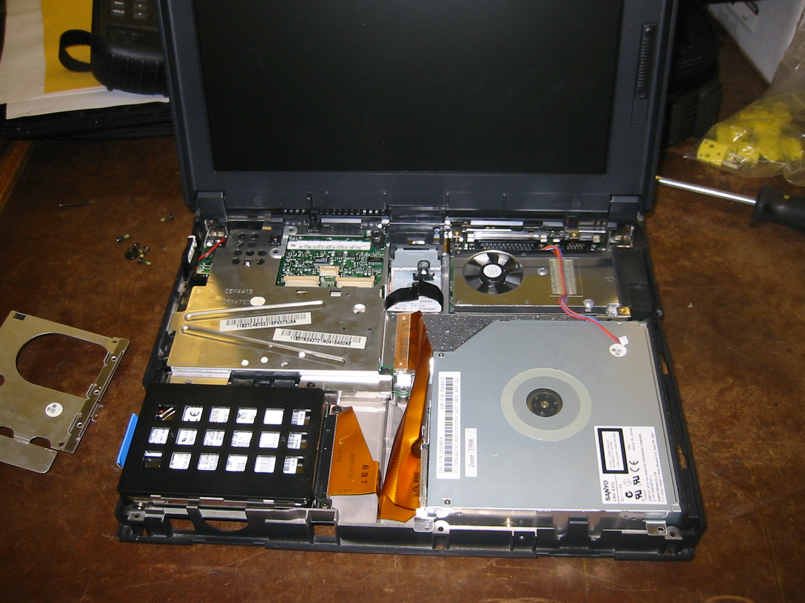
Fan/heat sink unit. Processor is underneath this component.

Figure 1 The insides of the laptop.

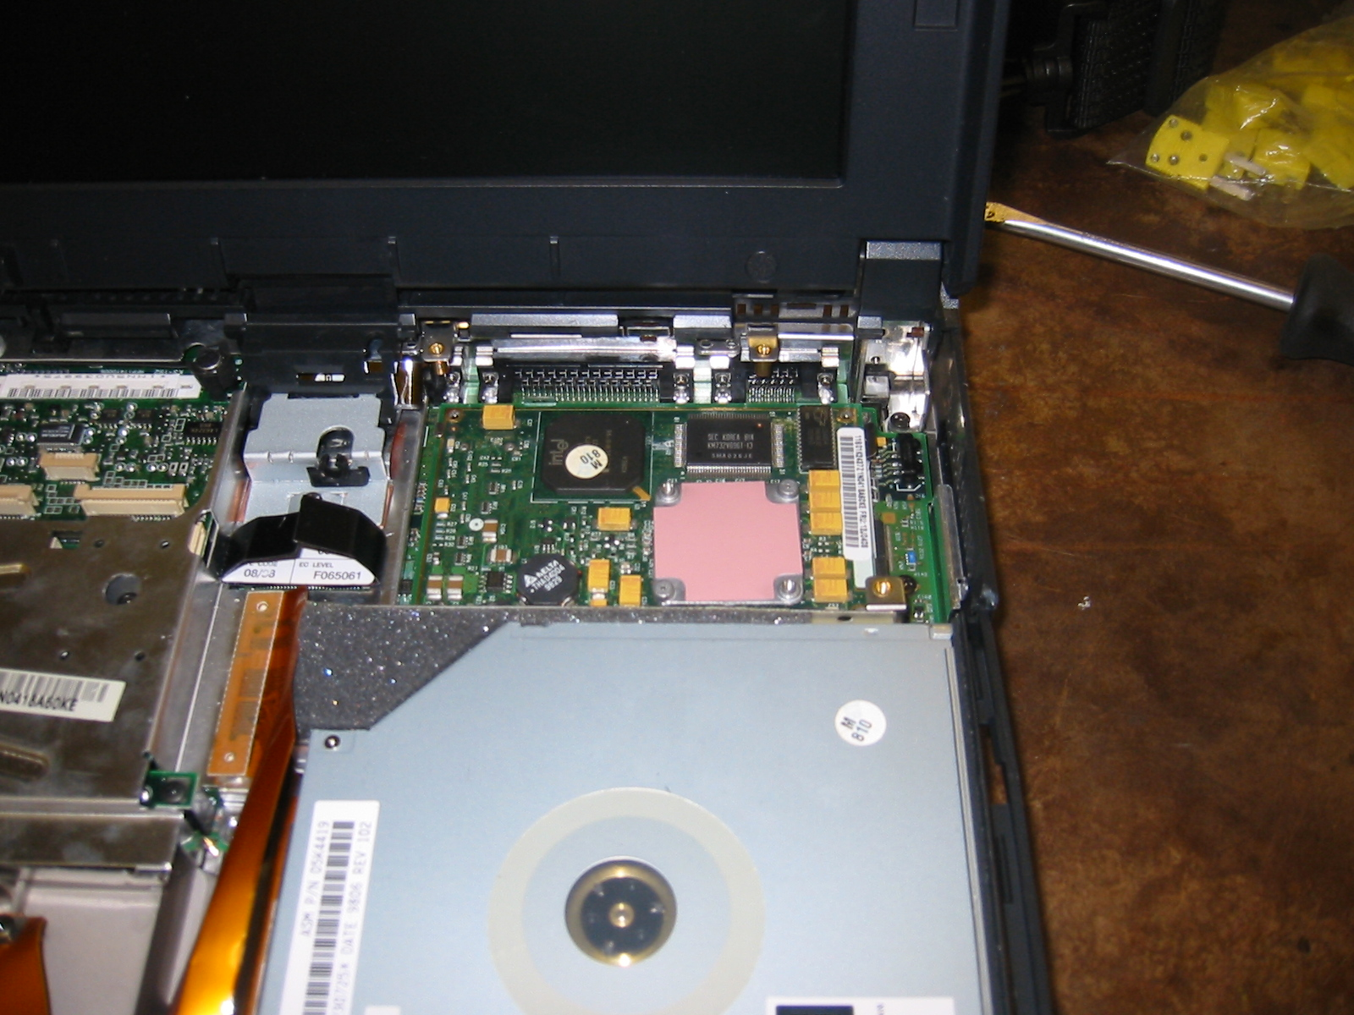
Processor covered by thermal pad

Figure 2 The fan/heat sink unit has now been removed. The processor is covered by a thermal pad.

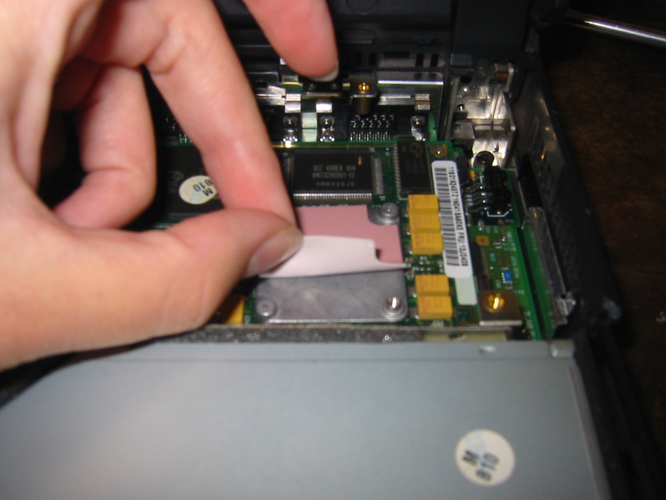

Figure 3 The thermal pad is being lifted, exposing the case of the processor below it. The thermal pad is tacky and can easily be removed and put back in place.

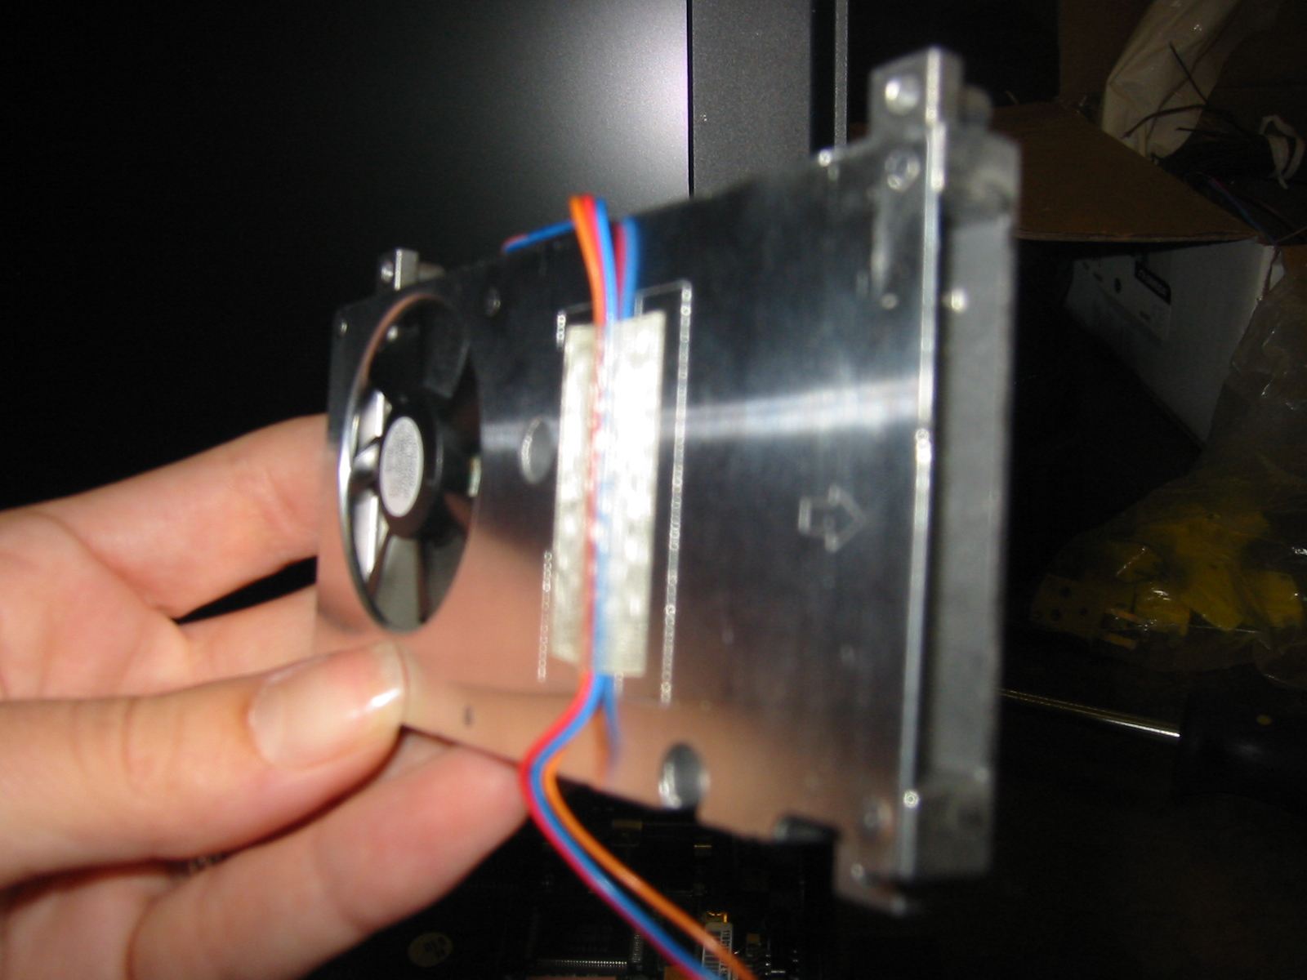

Figure 4 The top of the fan/heat sink unit
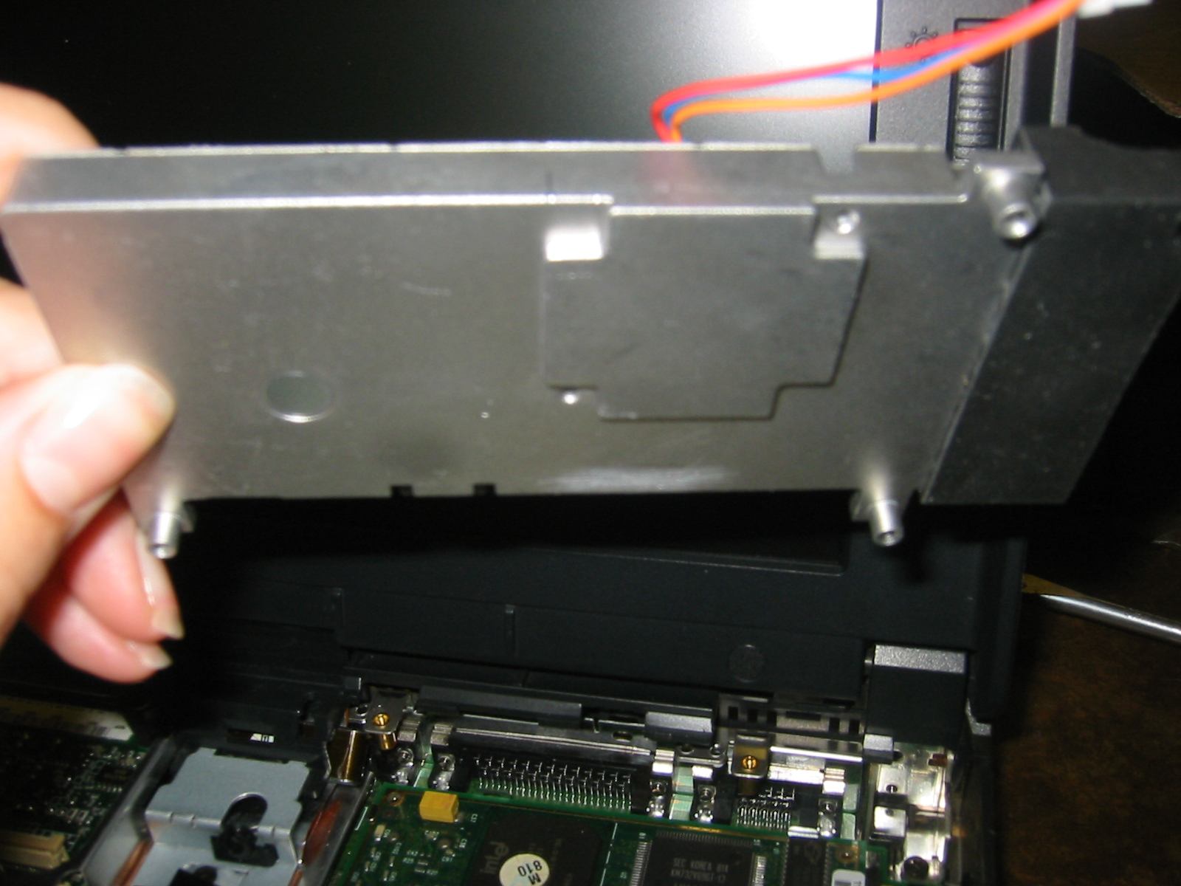

Figure 5 The bottom of the fan/heat sink unit. Notice the raised platform which rests on top of the thermal pad. The fan is screwed in place to help maintain good contact.

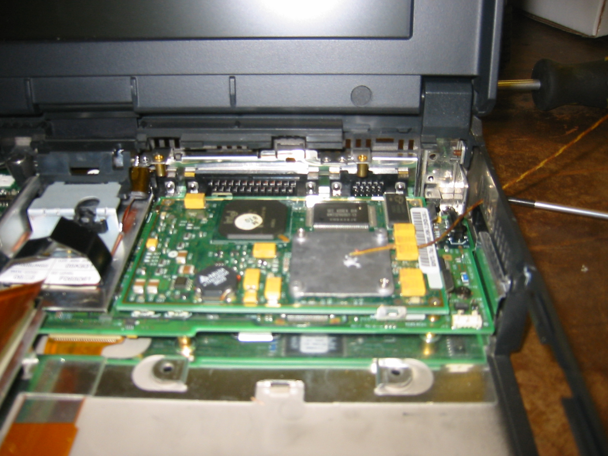

Figure 7 The first thermocouple is attached to the case of the processor.
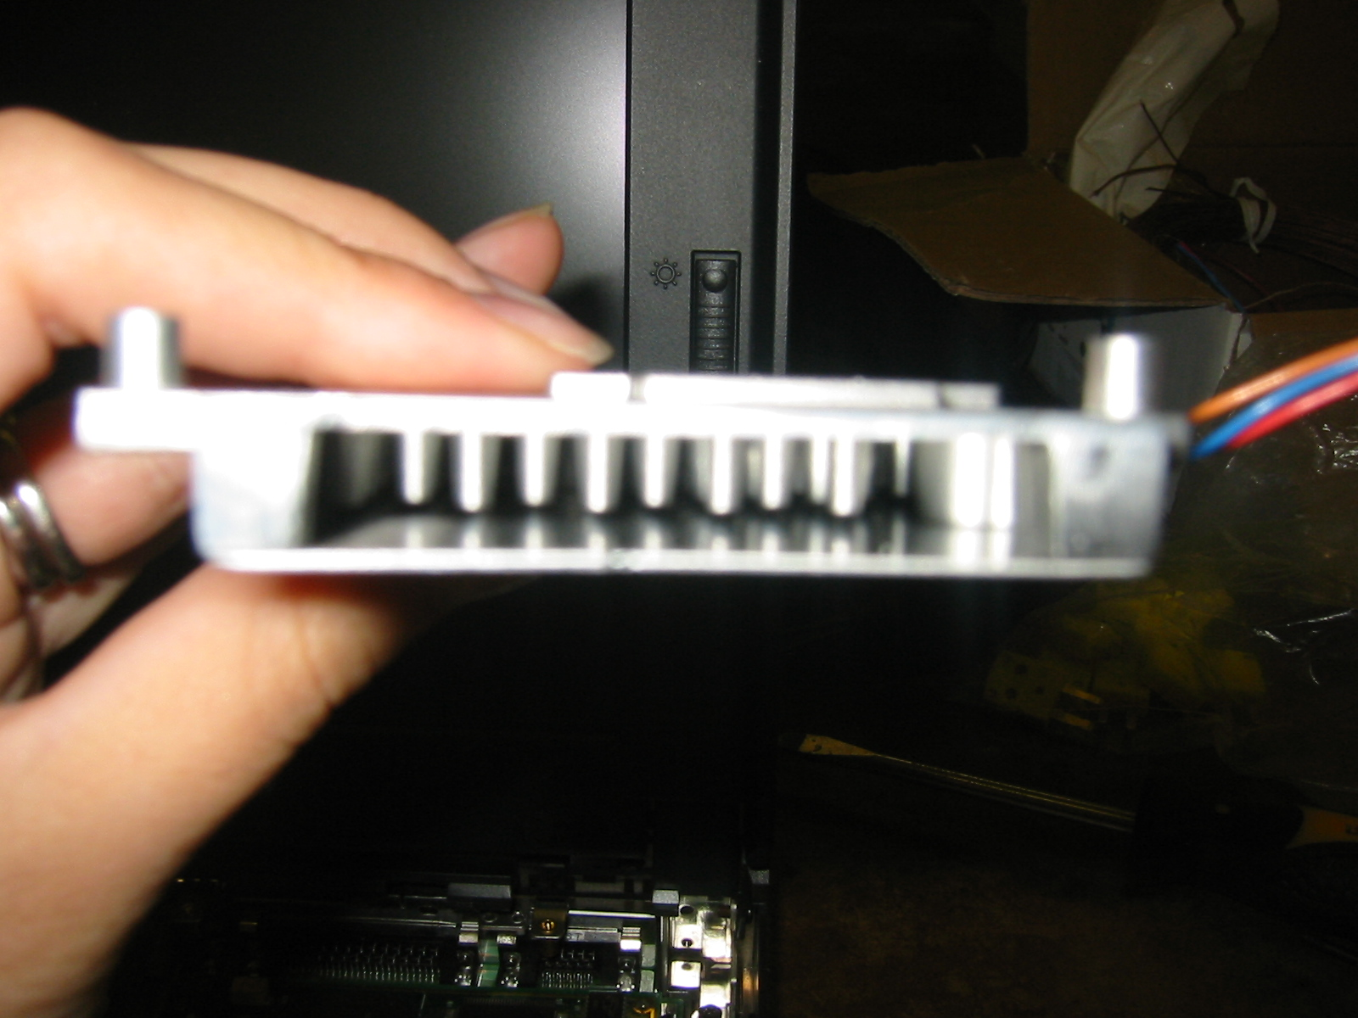

Figure 6 The insides of the fan/heat sink unit. Note the pin fins. Air passes through this enclosure and exits through a vent in the side of the laptop.

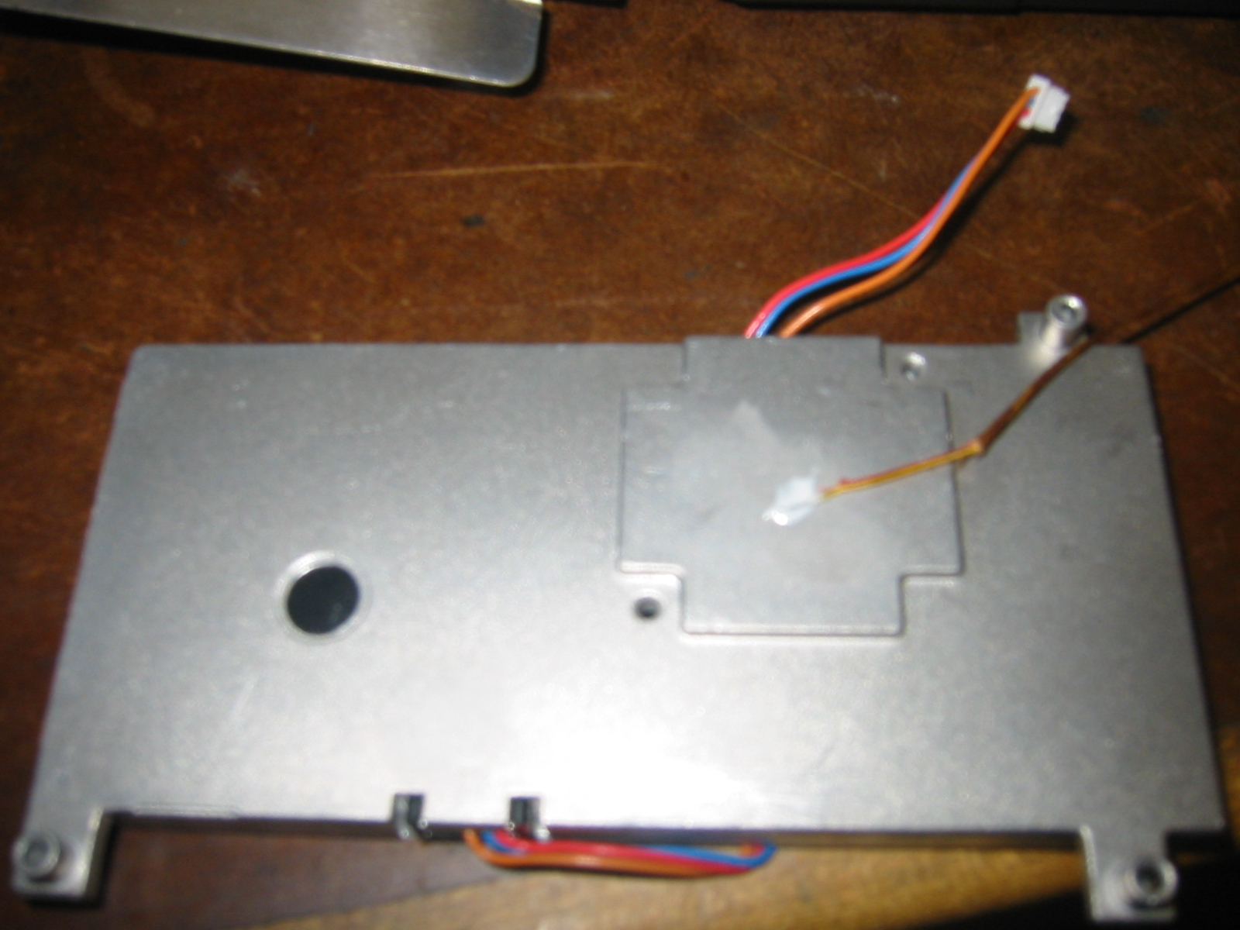

Figure 8 The second thermocouple is attached to the bottom of the fan/heat sink unit.

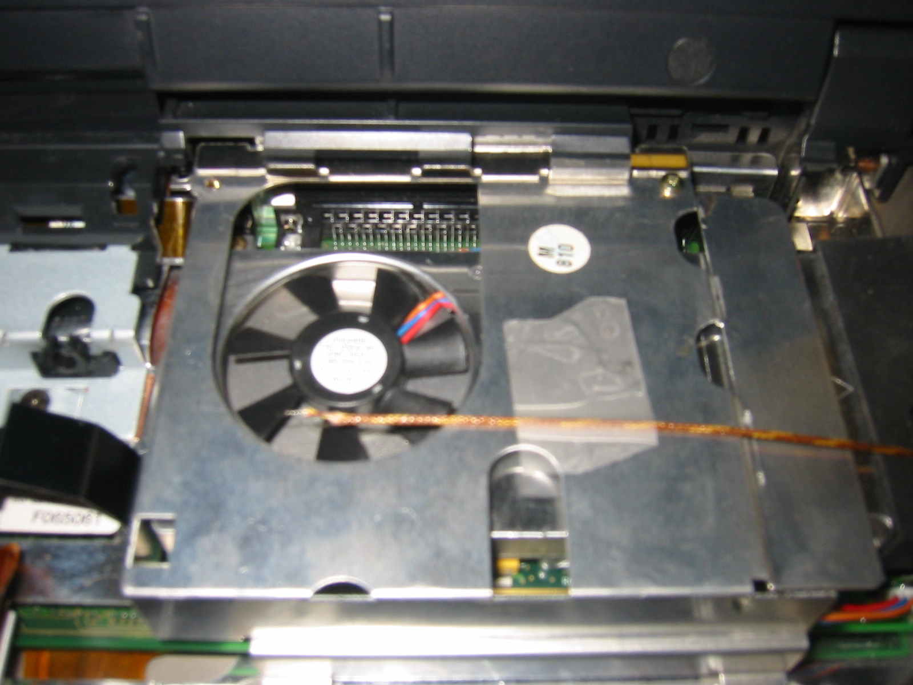
Figure 9 The third thermocouple is located by the fan air intake. The fourth thermocouple, which is not shown, is located just inside the air exit vent.

Procedure:

1. You should have been recording the laptop case temperatures once every minute after turning it on. Discuss among yourselves what condition to use to say that it has reached steady state.

2. After reaching steady state, open the Office Installer on the desktop. How is the case temperature affected? Once the installer is open, don’t hit “next” (we don’t actually want to install anything). After the temperatures have stabilized, close the Installer, and wait for steady state to be reached again.

3. Now measure the four temperatures. Be very careful with the thermocouples! The wires aren’t much thicker than the width of a hair, and if you pull on them they can break. Measure each temperature at least four times, and use the average in all calculations.

4. Shut down the computer when you are finished.

Questions: Turn in your answers to these questions before leaving the lab. They need not be in lab report format. Turn in one set of answers per team. Please make sure that your handwriting is legible!

1. Excessive thermal cycling can significantly reduce the life of your processor. How long did it take this processor to reach a steady state temperature after turning it on? What happened when you opened the Office Installer? Why should thermal cycling have a negative effect on the life of your processor?

2. Intel specifications recommend that the case temperature of the Pentium® Processor with MMX Technology stay below 70ºC. Does the cooling system seem to be adequate?

3. Under normal conditions, this chip dissipates approximately 7.9 W. Calculate the case-to-air thermal resistance in ºC/W (θ_{ca}). Use the air inlet temperature. Compare these values with the specs given below in Table 1. Do your numbers look reasonable?

4. Calculate the contact resistance between the case and the heat sink in ºC/W . What percentage is it of θ_{ca}?

5. Under extreme conditions, this processor can see a maximum power dissipation of 17.0 W. Is the cooling system still adequate under those circumstances?

6. With the value of θ_{JC} from Table 1, calculate the expected junction temperature for both 7.9 W and 17.0 W power dissipation.

7. Most laptops these days do not have room for a heat sink and fan. Estimate the new case temperature for this system if you removed the heat sink and fan. Use the data from the table. Would the cooling be adequate?

8. Brainstorm with your partner to come up with a conceptual design of a new cooling system using a heat pipe. Answer the following questions:
- What shape heat pipe will you use?
- To where will you transfer the heat?
- Once you have transferred the heat to its new location, how will it be removed?
Your answer need not be longer than approximately a half page in length (if your write fairly small). You may use hand sketches to illustrate your idea, but it is not necessary.

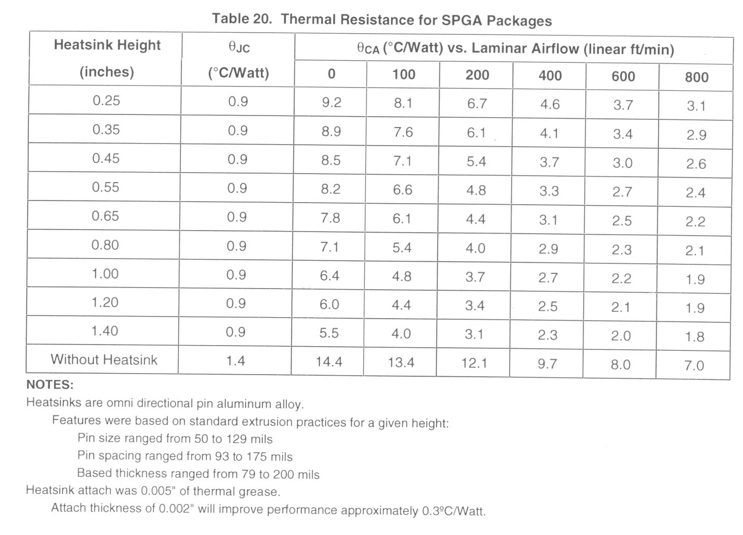
1
“Pentium® Processor with MMXTM Technology”, Intel Corporation website, ftp://download.intel.com/design/pentium/datashts/24318504.pdf

