Single Author
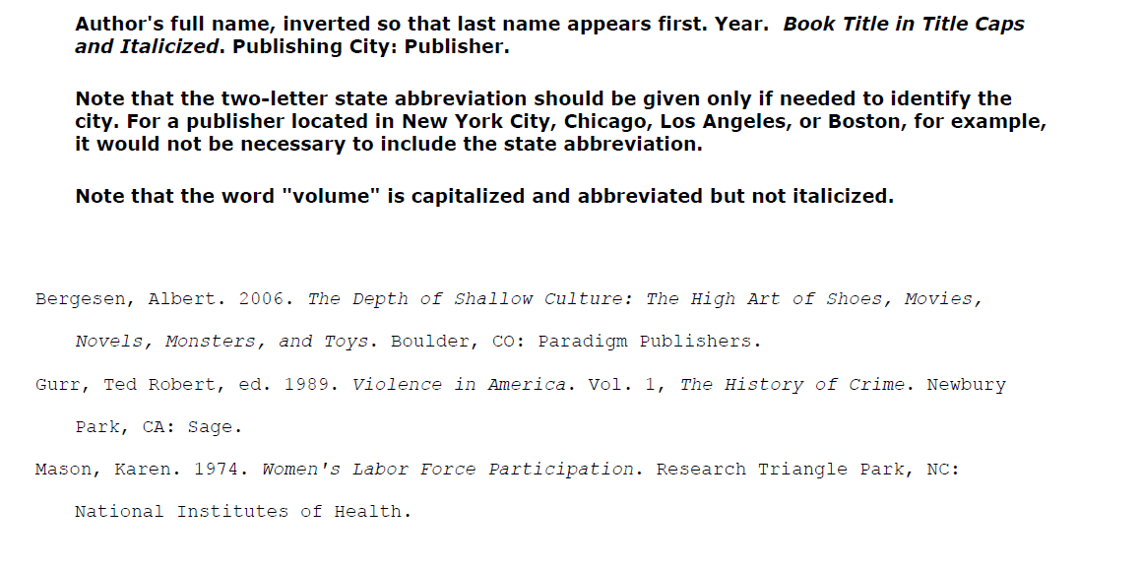

Two Authors [Book]
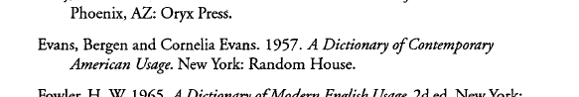

Three Authors [Book]
Evans, Bergen, Cornelia Evans, and Oh So Wise. 2013. Having Fun with Sociology.
New Haven, CT: Random House.

Journal Article
Berbrier, M. 2002. "Making Minorities: Cultural Space, Stigma Transformation Frames, and the Categorical Status Claims of Deaf, Gay, and White Supremacist Activists in Late Twentieth Century America." Sociological Forum 17(4): 553–591.
———. 1998. "Half the Battle": Cultural Resonance, Framing Processes, and Ethnic Affectations in Contemporary White Separatist Rhetoric. Social Problems 45(4): 431–50.

Lio, Shoon, Scott Melzer, and Ellen Reese. 2008. "Constructing Threat and Appropriating “Civil Rights”: Rhetorical strategies of gun rights and English only leaders." Symbolic Interaction 31(1): 5–31.

Newspaper/Magazine Reference

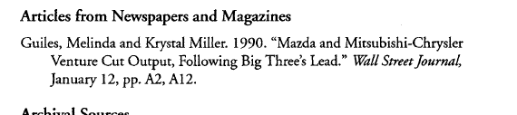

Online Journal Article
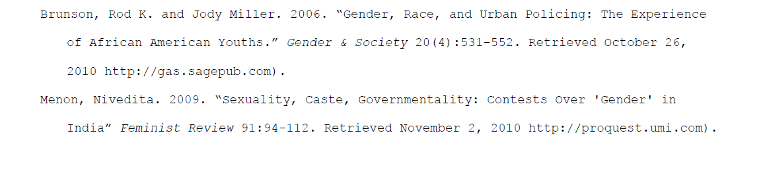

Web Pages
