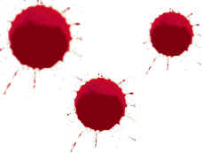
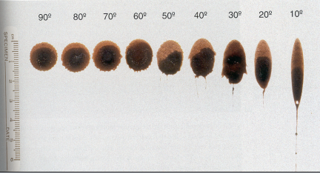

JS 112 Bloodstain Pattern Analysis Crime Scene Exercises

Introduction
Crime scenes that involve bloodshed often contain a gold mine of information in the form of bloodstains. The pattern, size, shape and location may be very useful in reconstruction of the events that occurred. Bloodstain Pattern Analysis is the examination of the shapes, locations, and distribution patterns of bloodstains, in order to provide an interpretation of the physical events that gave rise to their origin.

Information from the interpretation of the patterns may be used for one or more of the following:
- Location and description of individual stains and patterns.
- Mechanism that created the stains
- Direction a blood droplet was traveling by calculating angles of impact
- Area of origin- location of blow into blood source
- Type of object used in the attack (blunt, edged, firearm, etc.)
- Minimum number of blows (First one is for free)
- Presence of a subject at a scene
- Positioning of the victim, suspect, and objects during events
- Sequence of events
- Confirm or refute assumptions concerning events and their sequence:
Position of victim. (standing, sitting, lying)
Evidence of a struggle. (blood smears, blood trails)
- Confirm or refute statements made by principals in the case:
In this series of exercises you will examine and interpret bloodstains as a function of target surface, angle of impact and distance or height.

Materials
- Small and large droppers
- Mock Blood
- Smooth and non-smooth surfaces
- Tape measure
- Protractors for determining angles
- White paper
- Rulers for measuring
- Gloves, Laboratory Coats
General Directions for each Section
- For all sections, measure the drops in mm. For all sections measure the diameter and width.
- For All Sections you will utilize the large pipet
- For Sections 1 all drops will be made from 3 feet from the surface. In section 2, you will use at least 3 different distances to the target
- Always wear gloves and lab coats for this exercise. Of course if this were real blood you would also need to take all necessary safety precautions (e.g. Biohazard disposal, double glove, etc.)
- In your teams, designate the following roles and responsibilities:
  - Dropper- Individual will be responsible for dropping the blood at appropriate heights, volume etc.
  - Note takers- Two individuals will be responsible for taking notes and sketching the scene.
  - Measurers- One-two individuals should measure the drops once all three have been completed for each exercise. Take all measurements to the nearest mm.
  - Photographer (if available)- One person should take photos of all data generated using scale.
Documentation of all measurements should be conducted by all members of the team so you have a copy of the original data from your team.
Liason- You should designate someone on your team to gather at least one other teams data via email.

Once you have made and measured all the blood drops be sure to clean up and move your team sheets back onto the large butcher paper. Be sure all your papers are labeled with your team name and date.

Experiment 1- Bloodstain vs. Target Surface (measure diameter in mm)
Using your dropper, deliver 3 drops from 3 ft on the smooth white paper and then on sand paper.
Surface | Replicate 1 | Replicate 2 | Replicate 3 | Average diameter
Smooth
(measure diameter in mm and draw)

Non-smooth
(measure diameter in mm and draw)

Questions to include in your discussion:
- What differences did you observe for the smooth vs the non-smooth surfaces?

- Below, draw what you observed for each surface type.
Smooth Non smooth

Experiment 2- Bloodstain vs. Height (measure diameter in mm)
Deliver 3 drops on smooth paper from 1, 3, 6 and ceiling height if possible.
Origin | Replicate 1 | Replicate 2 | Replicate 3 | Average
1 foot

3 feet
6 feet

Ceiling

1) Did you observe differences at each height?

Experiment 3- Bloodstain vs. Angle (measure W and L in mm)
Using the board provided, set the board at the desired angle and clip paper on the board. Deliver 3 drops from approximately 3 ft at the 3 different angles.
Known Angle of impact | Replicate 1  W L | Replicate 2  W L | Replicate 3  W L | W/L Average | Arc sin W/L  average | Calculated Angle of Impact | Difference between Known vs Calculated
22.5

45
90  (already done in expt 1) | Fill in from #1 | Fill in from #1 | Fill in from #1

- Did you observe differences in the W/L average for each of the angles?
- Does the calculated angle of impact = the known angle? Why or why not?
- What are three variables that may lead to differences?

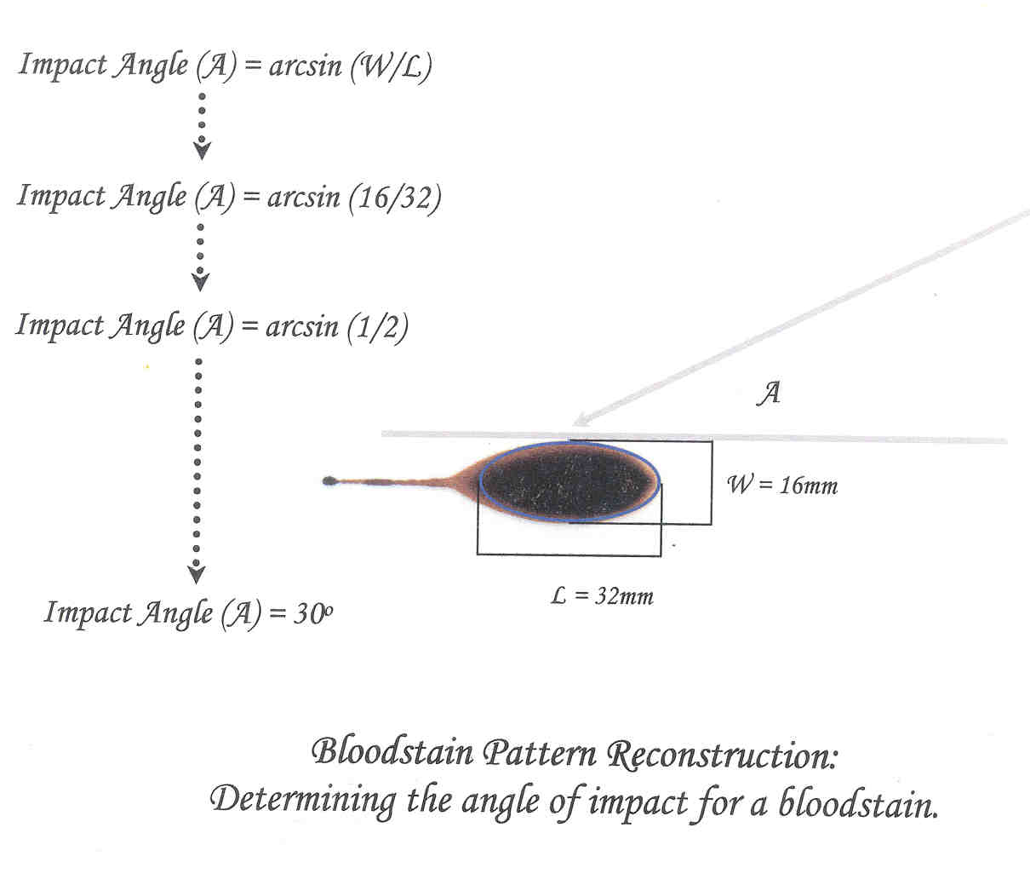
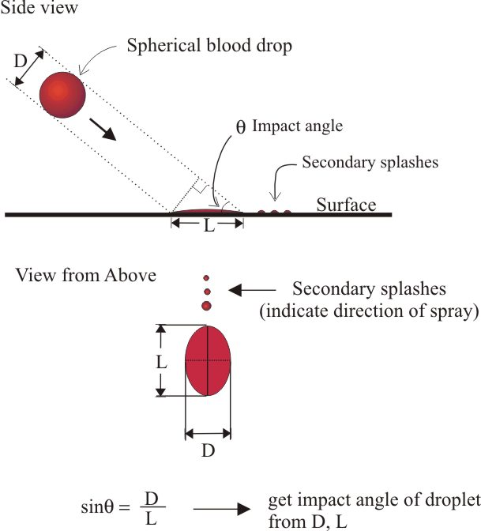
Links:
A blood spatter tutorial: http://www.bloodspatter.com/BPATutorial.htm
A primer on blood types:
http://www.biology.arizona.edu/human_bio/problem_sets/blood_types/Intro.html
A recent story on CNN on how blood spatter may clear a teen accused of killing her parents:
http://www.cnn.com/2005/LAW/03/03/johnson/
Another blood spatter story about a forensic scientist in Washington State:
http://www.truthinjustice.org/charles-vaughn.htm
A story from CourtTV about blood spatter:
http://www.crimelibrary.com/criminal_mind/forensics/serology/1.html
The website of a forensic scientist specializing in blood spatter:
http://www.bloodspatter.com/

Calculation of Bloodstain Angle of Impact
The relationship between these variables is:
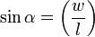
Therefore:
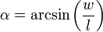
For example:

SIN < = Width (a) 1.5cm
Length (c) 3.0cm

Width (a) 1.5cm = SIN <
Length (c) 3.0cm

0.5 = SIN <
so, < = 30 degrees

For calculations of arc sin- see
http://mdmetric.com/tech/scicalculator.htm

Or use the graph below:
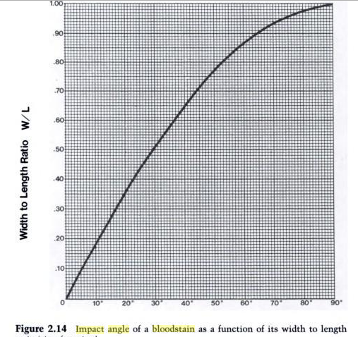
From: Interpretation of Bloodstain Evidence at Crime Scenes
By Stuart H. James, William G. Eckert Published by CRC Press, 1998 ISBN 0849381266, 9780849381263 324 pages

Online version at: http://books.google.com/books?id=KTN3MZ02j1gC&dq=bloodstain+angle+of+impact&source=gbs_summary_s&cad=0

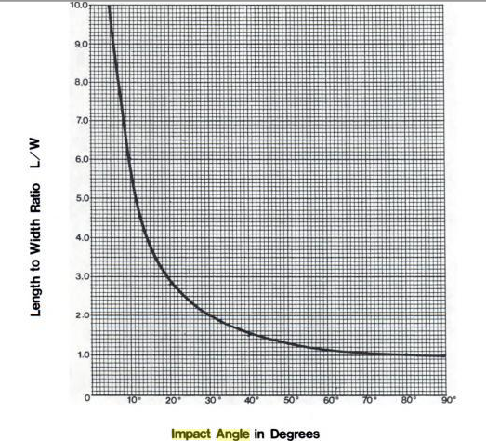
http://books.google.com/books?id=KTN3MZ02j1gC&pg=PA27&lpg=PA27&dq=bloodstain+angle+of+impact&source=web&ots=-TowLfJWld&sig=5geGMO4x0BxdFDs5RtH8Q5CS0SA&hl=en&sa=X&oi=book_result&resnum=3&ct=result#PPA33,M1

Glossary of Key Bloodstain Pattern Analysis Terms Angle of Impact: the angle at which a blood droplet strikes a surface
Arterial Gushing: the large pattern of blood that is created when blood escapes an artery under pressure; the increase and decrease in blood pressure is apparent
Arterial Spurts: large patterns created under pressure, but with less volume and usually more distinctive evidence of blood pressure rising and falling
Clot: a mass of blood and other contaminants caused through clotting mechanisms
Cast-Off Stains: blood that has been thrown from a secondary object (weapon or hand) onto a target other than the impact site
Drop Patterns: characteristic patterns present when blood drips into standing, wet blood
Expiratory Blood: blood which is spattered onto a target, as a result of breathing; typically, this occurs when an injury is sustained to the throat, mouth, or airway
Impact Site: usually the point on the body that received the blow or applied force, from which the blood was shed
Origin: the point in space where the blood spatter came from
Parent Drop: the droplet from which satellite spatter originated
Projected Blood: blood under pressure that strikes a target
Satellite Spatters: small drops of blood that break off from the parent spatter when the parent droplet strikes a target surface
Shadowing/Ghosting/Void: a pattern that helps to place an object or body in the scene; normally, the area in question lacks blood even though areas surrounding it show blood
Skeletonized Stain: the pattern left when an object moves through a partially dried stain, removing part of the blood, but leaving the outline of the stain intact
Spatter: bloodstains created from the application of force or energy to the area where the blood is
Spines: the pointed edges of a stain that radiate out to form the spatter
Splash: pattern created when a volume of blood in excess of 1 mL strikes a surface at a low to medium velocity
Swipe: the transfer of blood onto a target surface by a bloody object that is usually moving laterally
Transfer Pattern: the pattern created when a wet, bloody object comes in contact with a target surface, leaving a pattern that has the features of the object making it useful for identifying the object
Target: the surface where the blood ends up
Wipe: pattern created when a secondary target moves through an existing wet blood stain on some other object
Glossary from: http://www.bergen.org/EST/Year5/EA/Serology2_1.htm
Image from: http://www.assassinrecords.net/images/splash_04.jpg
Much of the procedure for this lab is from the following site which also has videos of some of the protocol: http://www.ap.stmarys.ca/~smitchel/for201labs/blood_angle/ang_procedure.html

References
Akin, L.2005.Blood. Interpretation at Crime Scenes. The Forensic Examiner. 14:6-10.
Bevel, T and Gardner, RM. 2002. Bloodstain Pattern Analysis. 2nd ed. CRC Press.
HemoSpat- Bloodstain Pattern Analysis Software: http://hemospat.com/
International Association of Bloodstain Pattern Analysis: http://www.iabpa.org/
IABPA (International Association of Bloodstain Pattern Analysts). Suggested IABPA Terminology List. Retr. 10/05 from: http://www.iabpa.org/RevEduc.pdf
James, SH, Kish, PE and Sutton, TP. 2005. Principles of Bloodstain Pattern Analysis: Theory and Practice.CRC Press.
*Slemko, J. BLOODSTAIN PATTERN ANALYSIS TUTORIAL – Retrieved Spring 2005 from http://www.bloodspatter.com/BPATutorial.htm
*Wolson, T. 2001. Bloodstain Pattern Analysis Workshop. Toby Wolson. Miami-Dade Police Department Course
- Wilkipedia: The Free Encyclopedia. Bloodstain pattern analysis. http://en.wikipedia.org/wiki/Blood_pattern_analysis_at_crime_scenes

